The Byzantine Empire
The Eastern Roman Empire
Matthew Kauffman

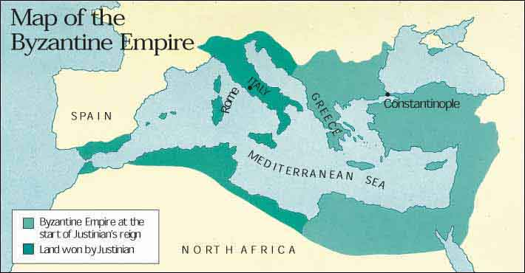
Origins
The origins of the Byzantine Empire can be traced back to 330 A.D. when Emperor Constantine I dedicated a new city on the site of the ancient Greek colony of Byzantium, from which the empire’s name is derived. It became the Eastern Roman Empire in 364 A.D. when Emperor Valentinian I split the Roman Empire in two, and its capital became Constantinople. All of the citizens of this empire fancied themselves Romans and Christians, yet the empire was very Hellenized and most people spoke Greek, not Latin. The city was ideally located on the Bosphorous Strait, making it a center of trade and in turn a center of culture and art.
Rome finally collapsed in 476 A.D. when the last Roman Emperor was overthrown. The Byzantine Empire proved less vulnerable to attack, thanks in part to its geographic location. Since Constantinople was located on a strait, it was extremely difficult to breach the capital's defenses. It also benefited greatly from a stronger administrative center and internal political stability, as well as great wealth compared with the medieval kingdoms of the era. The eastern emperors were able to exert more control over the empire's economic resources and more effectively raise armies to combat invasion.
Though the Byzantine Empire was ruled by Roman law and Roman political institutions, and its official language was Latin, students received education in Greek history, literature and culture. As to religion, the Council of Chalcedon in 451 officially established the division of the Christian world into five patriarchates, each ruled by a patriarch: Rome and Constantinople were the largest, and Constantinople received the power of the other three after the rise of Islam. The Byzantine emperor was the patriarch of Constantinople, and the head of both church and state.
Justinian
Justinian I, who took power in 527, was the first great ruler of the Byzantine Empire. Many monumental constructions the empire were built under Justinian, including the Hagia Sophia, which was built in 537 A.D. Justinian also reformed and codified Roman law, establishing a Byzantine legal code that would endure for centuries and help shape the modern concept of the state. What Justinian was best known for, and how he left his mark in history, was his reclamation of ancient Rome and its lands. Justinian had a dream of reuniting the Roman Empire, and he reconquered almost the entire empire, gaining lands in North Africa, Italy, and all the way to Spain.
At the time of Justinian's death, the Byzantine Empire reigned supreme as the largest and most powerful state in Europe. Debts caused by war left the empire in financial crisis, and his successors were forced to heavily tax Byzantine citizens in order to preserve the empire. Also, the imperial army was stretched too thin, and struggled to maintain the territory conquered by Justinian. During the seventh and eighth centuries, attacks by Persians and Slavs, combined with internal political instability and economic regression, threatened the empire. A new threat arose in Islam, founded by the prophet Muhammad in Mecca in 622. In 634, Muslim armies began their assault on the Byzantine Empire by attacking Syria. By the end of the century, the Byzantine Empire lost Syria, the Holy Land, Egypt and North Africa to Islamic forces.

Religion and Worship
Starting in 730 A.D., Byzantine emperors led a movement that denied the holiness of icons, or religious images, and prohibited their worship. Known as Iconoclasm (the smashing of images), the movement ended in 843 A.D.
During the late 10th and early 11th centuries, under the rule of the Macedonian dynasty, the Byzantine Empire enjoyed a golden age. Though its territory had decreased, the Byzantine Empire had more control over trade, more wealth and more international prestige than under Justinian. The empire patronized the arts, restored churches, palaces and other cultural institutions, and promoted the study of ancient Greek history and literature. Greek became the official language of the empire, and a flourishing culture of monasticism began. Monks administered many institutions as in Medieval Europe, and Byzantine missionaries won many converts to Christianity among the Slavic peoples. The empire’s religion split from Roman Catholicism and became Orthodox Christianity.
The Crusades
The holy wars of the Crusades began in 1095. As the Turks closed in on Constantinople, the Byzantine Empire turned to Europe for help. It was this action, accompanied by the Pope’s desire to regain the Holy Land in Jerusalem,that led to the First Crusade.
During the subsequent Crusades, tensions began to rise between the Byzantine Empire and the West, but it wasn’t until the Fourth Crusade in 1204 that it culminated. In the Fourth Crusade, Constantinople was sacked and conquered, and the Byzantine Empire briefly became the Latin Empire. The Latin regime established in Constantinople existed on shaky ground due to the open hostility of the city's population and its lack of money. In Nicaea, a Byzantine government-in-exile grew in strength until it retook the capital and overthrow Latin rule in 1261.
The End of the Empire
During the rule of the Palaiologan emperors, beginning in 1261, the economy of the Byzantine Empire collapsed, and was unable to recover. In 1369, the empire unsuccessfully sought financial help from the West to confront the growing Turkish threat, but was denied. A decade later, the empire was forced to become a vassal state of the mighty Turks. As a vassal state, the Byzantine Empire paid tribute to the sultan and provided him with military support. The rise of Murad II as sultan in 1421 marked the beginning of the end. Murad revoked all privileges given to the Byzantines and laid siege to Constantinople. It was his successor, Mehmed II, who completed this process when he launched the final attack on the city. On May 29, 1453, after an Ottoman army attacked Constantinople, Emperor Constantine XI died in battle, and the decline and fall of the Byzantine Empire was complete.
In the centuries leading up to the final Ottoman conquest in 1453, the culture of the Byzantine Empire flourished once again, even as the empire itself faltered. Byzantine culture would exert a great influence on Western tradition, as scholars of the Renaissance sought help from Byzantine scholars in translating Greek and Christian writings. Long after its end, Byzantine culture and civilization continued to influence countries that practiced Orthodox Christianity.

