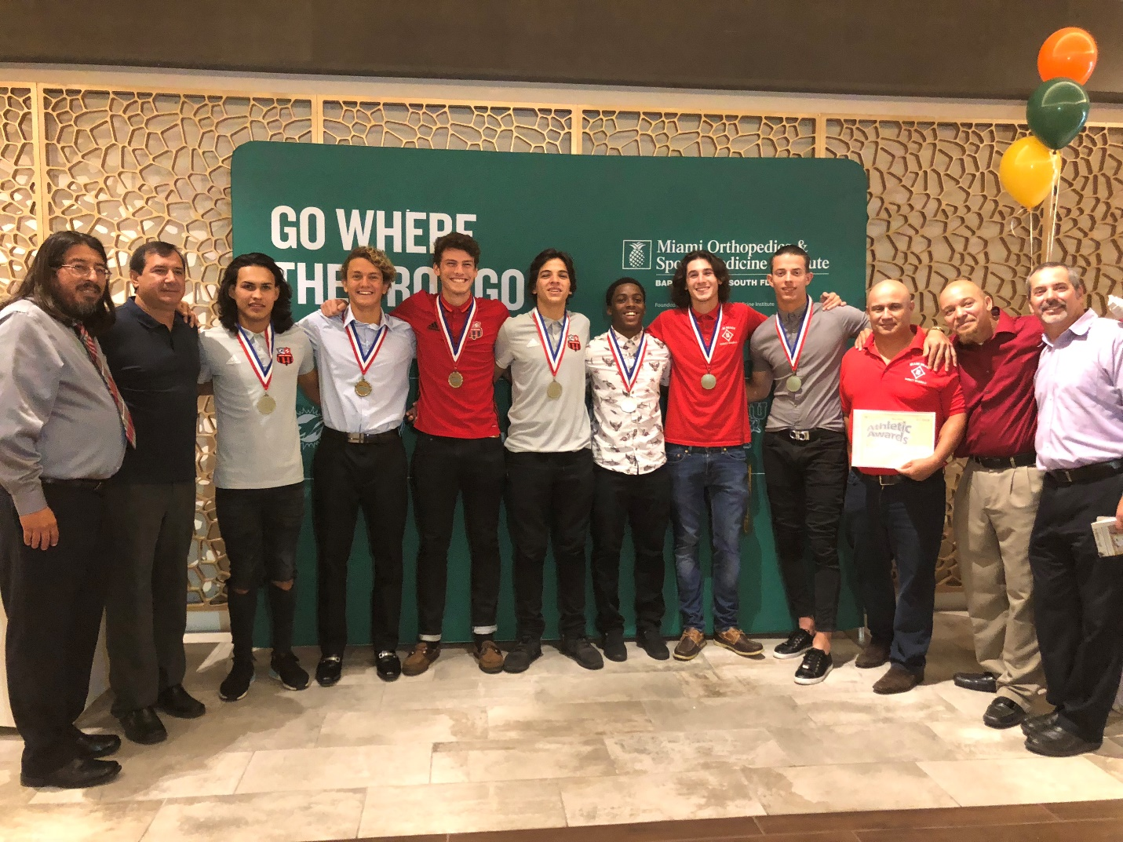
Thursday, May 24, 2018 9:37 AM
Congratulations to the following athletes that represented Beach High in the All-Dade Breakfast yesterday.

Josue Aguilar Soccer
Leonardo Acosta Soccer
Toby Squire Soccer
Daishaun Felton Wrestling
Nolan Santos Baseball
Bramdon Perez Baseball
Nicholas Fedotov Water Polo

In addition the following individuals were recognized on a great season.

Josue "Chino" Aguilar - Player of the year in soccer
Edgar Botto - Coach of the year in soccer
Juan Cordero - Coach of the year in Baseball
Attached is a picture taking after the event

Go Hi-Tides!

