# The Business Plan

# Owner: Mr. D. Schmidt

# 1400 Alton Road

# Miami Beach Florida 33139

# (305) 555-1212

# [www.thewheelexpress.com](http://www.thewheelexpress.com)

# November 20, 2019

Business Plan developed by Mr. D. Schmidt, consultant

## Statement of Purpose

The purpose of the business plan to get the *Wheel Express* started efficiently with the least amount of set-up cost and to open the store in a timely fashion. The plan will provide a guideline of making right cost-effective decisions.

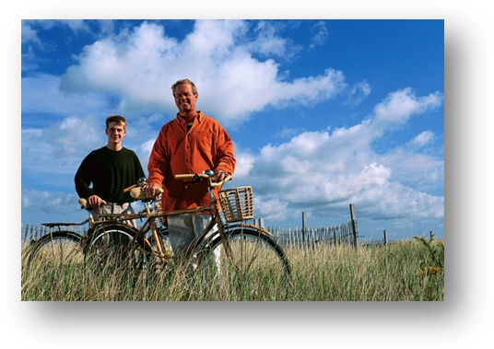The Business Plan will provide all the materials, supplies, and manpower to get the store open and operating in a successful manner. The plan will provide quantify the costs and manpower necessary for all aspects of operation.

The *Wheel Express* will be a Sole Proprietorship. The store will feature bikes, scooters, skates for the whole family to enjoy. The merchandise that the store will sell would keep in mind the lifestyle of the residence of Miami Beach. The store wills also lease bikes for the tourists.

Mr. David Schmidt is the sole proprietorship and he will take all fiscal and financial responsibility of the store. All decisions made for the store must have his approval. All profits from the store go to the owner for his decision of disbursement of profits.

The store will require a bank note for the start-up costs. The store will get a 5-year loan and pay a reasonable interest to offset the start-up cost.

# Table of Contents

## Part 1- The Organization Plan 5

Summary Description of the Business 6

Products or Services 7

Intellectual Property 7

Location 8

Legal Structure 8

Management 9

Personnel 10

Accounting and Legal 11

Insurance 12

Security 12

## Part 2- The Marketing Plan 13

Overview and Goals of Your Marketing Strategy 15

Marketing Analysis 19

Marketing Strategy 19

Customer Service 20

Implementation of Market Strategy 20

Assessment of Marketing Effectiveness 21

## Part 3- Financial Documents 23

Summary of Financial Needs 24

Loan Fund Dispersal Statement 25

Three-Year Projection 26

Projected Balance Sheet 27

Break-Even Analysis 27

Financial Statement Analysis 27

Business Financial History 28

## Part 4- Supporting Documents 29

Personal Resume 30

Owner Financial Statements

Credit Reports

Copies of Leases, Mortgages, Purchases Agreement

Letters of Reference

Contracts

Other Legal Documents

Miscellaneous Documents

#### Summary Description of the Business

The *Wheel Express* will be a bicycle retail store. In the inventory I will sell bicycles of all sizes for all ages to accommodate the whole family. With the bicycles I will also sell bikes accessories and parts. I will also sell other wheel goods, such as scooters, skates, wagons and battery-operated toy vehicles for children.

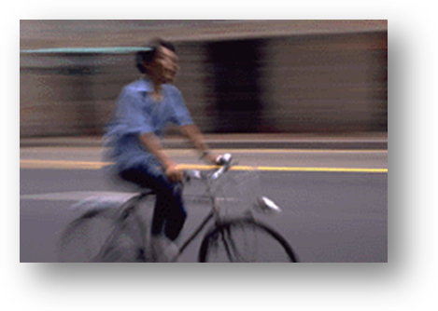I will serve to the Miami Beach market, where bicycles, skates and skateboards are a very popular mode of transportation to go through the traffic-congested area, and parking is at a premium. Bicycles can eliminate many of these problems. The city of Miami Beach is a highly populated area with majority of the population lives here on a permanent basis, and about 25% live in Miami Beach seasonally. That is why will set up a department to lease bicycles to these customers.

I will hire a bike technician to assemble bicycles for customers, as well as to help the store’s customers with problems with their bikes. I would like to hire as many people from the local area as much as possible; they would be more knowledgeable of the traffic situations and the wants and needs for the customers.

In the past I have worked with people that come from the Caribbean Islands, Central and South America for bicycle exports for large dollar sales, without saturation of bicycles in the local area.

I chose the Alton Road location for many reasons, first it has excellent traffic pattern; it is busy, but not difficult to get in and out. Also, it is close to the Lincoln Road Mall the shopping Mecca of Miami Beach. There are parks nearby as well as high school, middle schools and elementary schools.

This store will be a sole proprietorship, as Mr. David Schmidt as the owner and manager. There will be assistant managers who will be responsible when the owner is not there; eventually become store manager, when additional stores are added, or the manager shows the experience, knowledge and ability to handle customers at a high-level of competence.

In the Personnel Section I explained the hiring needs for the business. Two assistant managers, one in charge of the operations of the store and the other will oversee the merchandising and promotions of the store. I will have an assistant that will take care of the financial accounts and take care of the office correspondence. See Personnel.

I think that investing in this business makes good sense, but a business that is necessary for the people that live in the Miami Beach area. I see a lot of new business open successfully in this area, and I don’t see why not the *Wheel Express* can equally be successful.

## Products and Services

The *Wheel Express* is mostly considered a bicycle shop. The shop will carry all types of bicycles from professional style racers, tandems bikes, mountain bikes, touring bikes, to the 10-inch tricycle for the smallest toddler. The store will also carry other “wheel” goods, such as wagons, roller skates, scooters, and battery-operated children’s cars.

I will have in stock bike manufactures of known brands of bicycles, such as Co-Motion Cycles, Colnago, Huffy, and many more. The store will bike helmets and accessories from Bell Many of the brands in the store are highly known for the quality and price.

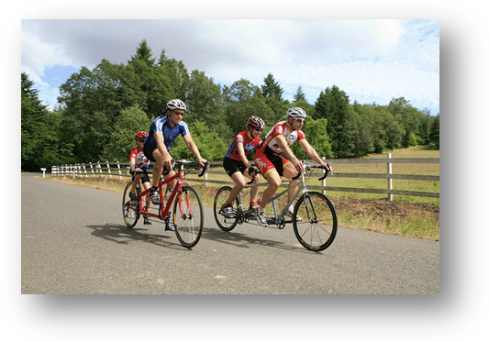With the unique composition of demographics of the city of Miami Beach, I see that leasing or renting out bikes to people visiting the Miami Beach area. Traffic and parking are difficult in this area and bikes, and scooters can help people get around easily and inexpensively.

I will have bike technicians working not only to build bikes to sell or lease, but to have them available to help customers to keep their bike in full repair, of course for a fee.

The store will keep in stock all the bike accessories needed that customers can purchase to keep their bikes in tip top shape.

## Intellectual Property

The Wheel Express Logo is currently being trademark by the Law Office of Stewart A. Merkin  
(Nexis, 2008), they will handle all our trademarks as well as any other legal business matters. Their website is <http://www.merkinlaw.net/> Their address is Rivergate Plaza, Suite 300, 444 Brickell Avenue, Miami, Florida 33131. Their office telephone number is 305-357-5556, and Fax: 305-358-2490.

## Location

The Wheel Express will be located on 14th Street and Alton Road. I feel that this is an excellent location for the store. There is good amount of traffic going by the site (Alton Road) and close by the center of shopping at Miami Beach at the Lincoln Road Mall. Many schools within a 3-mile range locate the store.

The Miami Beach area population is getting younger and younger. I feel that a bicycle shop will be ideal.

Flamingo Park is only a few blocks away, as well as the beach just a mile or so away.

There are many condominiums near this location, just west of Alton Road. There are many residences nearby to support this bicycle shop.

## Legal Structure

The *Wheel Express* will start out as sole proprietorship for at least the first five years. As a sole proprietorship, decisions can be made quickly to get the operation started. The store can find how they can compete effectively and quickly against the store’s competitors. Time consuming meetings with all the decision makers to decide even on the simplest problems or situations will be the problem of the competitors not the *Wheel Express*. We can adjust to changing technology of this industry quickly and get the newest prototype bikes out to our customers.

Mr. Schmidt is the sole proprietor; his personal resume is located in the Supported Documents of this Business Plan.

Mr. Schmidt will hire assistant managers to the store. After proper training and experience, successful assistant mangers will become store managers as *Wheel Express* adds stores and become a successful chain of stores.

After the initial five years of successful business Mr. Schmidt will take *Wheel Express* into a corporation and utilize increase capitalization from stockholders to build more stores in the state of Florida, then eventually throughout the United States.

## Management

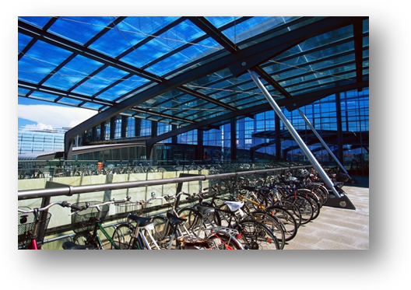Mr. Schmidt will be the sole proprietor; he will be responsible with all management activities of the store. He will be responsible for all decisions that relates to the Wheel Express.

I am a graduate from Florida State University with a B.S. degree in Business Management and Accounting. I have a teaching certification from Florida International University. Not only I have the formal education in management, but also, I have 13 years of retail management and 7 years being a labor manager for a large construction firm in South Florida.

I managed a Lionel Playworld (unfortunately went out of business 5 years after I left). We had the most successful bicycle departments in the national chain. I got to know many of the suppliers and manufactures in the area and understand how to choose quality in bikes and related items.

I have experience in the store operations and merchandising. I was successful in all my past endeavors in retailing.

For the past eight years I change my career to become business instructor at Miami Beach High School. I know the area very well and I have an excellent background to utilize my knowledge of this area to become successful.

I am in excellent health and have experience of opening new stores in the past and I have the physical stamina to work long hours if necessary. I will have two assistant managers that I will train them to make a dynamic management team. I will like to train them to become store managers with the company when the store expands to become a chain.

I will have an assistant to help with the bookkeeping and correspondence.

With my accounting background I will make sure proper accounting procedures are taken. Having an assistant in the office, I can free myself from the office and oversee the whole store operation. I can train my assistants and key personnel to become more professional in their work. I will be able to communicate with my suppliers to bring in the best selection of bikes for the customers.

Mr. Schmidt will hire assistant managers, to help with the day-to-day operations of the store. The Assistant mangers’ salaries will be in the $40,000 to $50,000 range, depending on knowledge and experience. Once new stores open store managers will make a salary around the $70,000, depending the volume of business.

Table 1

## Personnel

Figure 10-1

Mr. Schmidt

Owner

Cashiers/Sales

Assistant to the Owner

Bookkeeper, Secretary

Head Cashier

Warehouse Manager

Bike Technicians

Assistant Manager

Merchandising/Promotions

Assistant Manger

Operations

Stock/Sales Personnel

Inventory Control Clerk

In figure 9-3 shows a proposed Organizational Chart for *Express Wheels below is the description and projected salaries and wages for each position.*

##### Job Descriptions

##### Management:

**Assistant Manager Operations**- (Full-time) Pay range- $40,000-$50,000. Responsibilities: The day-to-day business operations. Responsibilities: Scheduling of Personnel, Charge of front-end activities (cashiers) and the stores warehouse.

**Assistant Manager Merchandising/Promotions**- (Full-time) Pay range- $40,000 -$50,000- Responsible for the store’s merchandising and display. Oversee stock orders and promotions. Responsible for the Bike Technicians, Stock persons and Inventory Control.

##### Store Personnel:

**Assistant to the Owner**: (Full-Time) Pay range- $25,000 to $35,000 depending on knowledge and experiences. This person can handle the daily bookkeeping of the company. The person will work with only the owner Mr. Schmidt, the person will take care of correspondence, set up meetings and make sure to utilizing Mr. Schmidt’s time and effort. She will help with some accounting procedures up to Trial Balance of the Accounting Reporting.

**Bike Technician**- (Full-time or Part-time) $10.00- $15.00 an hour- Assemble bikes and other inventory according to manufacture specifications.

**Stockperson**- (Part-time) Help bring out stock to the sales floor, customer service, sales, arrange bikes in cartons in the warehouse, and write-up bikes for repair when technician is not there.

**Cashier**- (Part-time) $10.00- $12.00 an hour- Customer service and sales, Ring up sales for customers correctly,

**Salesperson**- (Part-time) $9.00- $12.00 an hour plus commission- Customer service, Help provide product information to customers, help customers get the right merchandise to match their needs and wants.

**Inventory Control Clerk**- (Part-time) $7.00- $9.00 an hour- Make sure all merchandise is displayed and accounted for. Keep inventory and suggest order for the assistant manager.

### Accounting and Legal

At *Wheels Express* we will use a CPA firm of Pricewaterhouse Coopers LLP as our accounting firm to make sure our accounting records is correctly audited. Wheels Express will use that accounting firm for any advisement or any questions dealing with Accounting. We will use Quick Books to keep track with our daily bookkeeping entries. Currently Mr. Schmidt and the Assistant to the Owner will be responsible for the bookkeeping activities.

Our legal advisor is from the office of Stewart A Merkin Law Office. They are located: Rivergate Plaza, Suite 300, and 444 Brickell Avenue, Miami, Florida 33131. Their office telephone number is 305-357-5556, and Fax: 305-358-2490. (LexisNexis)

## Insurance

Mr. Schmidt will be responsible to all risk management of the company. The company will carry all the necessary insurance coverage necessary to run a company, without the fear of catastrophic loss. At this time, we will use Allstate Insurance Company as our primary insurance agent. We will work using the following insurance policies:

* Bodily Injury Liability
* Property Damage Liability
* Medical Payments Coverage
* Loading and Unloading
* And any other insurance coverage necessary

(Company)

### Security

Store security is a very important for the success of the company. The employees must feel safe at work and keeping our assets ours. The store will be secured electronically by ADT alarm service, and there will be video cameras placed in strategic places to monitor anything dealing with security. Security procedures will be followed by all the employees to make sure that we can protect our assets. Theft drives profits down and decreases the moral of the store. High priority for security will be given, and policies will be put in for prosecuting shoplifters, and any other people that cause a problem for security.

In recent reports theft has been one of the highest concerns to retailer. The following is an example of this problem:

* Employee Theft 46%
* Shoplifting 30.6%
* Administrative Error 17.6%
* Vendor Fraud 5.8%

(Survey)

Many of the problems can be limited by placing in policies to discourage. First, I will have all employees polygraph to find their tendencies towards theft. I want employees that I can trust. Policies toward employee theft will be extremely high and prosecute to the maximum of the law. There will also have drug test to screen-out any potential employees who would steal to support a very expensive habit.

Shoplifting can be minimizing several ways; first employees will be consumer helpful to discourage them to steal. Secondly expensive items in the store will security devices that will set off the alarm as it goes through the door. Again, there will be video cameras in key locations with signing to discourage shoplifting. According the past year here is some startling facts about shoplifting.

Table 2

|  |  |  |
| --- | --- | --- |
| **TIME FRAME** | **DOLLARS** | **INCIDENTS** |
| **EVERY YEAR** | **$9.0 - $10 BILLION** | **290 - 340 MILLION** |
| **EVERY DAY** | **$24 - $28 MILLION** | **800,000 - 920,000** |
| **EVERY HOUR** | **$1.0 - $1.1 MILLION** | **33,600 - 38,400** |
| **EVERY MINUTE** | **$16,800 - $19,200** | **560 - 640** |

(International)

There will be safe on the premises and the managers will be trained in handling money, making daily deposits, and understand cash flow management.

There will be a manager to receive goods from manufactures. They will be trained to check invoices and complete paperwork for accounting and to minimize vendor fraud.

## Overview and Goals of Your Marketing Strategy

There are many bicycle shops in South Florida, however there are very few in the City of Miami Beach. With the intense traffic situations and the lack of parking and especially free parking a bicycling is a great alternative to beat those problems. In this section I will give the demographics of the people in the Miami Beach area. This will help come with ways to best utilize our marketing strategies.

Quick Facts• Population: 91,026  
• Number of Hotels: 187   
• Number of Hotel Rooms: 20,300   
• Average Temperature: 82.6 degrees in July, 67.2 degrees in January   
• Average Annual Rainfall: 55.92 inches   
• Average Annual Snowfall: Zero  
• Elevation: 10 feet above Sea Level   
• Local Personal Income Tax: Zero  
• State Personal Income Tax: Zero  
• State Corporate Income Tax: 5.5%   
• Sales Tax: State of Florida-6.0%, Miami-Dade County-1.0% (Miami Beach City Hall, 2011)

Table 3

|  |  |  |
| --- | --- | --- |
| 2000 United States Census Report | | |
| Miami Beach Population | Number | Percent |
| **Sex and Age** | 91,026 | 100% |
| Male | 49,062 | 53.9% |
| Female | 41,964 | 46.1% |
| Under 5 years old | 3,452 | 3.93 % |
| 5 to 9 years old | 3,181 | 3.62% |
| 10 to 14 years old | 3,216 | 3.66% |
| 15 to 19 years old | 3,340 | 3.66% |
| 20 to 24 years old | 5,502 | 6.6% |
| 25 to 34 years old | 18,395 | 20.92% |
| 35 to 44 years old | 15,185 | 17.27% |
| 45 to 54 years old | 10,886 | 12.38% |
| 55 to 59 years old | 4,114 | 4.68% |
| 60 to 64 years old | 3,375 | 4.25% |
| 65 to 74 years old | 7,695 | 8.75 |
| 75 to 84 years old | 6,200 | 7.05% |
| 85 and older | 3,032 | 3.45% |

The median age of the population is 39 years old.

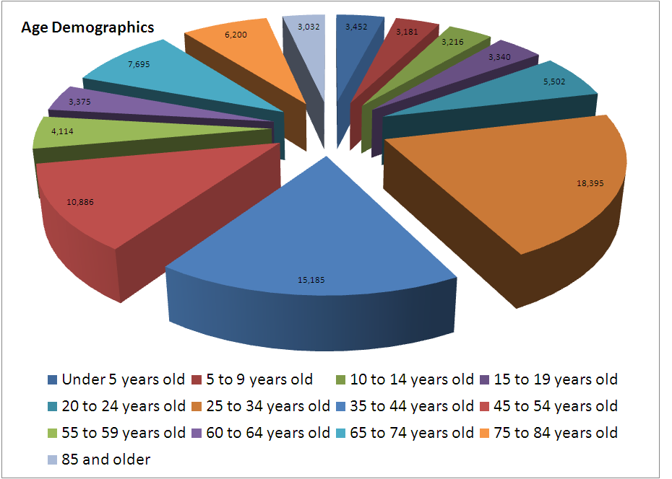

Table 4

|  |  |  |
| --- | --- | --- |
| **Race Demographics of Miami Beach** | | |
| **Description** | **Number** | **Percentage** |
| Asian | 1,109 | 1.2% |
| White | 38,031 | 41.8% |
| Black or Black African | 2,292 | 2.5% |
| Two or more races | 694 | .8% |
| Other race | 1,698 | 1.9% |
| Hispanic or Latino | 47,048 | 51.7% |

Table 5

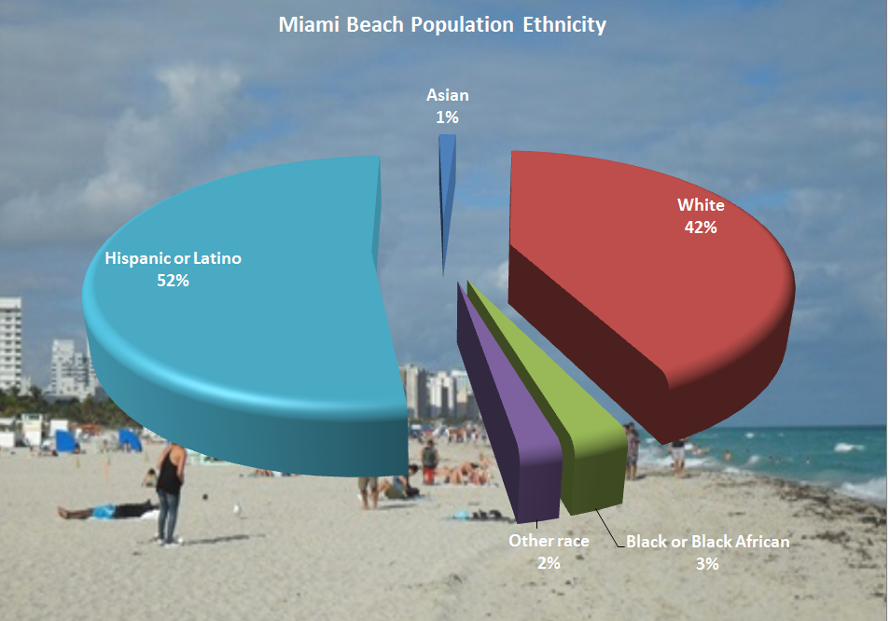

Table 6

|  |  |  |
| --- | --- | --- |
| **Housing Occupancy of Miami Beach** | | |
| **Housing Occupancy** | **Number** | **Percentages** |
| Total Housing Units | 59,725 | 100% |
| Occupied Housing Units | 46,194 | 77.75% |
| Vacant Housing Units | 13,524 | 22.65% |
| Seasonal, Recreational | 7,668 | 12.84% |
| Homeowner vacancy rate |  | 7.6% |
| Rental vacancy rate |  | 8.08% |

Graph 7

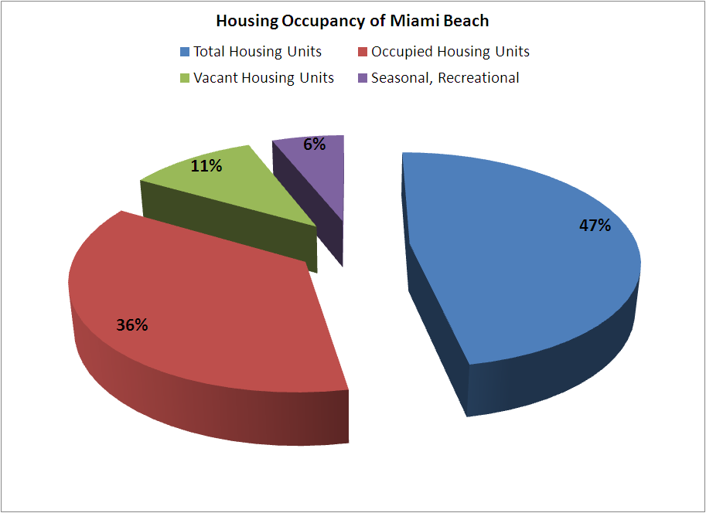

## Marketing Analysis

As the population and the race demographics explain my future customer base, I need to use the information to reflect in my business decisions.

The age demographics explain what type of employees I should expect to hire. The average age of the population is 39 years old and referring to the tables and pie charts I see the greater part of the population is older than 25 years old. So, I expect that the employees should be older than most bicycle shop in South Florida.

The customer base will probably reflect with the age demographics as well. This gives me the insight of what types bikes I need to sell and how many of bikes in my inventory. What type of merchandise mix I need to have to have the bikes for my customer needs, yet keep my inventory levels down?

## Marketing Strategy

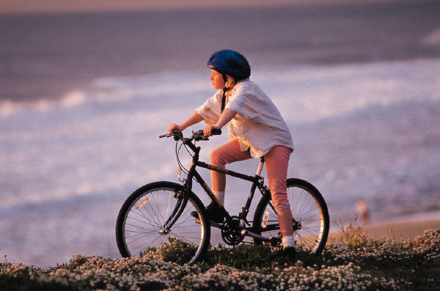I would like the bicycle shop marketing to the whole family, father, mother, and their children. Refer to Table 3; over 13% of the population is under the age of 14. This age group is in elementary and middle schools where the mode of transportation is riding bikes to school. I want their parents to be assured that the bikes they are riding are safe and get them to school on time. We will have locks for sale to keep the bikes safe from would be thieves.

A good section of the demographics I would call young adults (Ages 19-34 years old.) I will provide bikes to fit the needs of the group, which is 32% of the total population of Miami Beach. I will provide racing bikes for the enthusiasts, touring bikes for the ones who like to take a spin by the beach side, and street bikes to help the young adults to go through the congested traffic and little parking (especially free parking!) to go where they need to go to in Miami Beach.

The older population of Miami Beach is not the target market of bicycles; however, I will have in stock of bikes that will satisfy their needs of “very green” mode of transportation. Bike riding is an excellent exercise for the older population; bike riding doesn’t take the wear and tear of their legs which they would get from running or jogging yet keep a good cardiac exercise for good long healthy life.

Almost 13% of the population (Table 5) is here seasonal. Of this group majority are here during the months of October through March. I will provide a bike leasing opportunity with this group where they can rent a bike for that time period and returned the bike at the end of that period; this way the seasonal customer will not have to bring their bike back north with them. With the price of airline luggage this could be a great savings!

I will also keep a bike mechanic available for customers that need to get their bikes worked on for a fee. Fixing or replacing brakes, tires and chains can be done quickly and easily with the proper tools and equipment that the bike mechanics will have.

We will also sell bike parts and accessories for the bike “do-it-yourselfers”. Seats, inner tubes, helmets, chains and locks will be available for sale. Shirts and shorts for bicycling for the pros to travel in groups or clubs.

## 

## Customer Service

The success or failure of any business is customer service. 20% of customers are responsible for 80% of sales. These customers are what your business keeps the business in operation year indefinitely. The owner, mangers and all the employees should know these customers by first name and market them with personalize e-mails of new arrivals and sales.

Employees will be trained to develop a professional sale a skill, listening to what the customers wants and needs and match them with the right goods. Listening skills, questioning skills and product knowledge are key skills for a salesperson.

The Bike technicians will handle both bike assemblies for the store and work with customers with when bikes need repair or add accessories to the bikes. The technicians need to have training not only how to assemble, and repair bikes and other items, but able to have the proper understanding how to handle customer repairs, and billing.

Management should have a program to have a positive reinforcement of the best customer service possible. Incentives are usually the best way, and to keep a good company morale.

## Implementation of Market Strategy

From the information given in Table 3 this will give me the merchandise mix for the bikes. How many bikes I need to have for the very small children (tricycles, small 10’ or 12” bikes with training wheels), and how many bikes I need to have for the other age groups. I will start with 350 bikes as my inventory. By using the same percentages from Table 3 I should have bikes as the merchandise mix as below.

Table 9

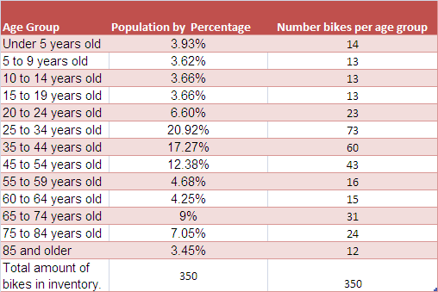

As the business continues and I have a more accurate read of actual customer base changes will be made to make sure that my inventory turnover it is at the highest level possible. With the higher turnover the bikes will be replaced with the most current styles and materials in the industry.

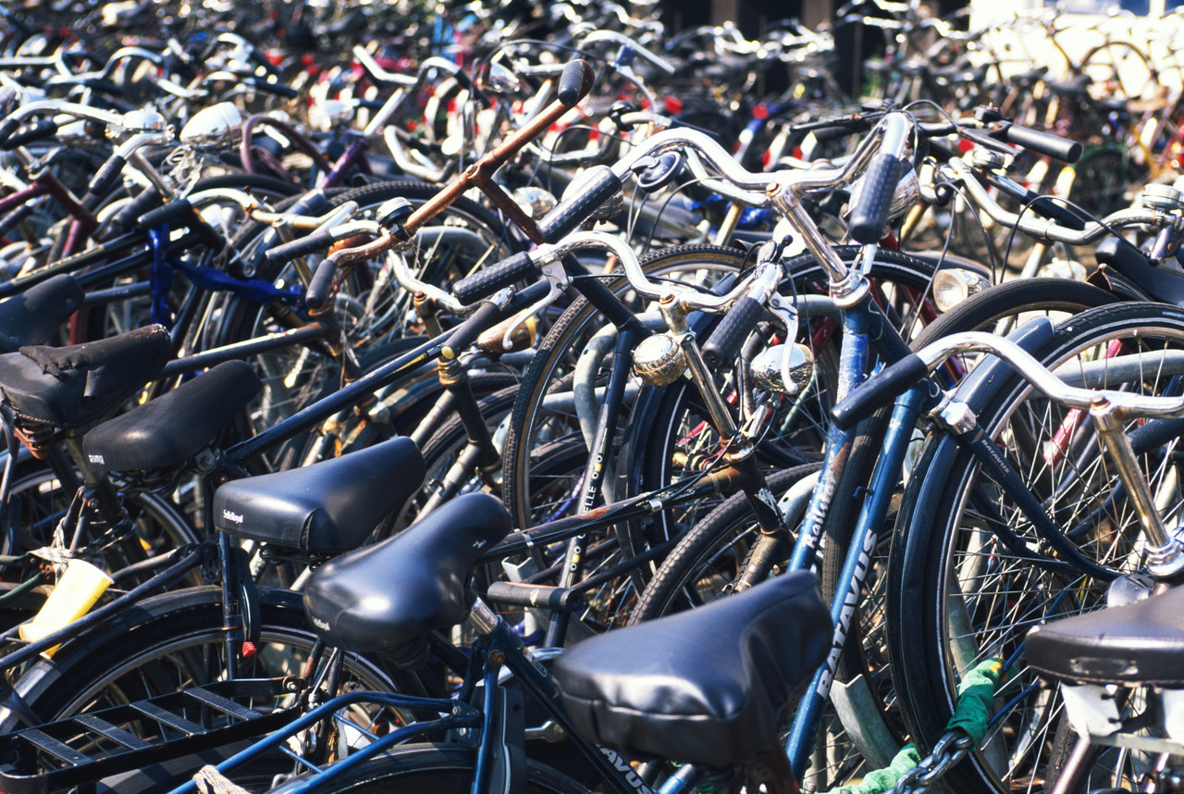Another aspect of my inventory I need to know is the “lead time”, the time when I order the merchandise to the time, I received the merchandise. The longer the period the larger of inventory needed. Ideally the store would to be able to sell the last item when its replacement will be in place. So, if I can find a local bike distributor that I can work with reliable, high quality products I can redefine my inventory to a smaller amount, less inventory costs, security problems, and able to have a higher merchandise turnover and more profits for the bike shop.

## Assessment of Marketing Effectiveness

To be successful in any business, you must be aware of how your business is doing in an annual, monthly, and daily sales and expenses. Assisting your business is an ongoing action that management must do. In the bicycle industry I had in the past I worked with importers purchase bicycles 70-100 bikes at a time. I do advertise to these customers and give them a small discount for their business. The advantage of making sales like this is to keep inventory turnover high and keep the inventory with the current technologies. Another advantage is that selling to an exporter the concentration of bikes does not change. Normally bikes have 3-7 years life. Once someone buys a bike, I won’t expect to buy another bike for several years. I still can sell bikes to in the local area, even if the exporter buys 100 bikes.

I will keep track of the top selling 100 bikes and items of the store. It is imperative to keep these items in store 100% of the time. If a customer comes in and cannot find an item that normal carry, that will be considered an opportunity lost Chances are that customer will go to my competitors, and hopefully I can increase my customer base when my competitor’s customers can’t find the item there, and they can buy it from our store.

I will keep a keen eye to my competitors, to see their merchandise mix, customer service, and store operations. I will keep my prices competitive and keep my attention to the information about the newest technology, materials, and styles of the merchandise.\

Below you will see a table that I use to keep my competitive advantage over my competition. I will check this table in a daily basis. By doing this I can be more informative and provide the best service to my customers, showing the knowledge of the bike market at Miami Beach.

Table 10

|  |  |  |  |  |
| --- | --- | --- | --- | --- |
| **Name of Competition** | **Address** | **Website** | **Telephone** | **Hours of Operation** |
| J B Bike Shop | 7316 Collins Ave.  Miami Beach, FL 33141 | <http://www.jbbikeshop.com> | (305)  866-3622 | Monday –Saturday  10 AM – 7 PM  Sun 11 AM-4 PM |
| Fritz Skate Shop | 1620 Washington Ave Miami Beach, FL 33139 | <http://www.fritzsmiamibeach.com> | (305)  532-1954 | Monday –Saturday  10 AM – 7 PM Sun 11 AM-4 PM |
| Miami Beach Bicycle Center | 601 5th Street  Miami Beach, FL | [http:/bikemiamibeach.com](http://bikemiamibeach.com) | (305)  674-0150 | Monday –Saturday  10 AM – 7 PM Sun 10 AM-5 PM |

### Summary of Financial Needs

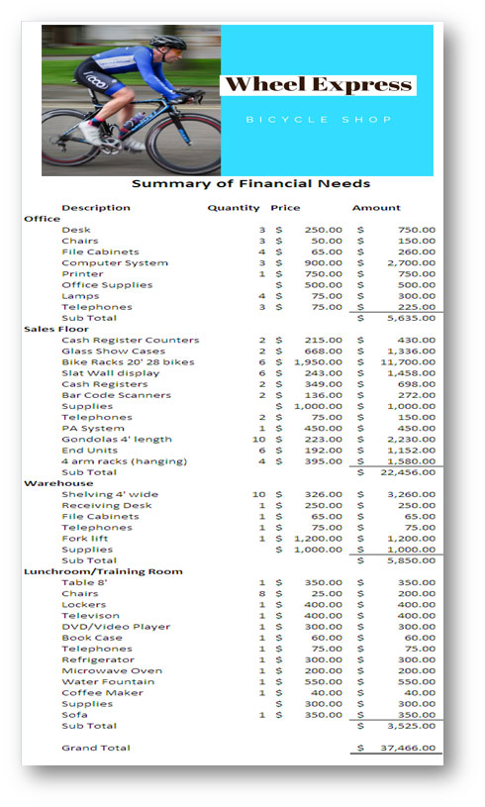

### Loan Fund Dispersal Statement

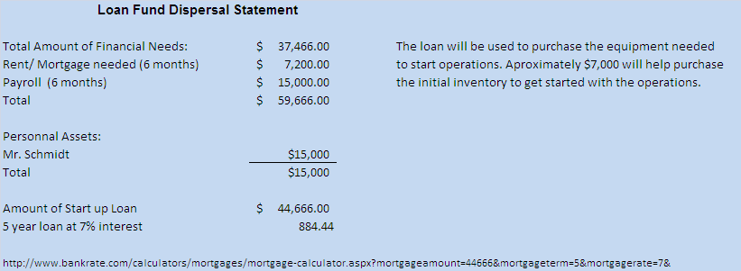

### 3-Year Income Statement Projection Project Balance Sheet

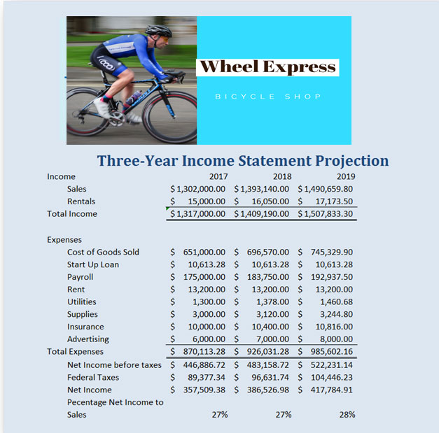

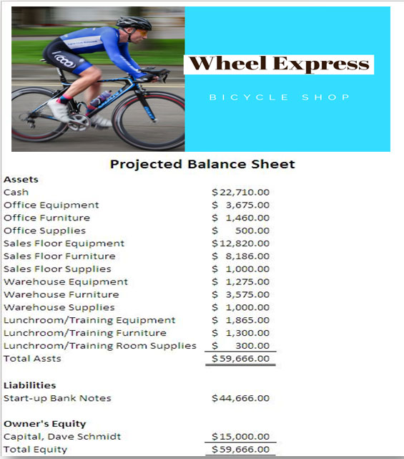

### Break-Even Analysis

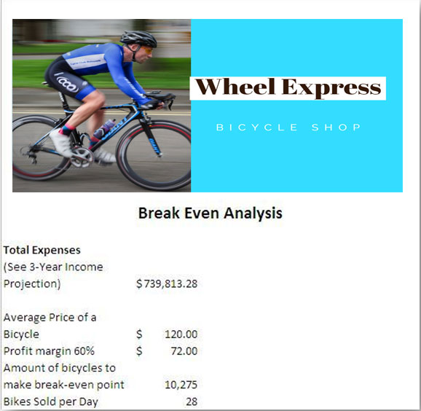This report shows how many bikes that The Wheel Express needs to sell annually and daily to break-even. After that bikes sold past that mark will the gross margin will go to profits.

### Financial Analysis

After reviewing the financial documents, a bicycle shop is a very “doable” venture. Cost of starting the business is less than $40,000, and financial profits opportunity is great. The break-even point don not consider selling any parts, or other products, and not any profits for leasing out bicycles. With the popularity of skates, skateboards and razor scooters this will add the opportunities for profits.

### Business Financial History

Managing Lionel Playworld for 13 years I learned a lot about the popularity of bicycles, and which bikes are the most popular and the popular brands. I will try to keep at least 3 different price points for each type of bikes. One price for the budget conscience shopper, another price for shoppers that are looking a good quality price at a good price, and the top-quality bike for the bike enthusiasts.

Knowing my market demographics, I will have the proportionate types of bike inventory that the demands needs. I will keep inventory to the minimum yet have the bikes available for the customers. A good communication between my distributors and the store is essential to have this happen.

### Personal Resume

### Owner Financial Statements

### Credit Reports

### Copies of Leases, Mortgages, Purchases Agreement

### Letters of Reference

### Contracts

### Other Legal Documents

### Miscellaneous Documents