NAF Principles of Information Technology
Lesson 10
How the Internet Works
Student Resources
Resource | Description
Student Resource 10.1 | Reading: How the Internet Works
Student Resource 10.2 | Reading: How Data Travels the Internet
Student Resource 10.3 | Reading: Connecting to the Internet
Student Resource 10.4 | Comparison Shopping: Learning about ISPs
Student Resource 10.5 | Project Planner Page 6: Planning a Dream Personal Technology System
Student Resource 10.1
Reading: How the Internet Works
What Is the Internet?
Sending emails, downloading music, searching for information: all of these are acts that have become so automatic for us. But have you ever stopped to think about what is happening when you click Send or Download or Search? What actually is “the Internet” and how does it work?
At its most basic, the Internet is a network. In fact, it is the world’s largest wide area network (WAN). As of November 2015, more than 3 billion people were regular Internet users (3,366,261,156 users according to Internet World Stats at http://www.internetworldstats.com/stats.htm). So what makes up this giant WAN? The answer is: smaller networks. Everything that you find online, including web pages, email, instant messaging, FTP sites, online games, and more, comes to you through the Internet. But it was not always this way. In the early 1990s, the number of Internet users was only in the thousands. And at the very start, the Internet was made up of only three computers.
How Did the Internet Begin?
Let’s take a step back in time and see how we even got to this big complicated network.
We associate the Internet with our current times, but really it began much earlier. Let’s take a look at the important dates in the history of the Internet:
Early 1960s: The idea of connecting computers across long distances is born. The researchers at the US Department of Defense’s Advanced Research Project Agency (ARPA) had three computers—two in California and one in Boston—and they wanted to be able to access each of them, regardless of their location. Their work to make this happen led to the idea that would become the Internet.
October 29, 1969: The first ARPANET message is sent. Once the groundwork had been laid by ARPA, work began on the ARPANET, the first WAN. To manage the messages, this network had four small computers (called interface message processors) that connected to four large mainframe computers, three in California and one in Utah.
1969: The first network protocol is established. Early on, there was a need to establish rules for how computers in a network communicate with each other. These rules are called network protocols. Protocols control or enable the connection, communication, and data transfer between two computing endpoints.
1971: The ARPANET starts being used for email.
1972: ARPA is renamed DARPA. When ARPA’s mission became more focused on national security and defense issues, a D for defense was added to the beginning of its name. The name has changed back and forth over the years, but today the agency is most commonly known as DARPA.
1973: File Transfer Protocol (FTP) comes into use. A common set of rules for transferring files, FTP created a standard that allowed more computers to join the ARPANET.
1981: 213 computers are connected to the network, including several outside of the United States. In the early 1980s, new networks started to crop up. Each of these networks used its own set of protocols to handle data. Some of these networks gave network access to personal computer users. The earliest bulletin board and real-time chat services also appeared around this time.
1983: TCP/IP is introduced. Transmission Control Protocol (TCP) uses a set of rules to exchange messages with other Internet points at the information packet level. Internet Protocol (IP) uses a set of rules to send and receive messages at the Internet address level. TCP/IP became the standard that networks used to exchange data, allowing the various networks to link up and communicate. The transition to TCP/IP, along with the original ARPANET, led to a new name being used: Internet.
Soon, the term Internet began to be used to describe any network that used TCP/IP. TCP/IP is still the standard Internet protocol today.
Mid-1980s: The Internet expands globally. Also, the first Internet service providers (ISPs) appeared near the end of that decade.
1993: Netscape is introduced. Netscape was the first popular web browser, and with the addition of the World Wide Web, the Internet took on the basic form we know today.
How Does the Internet Work?
We think of the Internet as being an invisible area where information just floats around. In reality, it is made up of very real—and visible—hardware: computers on the Internet connect through fiber-optic cable, telephone networks, and long-distance communication via satellite or microwave radio waves.
Networks
These physical connections build networks. As you know now, the Internet is actually made up of many small networks. So, imagine a big room full of people who can only communicate by passing notes to each other. In one corner of the room, a few people start writing notes on paper they find. They are one network. In another corner, they write on their hands and hold them up for the others to see. In yet another corner, they have small whiteboards they pass around. Each small group can talk to each other, but the people with paper can’t communicate with the hand or whiteboard people, and vice versa. What they need is an agreement about the type of material they are going to use to pass their messages. This is what the protocols do on the Internet. In fact, because the Internet is so large and made up of so many different parts, it is these protocols that do most of the work in defining it.
Internet Protocols
TCP/IP is still the standard that defines what data packets look like on the Internet and how they are sent and received. In addition, protocols like Hypertext Transfer Protocol (HTTP) and File Transfer Protocol (FTP) control the more specific messages and data formats used by the network.
Let’s go back to our big room full of people. Let’s say they decided to all use paper. So, bits of paper are moving from person to person and flying through the air. Messages are going, but it is chaos. How do people get the messages intended for them? What we need is a way to manage the flow of messages. On the Internet this is called the Internet backbone. The backbone is a group of networks that includes what are known as core routers, responsible for identifying which network to route a message to from the backbone. The backbone used to be maintained by the US government and other governments, but today management of the backbone is handled by the largest of the ISPs, such as AT&T and Sprint.
Servers and Clients
Remember, the Internet is made up of networks, which are in turn made up of individual computers. Every computer on the Internet is either a server or a client. A server provides information or services to other computers. A client asks for information from a server. There are many kinds of servers (such as web servers, gaming servers, and email servers). How a client computer connects to the server and what software it uses to access the server’s information is determined by the server type and the type(s) of protocol that this type of server uses.
So how do clients and servers find each other? Let’s go back to our big room once again. Now we have managers who are getting all of the messages and sending them on to the right network. But how do they know which network—and which computer—to go to? In the room, individuals have to write the name and location of the person they are sending a message to. Computers on the Internet use the IP address of the other computer (whether server or client). The IP address is a computer’s unique address, like its name. But that’s not the only number in play: When a client computer connects to a server, it also uses a numbered port on the server. The number of the port that it is connected through also depends on what type of information the client computer is trying to get from the server.
What Are the Parts of an Internet Address?
Because of the sheer number of computers on the Internet, IP addresses have to be really long to ensure that there are enough variations for each computer to have its own. All IP addresses are 32-bit numbers separated into four parts known as octets. For instance, one Internet address could be 10.11.12.13. While it is helpful to have that address, it is not efficient for the core routers to have to find a specific address out of millions. In our room, we said messages have to list both who they are for and where they are located in the room—which network they are in. IP addresses are the same; they have two parts: a network address, and a device address on that network. As an example, 10.11.12.13 might represent the network 10.11.12 and the device 13.
Currently two forms of IP addresses are in use. The older form, known as IPv4 (Internet Protocol version 4) has been in use since the 1980s. The IPv4 address consists of 32 bits providing for roughly 4 billion unique addresses. This sounds like a lot, but we are quickly running out of unique addresses. A newer addressing scheme is called IPv6 (version 6). Although not in use by everyone, it promises to provide far more addresses than we can ever use, because the IPv6 address will be 128 bits in length.
Now, imagine you are doing research for a project. Numbers are the language of computers, but it’s not realistic that you would remember a 32-bit number for every website you want to visit. Instead, you use addresses with words. We refer to these as IP aliases instead of IP addresses. The most common form of IP alias is the URL. So rather than 10.11.12.13, you would use the IP alias research.com (that’s a made-up example!). The IP alias (or URL) and the IP address are interchangeable. For example, if you wanted to go to cnn.com, in any browser, you could type http://www.cnn.com or http://157.166.226.26.
While the names are easier for us to remember, they still contain a lot of information. A basic Internet URL has three parts: the protocol, the web server’s name (called a host name), and the specific resource being requested (a file).
For example, consider the web address for CNN online: http://www.cnn.com.
- The first part, http://, is the protocol that is needed to view the page. Although HTTP is the most commonly used protocol, others include HTTPS (for secure communication), MAILTO, and FTP.
- The second part, www.cnn.com, is the web server’s name. Let’s break this down:
  - The www refers to the World Wide Web. Sometimes called “the web” for short, the World Wide Web is the huge set of documents (web pages) stored on special computers called web servers. In fact, it is so large, people often incorrectly use its name interchangeably with the Internet. The documents of the web are linked together by hyperlinks and URLs and are sent using the protocol HTTP, creating an interconnectivity (that’s why it’s called a web).
  - cnn.com is the domain name. Domains are a way to organize web pages on the Internet. There are several top-level domains that divide all web pages into types. The end of the domain name lets you know what kind of domain it is. The domain .com stands for commercial, while .edu stands for educational and .gov for government. Other top-level domain names may signify the country code. For example, a domain name of .cn stands for China, .uk for United Kingdom, and .it for Italy.
  - The third part is the file name. Let’s say you wanted to send a message to CNN. You might go to www.cnn.com/contact. The contact is the file name. In the case of the home page, www.cnn.com, the file name has been omitted because you are using the default file, often named index.html (or index.php or some other variation). Our web servers are programmed to fill in the default file name if it has been omitted. In other words, when you point your browser to http://www.cnn.com, you are actually going to http://www.cnn.com/index.html.
Translating a Computer’s Domain Name to an IP Address
So how do the names of web pages or specific computers get changed from our human names for them to the 32-bit number that computers can understand? Well, we need a translator. On the Internet, that translator is the Domain Name Service (DNS).
DNS is like a phone book for the Internet; it looks up a host name and returns an IP address, or vice versa. When you type www.cnn.com into a web browser, the application has to go to a DNS server to find the IP address associated with www.cnn.com. Of course, one translator cannot handle all of the requests flying around the Internet. Instead, there are multiple DNS servers assigned to different physical parts of the Internet. Each part of the Internet has DNS servers, and each computer is configured to query a specific DNS server. Usually home computers are configured to send requests to their Internet service provider’s name server or a free DNS name server.
When you type in cnn.com, your computer sends a request called a DNS lookup to its assigned DNS server. Remember, no one server knows all of the domains and IP addresses on the Internet. So if your computer’s assigned DNS server doesn’t have information about cnn.com, it asks its friends, sending out its own request to other DNS servers, which are all linked in a network. That network is linked to a root server, which in turn is linked to other DNS root servers. So, if your DNS server’s network still doesn’t have the information, the root server sends a request to its friends, and the DNS lookup goes on until the DNS name is found on a DNS server and sent back through all of the requests to the original DNS server.
Then the DNS server “resolves” the name to the IP address that the application needs to find the right computer. For our www.cnn.com example, the DNS would return the IP address of www.cnn.com, which is 157.166.226.26.
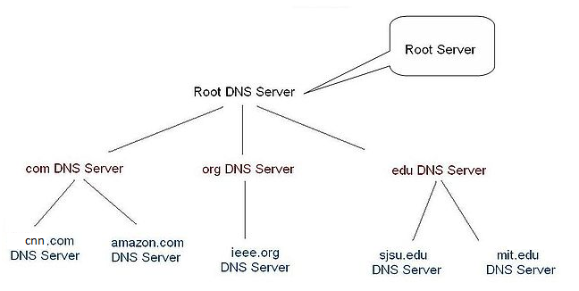

Student Resource 10.2
Reading: How Data Travels the Internet
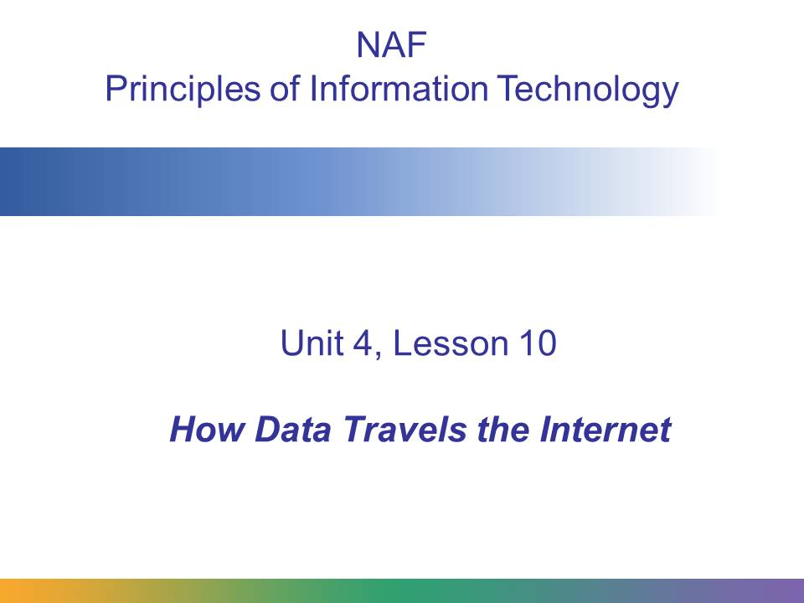
This presentation explains how data is packaged to travel across the Internet and how computers that connect to the Internet send and receive the packaged data.
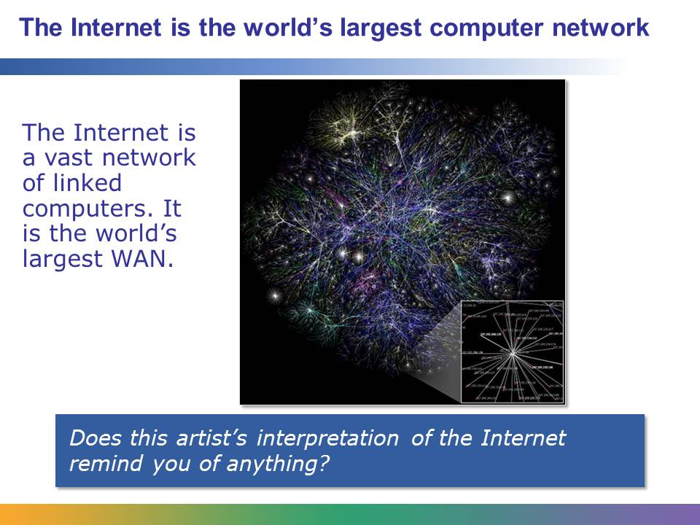
The Internet is the world’s largest computer network. It is, at the most basic level, a WAN made up of many, many smaller WANs and LANs.
This picture shows an artist’s view of the Internet. Does it remind you of galaxy or star maps you have seen in science classes? It is not hard to think of the Internet, with its millions and millions of connection points, as being a lot like the universe, with its millions and millions of stars.
Image retrieved from http://commons.wikimedia.org/wiki/File:Internet_map_1024.jpg on June 21, 2012, and reproduced here under the terms of the Creative Commons Attribution 2.5 Generic license. Image created using data from The Opte Project.
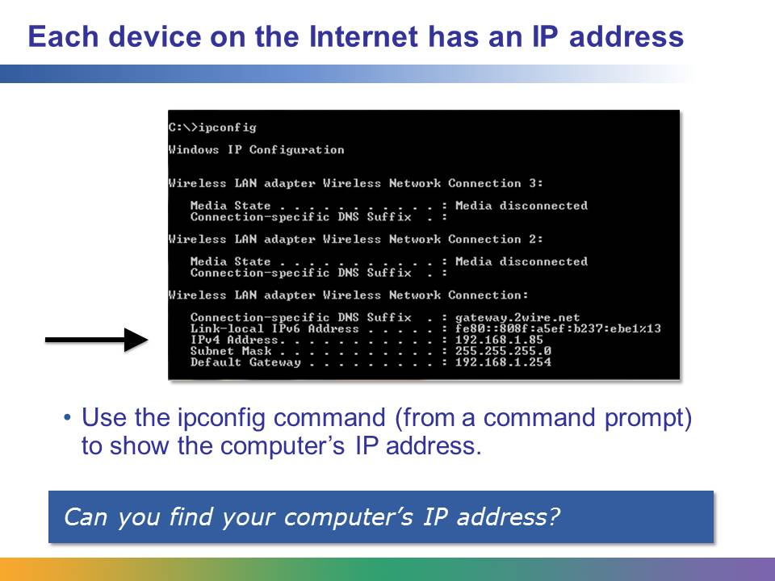
Every device on the Internet has an IP address. Think of it like the street address for a house. This address tells data where it should be delivered and also helps track where data has been sent from.
To find your computer’s IP address, click the Windows Start icon and type command prompt in the search box. When the Command Prompt window opens, type ipconfig. In Mac OS X or Linux/Unix, open a terminal window and use ifconfig (or the newer ip addr command).
A computer’s IP address is usually assigned “dynamically” by the router and may change whenever the computer is rebooted. However, computers or servers that host web pages must have a fixed, or strategic, IP address, since the Domain Name Service (DNS) must know where to find the website.
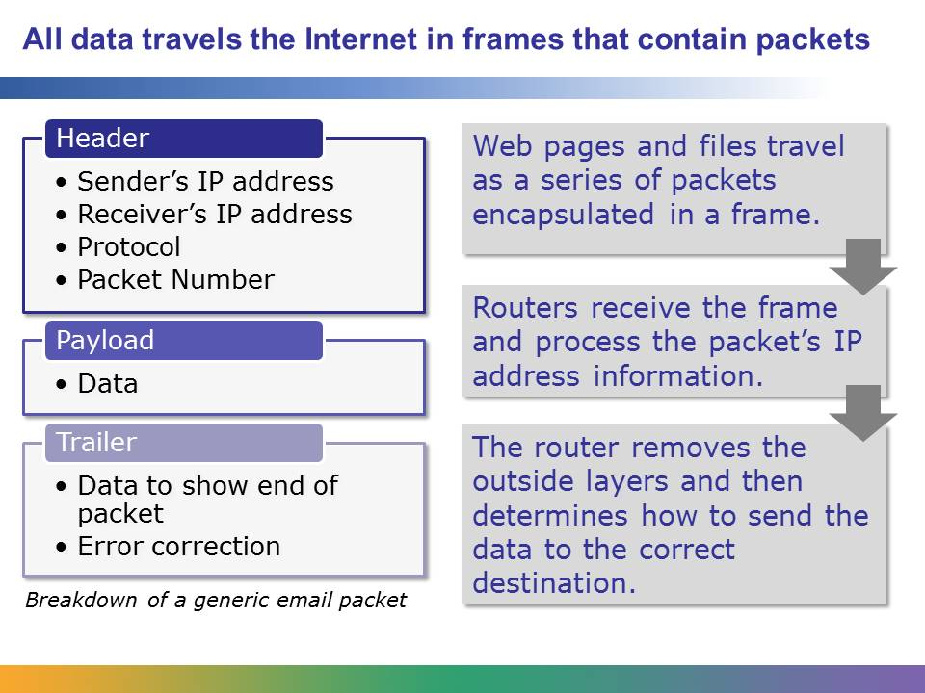
As this chart shows, data is placed into logical packets that are addressed individually with the destination. This allows multiple messages (packets) to be turned into one coherent message.
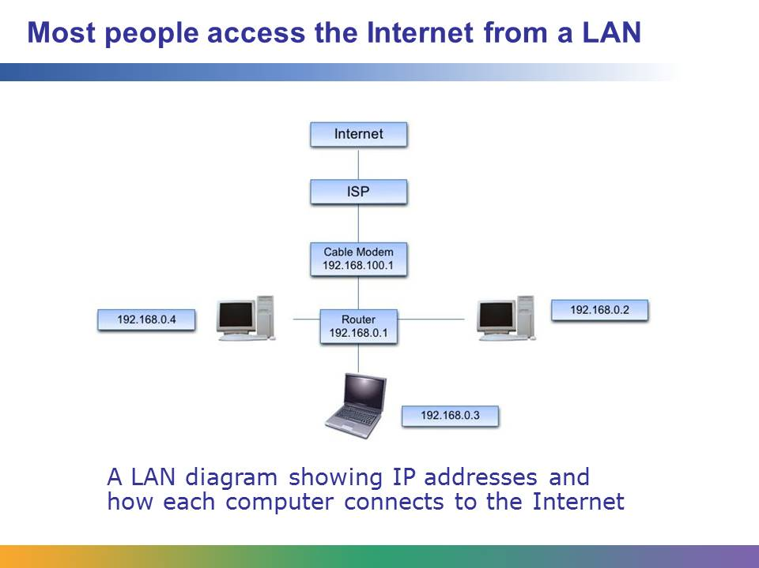
Computers in a home or an office often use a router and cable modem to connect to the Internet through an ISP. Data from the Internet comes through the ISP’s network to the user’s cable modem.
Once it arrives at the cable modem, the router takes over, directing the information to its intended recipient on the network. The router can tell which machine to send data to based on the IP information in each packet; it matches the data to the IP address assigned to each machine. A cable modem may include the capabilities of a router, simplifying the home network.
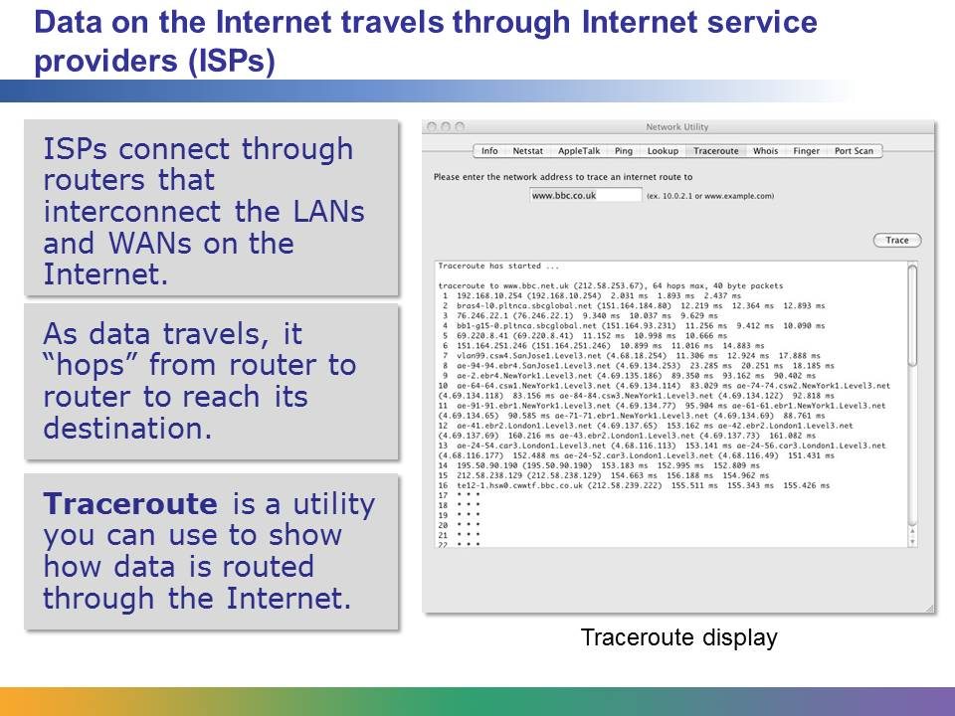
Once a user has requested data from a website, the request and reply are sent across the Internet using many different computers and computer networks. Each stop along the route is called a “hop.” This request, sent from a computer in the San Francisco Bay Area to the BBC News website in London, England, took 16 hops.
As a request or data transmission is sent to a router, the router analyzes the packets and then looks at the available routes to send the data. The router then sends each packet on to the next most-efficient location. Sometimes a packet may spend most of its time traveling through a single data network (as the example here shows, where the packet spent most of its time in the network owned and operated by the firm Level 3). Other times, a packet might change networks or travel along a large backbone connectivity line before reaching its destination.
Depending on the path each packet takes, packets will likely arrive out of order. The destination computer reassembles the packets into the correct order and can send a request for re-transmission if a packet is missing or corrupted.
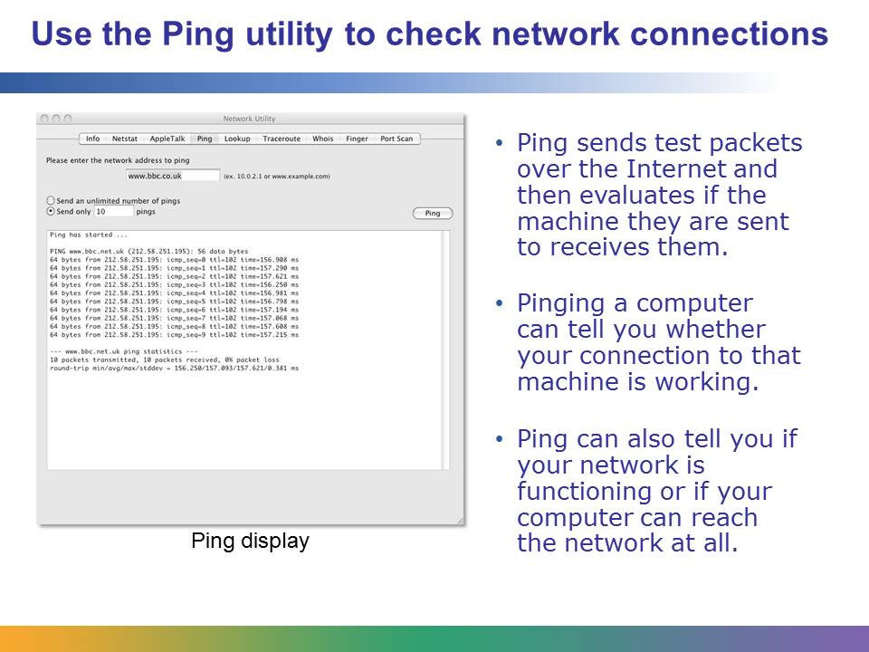
If you are worried that your connection to another computer is not working well, you can “ping” that other computer. When you ping a machine, test packets are sent over the Internet to the other machine and then evaluated to see if they were delivered and how long they took to arrive. This example shows a successful ping test—no packets were lost during the test transmission and response.
Sometimes a ping request doesn’t work even if the connection to the other site is working, because many ISPs block Internet Control Message Protocol (ICMP), which is the protocol needed for ping requests. If ICMP is blocked, the ping will fail, even if the other site is working.
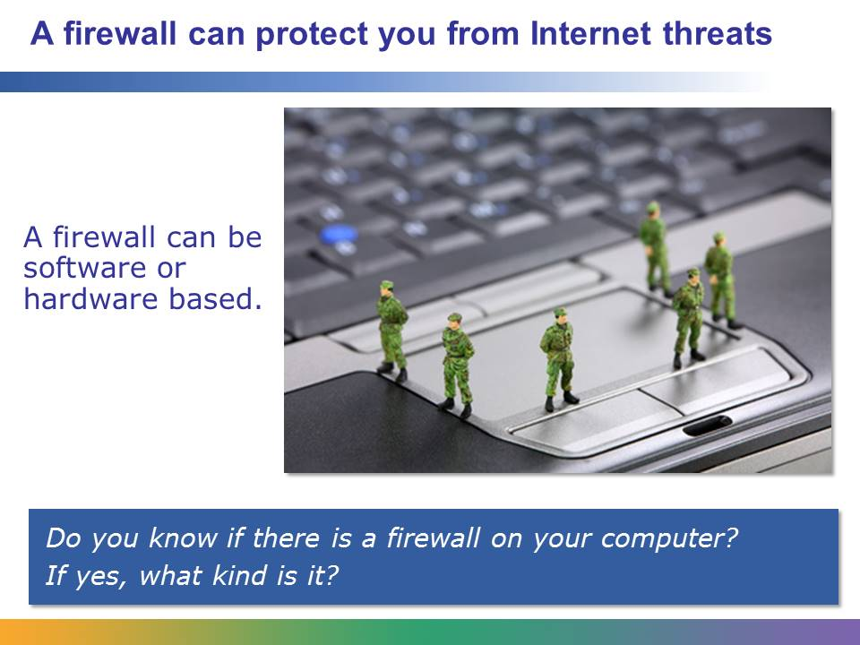
A firewall can protect your computer from Internet threats. It is usually a software program that filters the messages that reach your computer over an Internet connection. If an incoming message is flagged by the filter, the firewall does not allow that message to pass. Firewalls also filter outgoing messages.
The operating system on your PC probably includes a software-based firewall. You can even download a free firewall program from the Internet. Although you can customize the firewall on your own PC, most people rely on the firewall in their operating system, which uses default rules and restrictions.
You can also connect a hardware-based firewall device to your computer using an Ethernet cable. Many routers that send and receive data between networks use a hardware firewall. Hardware firewalls are sometimes more secure, although software-based firewalls are convenient and inexpensive. Most of the time, hardware and software firewalls can coexist, although this may not significantly improve your protection from outside threats.
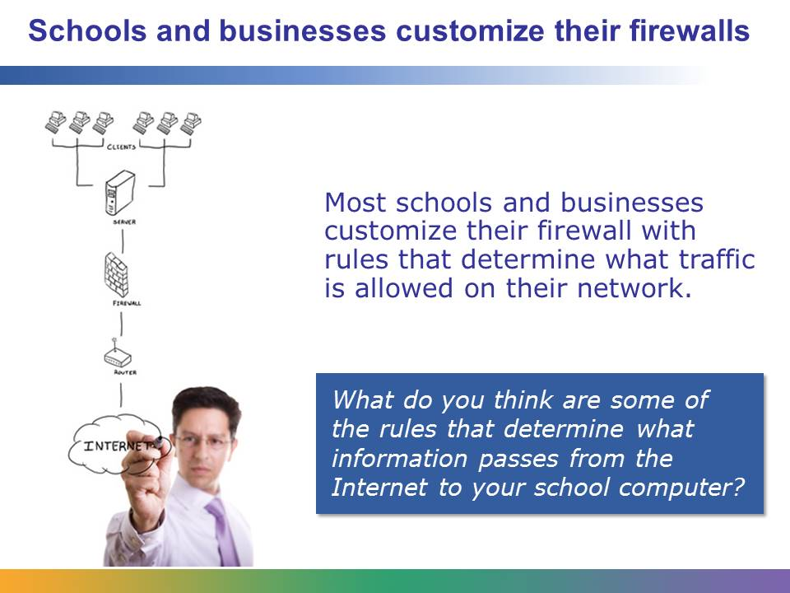
A firewall works by having rules that define types of acceptable and unacceptable messages. The firewall compares messages against the rules. A rule will have some matching criteria, and if the message matches, the rule is “fired” (executed). The criteria of the rule might be specific to a website (reject all messages from Facebook.com), specific to a port (accept all messages from port 22), or based on other features such as the size of the message, the time that the message was sent, or the protocol used to send the message (reject any message sent by ICMP but accept any message sent by HTTP).
Schools, large companies, and other organizations configure their firewalls to comply with a set of rules. These rules determine what information can pass to and from the computers based on certain words, websites, or IP addresses.
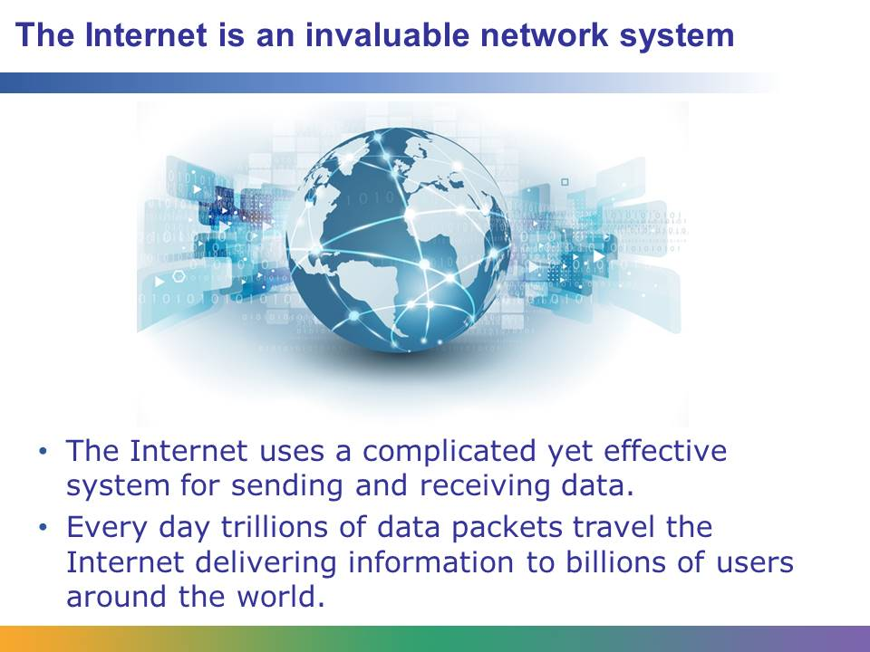
As we’ve seen, the Internet is a vast, complicated system of data transfer rules. Because the packets we send follow these rules, the Internet is also a highly reliable way to send and receive information, whether that information is traveling across town or across the world.
Internet travel time is measured in seconds or less. It is common for a user to see the result of clicking a hyperlink in a second or less. The time it takes to transfer content is more likely to be affected by the amount of traffic a server is dealing with than by physical distance.

Student Resource 10.3
Reading: Connecting to the Internet
How Networks Link to the Internet
The Internet is a collection of many smaller networks that communicate with each other. Therefore, instead of thinking of “networks linking to the Internet,” you might think of many networks connecting to each other to create the Internet. The smallest networks are the ones individual Internet users set up in their own homes. These connect to a larger network run by an Internet service provider (ISP). The ISP then connects at network access points to other networks, all of which follow rules that help them to communicate freely. The Internet is just a conglomeration of connections made at network access points. Backbones and routers handle data at the highest levels. Backbones are large fiber-optic cables (or bundles of them), or in some cases, connections made through microwave or satellite communication. Routers are responsible for moving data between networks or sections of a network. Different networks use this equipment to talk to one another as though they were part of the same network.
What Is an Internet Service Provider (ISP)?
An ISP provides individuals and companies with a connection to the Internet. When you sign up with an ISP, you can expect to be given an email address and access to some storage space on the ISP’s servers. ISPs also allow their customers to choose the type of service that best suits their needs. Not so long ago, dial-up accounts (connections that ran over telephone lines) were common. The first type of broadband connection available to consumers was called ISDN (integrated services digital network), but it has been replaced by faster broadband services. Today, DSL (digital subscriber line) and cable Internet are the most common types of consumer connections. Connections can be made through copper wire telephone lines or cable TV lines, but fiber-optic lines are slowly becoming more and more popular.
Connecting Your Computer to the Internet
There are many ways to connect a computer to the Internet, but all those ways are the same at the most basic level: get a modem and an ISP, plug your computer into the modem, and then turn the modem on. What happens when you do that is a little more complicated. If you have a broadband connection, you connect your computer to a modem, but you needn’t connect to your ISP every time you want to use the Internet—the connection is always on. DSL (and ISDN) connections use phone lines, but the lines carry digital data at a higher frequency, so they do not tie up the phone line. That is why DSL can be “always on.” Cable modems work like DSL but use the same coaxial lines that go to your television. In other cases, a dedicated fiber-optic line might be connected to your household, capable of carrying Internet, telephone, and cable television. If you have a T1 connection, you have a dedicated line—no one else can use it. T1 lines are connected using a pair of copper wires, similar to phone lines. If you have a dial-up modem, each time you connect to the Internet, your modem uses a phone line to dial the banks of modems at your ISP. Once your modem “handshakes” with the network, it converts digital signals from your computer into analog signals that can be sent over your phone line to your ISP.
You can also choose to connect to the Internet wirelessly. Most wireless devices connect to the Internet in the same way as the wired ones described above, but instead of the modem connecting to your computer, the modem connects to a wireless hub or router. With a wireless networking card, your computer can then connect to the hub or router.
When your computer connects to your ISP, the ISP assigns it an IP address, the number that is used to identify your computer on the Internet. This is typically a dynamic address that changes every time your computer connects to the Internet. Servers or computers that host web pages are issued a static IP address that stays the same so that the DNS can find the site. Static IP addresses are more expensive and are used much less frequently on today’s Internet.
Student Resource 10.4
Comparison Shopping: Learning about ISPs
Student Name:_______________________________________________ Date:____________
Directions: Follow the steps below to learn how to compare different Internet service providers. Keep this resource handy as your culminating project group discusses choosing an ISP.
Open your web browser and go to http://www.earthlink.net. Select the Residential tab in the upper-left corner of the page. What types of access are offered in the menu bar across the top of the screen? What types of high-speed access are offered?

What is the typical price for the services? Do you see any pricing trends (what makes a price higher or lower)?

Choose one service plan and click “Learn More.” Record what the plan offers here:

Now go to http://www.att.com.
Use the menu to select Shop > Internet > U-verse Internet.
What types of service do you see advertised? Write three different levels of service here:

What is the typical price for the services? Do you see any pricing trends (what makes a price higher or lower)?

Choose one service plan and click to learn more. Record what the plan offers here:

Now go to http://www.megapath.com.
Use the Check for Services feature.
What types of service do you see advertised? Write three different levels of service here:

What is the typical price for the services? Do you see any pricing trends (what makes a price higher or lower)?

Choose one service plan, and click it to learn more. Record what the plan offers here:

What differences have you observed between the service plans offered by Earthlink, AT&T, and MegaPath? How would you use this information to select an ISP?

Student Resource 10.5
Project Planner Page 6:
Planning a Dream Personal Technology System
Student Names:________________________________________________ Date:_____________
This is the sixth page of the project planner you’ll use to help plan your group’s personal technology system. Later, you will choose items such as the operating system and deal with other considerations you might need to keep in mind. Remember that you should be keeping track of all of your project planner pages for the entire course. Your group will collect and submit all of these resources at the end of the project.
Answer the questions below to identify and plan whether and how the dream system your group is designing will connect to the Internet. List the factors (such as ease of connectivity, desired connection speed, and so on) you will keep in mind while making plans for the system. Don’t forget to think about the goals you outlined for your personal technology system when you are making these choices.
When discussing your plans, be as specific as you can, but don’t worry about the exact service plan or ISP you might choose. For example, if you know you will choose broadband but have not yet chosen the specific connection speed you would want, you can come back to this later and add that information. You may also choose to add the ISP you would use at a later date. If you do not believe that your system needs to connect to the Internet, be sure to explain this and justify your reasoning.
When your group has completed this planning sheet, add the information to the culminating project report you began in Lesson 7. Be sure to keep that report up-to-date—including adding a line to your project planning summary table!
What this system will be used for:

Type of Internet access we need (be as specific as you can):

How will you connect to the Internet (dial-up, DSL, cable, satellite, T1, etc.)?

Why did you make these choices?

Additional notes:

