NAF Principles of Information Technology
Lesson 11
Communicating over the Internet
Student Resources
Resource | Description
Student Resource 11.1 | Survey: Who Knows About…
Student Resource 11.2 | Reading: Communicating on the Internet
Student Resource 11.3 | Guide: Email Client/Server Role-Play
Student Resource 11.4 | Writing Assignment: Professional Email
Student Resource 11.5 | Reading: How VoIP Communication Works
Student Resource 11.6 | Reading: What Is the Digital Divide?
Student Resource 11.7 | Writing Assignment: Blogging about the Digital Divide

Student Resource 11.1
Survey: Who Knows About…
Student Name: Date:
Directions: Interview your classmates to find people who fit the statements listed below. When you find someone who matches one of the statements, have that person put his or her initials in the appropriate box. You cannot have any student put his or her initials in more than two boxes on your sheet; your goal is to survey as many classmates as possible. See if you can get initials in all of the boxes.
I use Twitter. | I use Pinterest. | I use Facebook.
I use Instagram. | I use Snapchat. | I use Google+.
I am a member of at least one active Meetup group. | I have used an app on a smartphone to make a video call. | I have made a video call using Skype or FaceTime.
I have contributed to a blog. | I post regular updates on my own blog. | I have a Gmail or Hotmail account that I use daily.
I use Gmail Chat on a daily basis. | I use iChat on a daily basis. | I have participated in online video group chats or Google Hangouts.
I use a mobile device (smartphone or tablet) to go on the Internet more often than I use a laptop or desktop computer. | I use LinkedIn or another professional networking site. | I use Microsoft Outlook.
Student Resource 11.2
Reading: Communicating on the Internet
Every day billions of people from around the world use the Internet to communicate. The Internet is now a mainstay of our culture, so it’s wise to understand how Internet technologies such as email and instant messaging work.
Email Clients and Servers
Email uses client/server technology. If you’ve ever sent or received an email, you’ve used an email client. Whether you use a piece of software designed solely for the purpose of handling email, such as Microsoft Outlook or Mozilla Thunderbird, or a web-based client provided by a service, such as Gmail or Hotmail, the client is what lets you perform tasks such as reading and sending email messages and downloading attachments.
Your email client is also what communicates with the email servers that are responsible for getting email messages where they are supposed to go. If you are using a program like Outlook, you will need to give it information that allows it to connect to the email server that you use. Once the client has this information, it streamlines the process for you, taking care of all the details of how mail is sent and received so that you don’t have to do it yourself.
How Email Is Delivered over the Internet
Once you have written your email message, addressed it, and hit Send, what happens? The first step is that your email client converts your message to MIME (Multipurpose Internet Mail Extensions) format and then connects to a Simple Mail Transfer Protocol (SMTP) server for your email domain (the part of your email address after the @ symbol). Remember that a protocol is a set of rules for how two computers communicate, so SMTP is just the set of rules for handling outgoing email. Your email client tells the server who the email is from and who it is going to.
The SMTP server then looks at the domain of the address that the email is being sent to and queries a Domain Name System (DNS) server to ask for the IP address of the domain in question. Once it has that information, the SMTP server sends the email (possibly in as many as hundreds of packets) across the Internet to the destination domain’s SMTP server. That SMTP server looks at what user the message is addressed to and then passes it to the incoming-mail server for delivery. For example, for the AT&T (Yahoo!) mail server, the DNS would return 67.195.118.77, for the mail server named pop.att.yahoo.com.
There are two types of incoming-mail servers: POP3 and IMAP. The biggest difference between the two is that when you get an incoming email from a POP3 server, you download it from the server onto the computer you’re using. If you get email from an IMAP server, the email stays on the server until you delete it, so you can access it from any computer that you can use to log in to the server. Most email clients will have a way for you to make a local copy of whatever email you have on the server. Additionally, most POP3 clients offer an option to leave the mail on the server. Nearly all modern email servers support both POP3 and IMAP functionality, and leave it up to the email client whether to download messages and delete them from the server, download messages and keep copies of them on the server, or simply access messages on the server.
If you use email software installed on your computer, such as Microsoft Outlook or Mozilla Thunderbird, your email interacts with an email server at some point. But if you use a web-based system for email, such as Google’s Gmail, which you access only on the web—not from a piece of software installed on your computer—then your email is handled by a web server, because it is web content. An advantage of using a desktop email client is that you can compose emails when you are offline and then send them when you are online. Web-based systems require a live connection to the Internet.
One interesting fact about email is that all emails are sent as text only, including email with attachments. When you send an attachment, the binary of your attachment is converted to text, and then once the email gets to its destination, the text is converted into the original attachment. If you need to send an email securely, you can use a program that encrypts email such as PGP (http://en.wikipedia.org/wiki/Pretty_Good_Privacy).
How Instant Messaging Works
Instant messaging (IM) has been around since the early 1990s. It grew up as an alternative to chat rooms for people who wanted to chat in real time over the Internet. Today, instant-messaging software allows you to do a lot more than chat with other Internet users. With IM, you can send and receive files, create chat rooms, and send messages to and from a cell phone.
Before you can use IM, you must download the client software for whatever service you want to use. Once you have the client software installed on your computer, you can run the client to have it connect to the server. After you connect to the server, you can log in or create a new account.
When you are logged in, your client sends the server your IP address, the port that your computer is using for IM, and information about the contacts you have. The server checks your list of contacts against the list of users who are online, and then it sends your client the IP address and port information for any of your contacts who are online. Likewise, it sends your information to any users who have you on their list of contacts. After that happens, the server stays out of the IM process. Because your user client has all the information it needs to send messages directly to your contacts’ clients, the server doesn’t need to be involved. Usually, the next thing that the server does is terminate your session when you sign off, letting people who have you listed as a contact know that you have gone offline.
Gmail Chat, Yahoo! Messenger, and Apple’s iChat are some of the more popular IM software packages available. All are free. Many websites, too—such as Facebook and Twitter—offer built-in IM applications that people can use while at the website.
With the widespread use of text messaging and social media on Internet-enabled smartphones and tablets, the use of IM isn’t as widespread as it was in the past.

Student Resource 11.3
Guide: Email Client/Server Role-Play
Directions: Assign one of the following roles to each person in your group. (If you don’t have enough people, some people can play more than one role.)
- Jenny Chun
- Microsoft Outlook
- Gmail SMTP server
- DNS server
- Hotmail SMTP server
- Hotmail POP3 server
- Lucy Garcia’s email box
- Lucy Garcia
Next, using the following script, make any props that you need to identify yourselves and the information you are communicating. Then use your creative skills to make the script your own, practicing the role-play so that you are ready to perform for your class. You need to stick to the basics of how the information is communicated and who talks to whom, but try to be creative in your approach so that your presentation will help your peers remember how email clients and servers actually work.
Jenny Chun, whose email address is jchunchun@gmail.com, uses Microsoft Outlook to write a short email to send to her friend Lucy Garcia, whose email address is lucy357@hotmail.com.
When Jenny asks Microsoft Outlook to send the message, Microsoft Outlook connects to port 25 of the Gmail.com SMTP server.
Gmail.com SMTP server is listening for emails on port 25 and “hears” the email that Outlook brings.
Outlook has a conversation with Gmail.com SMTP server, telling it the following:
- The sender’s email name and domain
- The recipient’s email name and domain
- The message
Gmail.com SMTP server takes the address of the recipient and breaks it into two parts:
- The recipient’s name (lucy357)
- The recipient’s domain (hotmail.com)
Gmail.com SMTP server then goes to DNS server and asks, “Can you give me the IP address of the SMTP server for Hotmail.com?”
DNS server replies to Gmail.com SMTP server with one or more IP addresses for Hotmail.com (an IP address looks something like this: 65.55.75.231).
Gmail.com SMTP server connects to port 25 of the Hotmail SMTP server at IP address 65.55.75.231.
Hotmail.com SMTP server is listening on port 25. Gmail.com SMTP server has a conversation with Hotmail.com SMTP server, telling it the following:
- The sender’s email account name and domain address
- The recipient’s email account name and domain address
- The message
Hotmail.com SMTP server recognizes that the domain name for lucy357 is at Hotmail, so it hands the message to the Hotmail POP3 server, which puts the message in Lucy Garcia’s email box on the email server. (Think of this as Lucy’s mail being put into a post office box at the local post office.)
Lucy, sitting at her computer, logs on to her email client software (such as Outlook or Thunderbird). The software contacts the email server. After getting the proper identification, the email server sends the email to Lucy’s computer. (Think of this as Lucy going to the post office, identifying herself to the clerk as lucy357, and providing her password. The clerk then retrieves her mail from the post office box and hands it to her. But unlike the post office, the email server may keep a copy of her email on the server, depending on the options Lucy has chosen in her client software.)
You may be wondering: Why does Lucy’s email go to a server? Why doesn’t it just go straight to her own computer? The answer may sound complicated: Because there aren’t enough unique fixed IP addresses to meet the world’s demand, some reusable addresses, usually starting with 192.168.xx.xxx, are assigned within a router for the computers attached to it. When a computer connects to the router, it will get one of these addresses. Think of Lucy living in a very large apartment complex where the residents switch around the apartment they live in each day or each week. The poor mail carrier has no chance of delivering the mail correctly, because the addresses keep changing and the mail carrier is never told in advance. That is why Lucy has to go to the “post office” (server), which does have a fixed IP address, to ask for her mail.
Student Resource 11.4
Writing Assignment: Professional Email
Directions: As your class has discussed, there are different types of emails: professional and personal. The words you use, the style in which you write the email, and the subject matter all determine whether an email is professional in tone. Use what you learned during your class discussion about professional email to send an email to a member of your NAF academy advisory board.
Think about the system your group is designing for your culminating project. What are your questions about the components that you need? You might be wondering about software or hardware selections, how the system could be used for certain tasks, or something else entirely. You may have questions about hardware and software compatibility. For example, will the peripherals you choose work with Windows 10? Will you need a high-end graphics card? Will you need a tablet or iPad?
Your teacher will give you the name and email address of a member of your NAF academy advisory board. Compose an email to the board member asking for advice about your question. Look over the assessment criteria and the example below before you start writing.
Send the email using your email address that you use for schoolwork. Send a copy of your email to your teacher by putting your teacher’s email address into the CC field when you are composing your email.
Make sure your assignment meets or exceeds the following assessment criteria:
- The email address is professional.
- The email politely asks for the board member’s help or advice regarding the culminating project.
- The purpose for the email is clear and easy to understand.
- The tone and structure of the email are professional at all times.
- The email uses proper spelling and grammar.
Example: Professional Email
Dear Mr. Herrara,
My name is Henry Foster. I am a student in NAF’s Principles of Information Technology course at Summerfield High School, and I am currently working on the “dream technology” project. I want to use my computer to play games with advanced graphics, such as Far Cry and Tomb Raider. I know that it is important to get a powerful video card for a computer used to play games, but I am not sure the card I have chosen will perform well enough.
There is a large range in both price and performance for the video cards I have looked at. One reasonably priced card I am looking at is the GeForce 8600 GT. It has 256MB of memory, 32 stream processors, a core clock of 540 MHz, a shader clock of 1180 MHz, and a memory clock of 700 MHz, all of which I found on the manufacturer’s website. As you can see, there is a lot of data, and I don’t know which specifications for the card are the most important.
Do you think this card will be sufficient for my computer? Additional information about how to interpret different specifications on video cards would be very much appreciated as well.
Thank you for spending your time to help me with this question.
Sincerely,
Henry Foster
Student Resource 11.5
Reading: How VoIP Communication Works
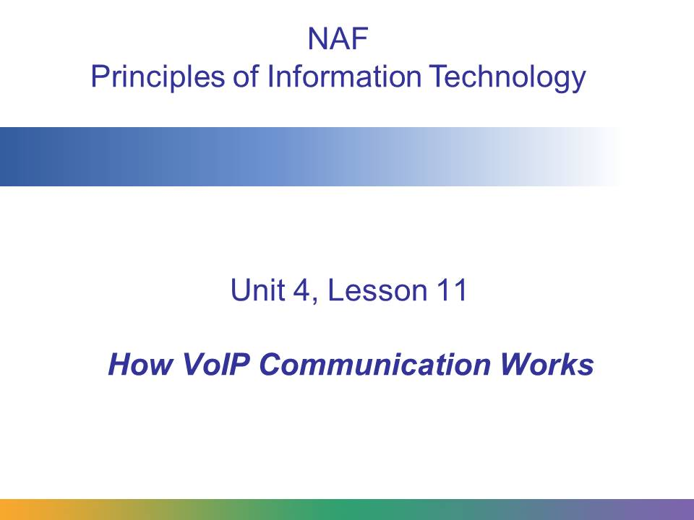
These slides illustrate the differences between analog and digital communication. They also explain what happens when a voice over Internet Protocol (VoIP) phone call is placed.
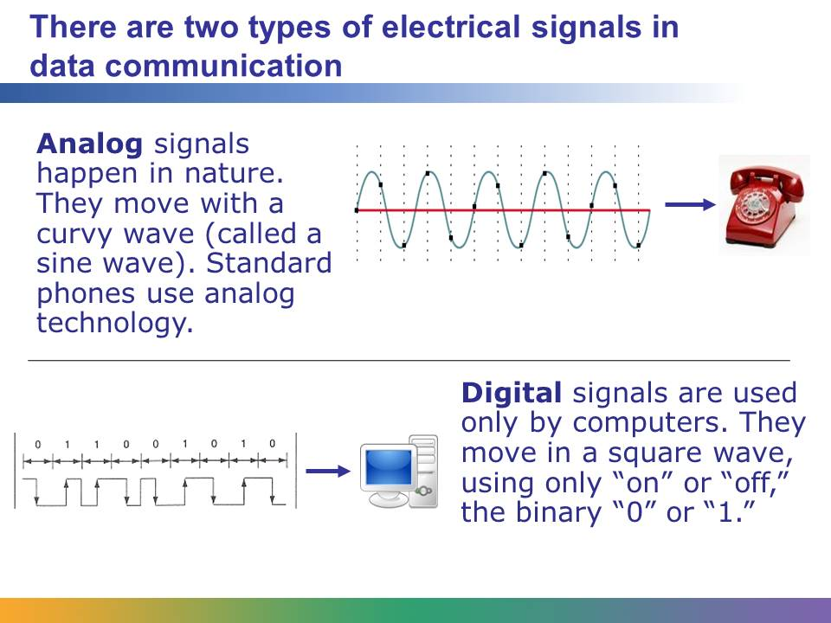
Standard phones use analog signals to send data across telephone wires. VoIP telephones and systems, however, use digital signals. Soon we’ll be experimenting with an all-digital phone call: we will use one of the computers in the room to call another computer in the room.
Analog signals are those found in nature: the sound of a voice, a bird’s song, or wind rustling through the trees. Digital signals, however, are binary-based (0s and 1s, or “ons” and “offs”). They exist inside the world of computers and are carried over digital communication lines.
In order to convert the digital information stored in a computer into an analog form, we use a device called a MODEM (MOdulation/DEModulation). Modulation is the process of converting a signal from digital to analog, and demodulation is the process of converting a signal from analog to digital. A modem will do both.
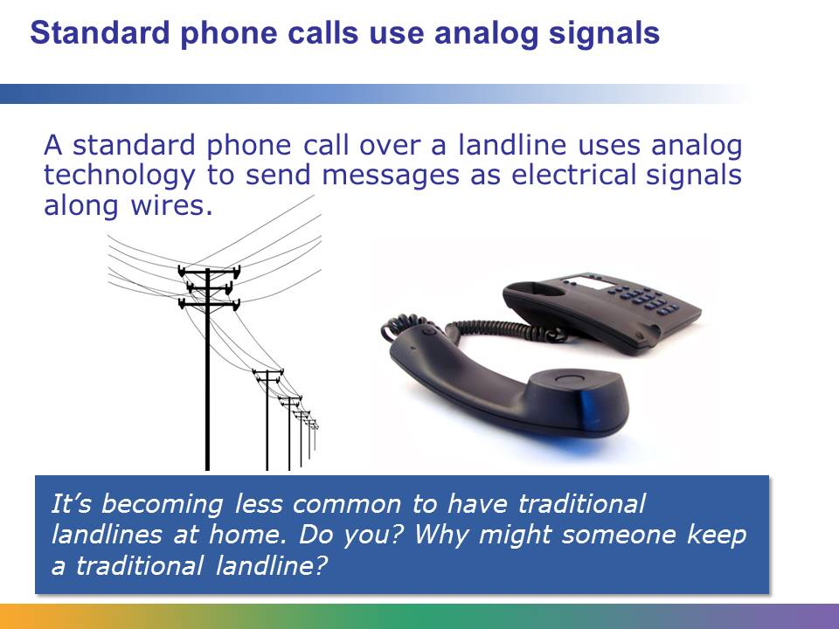
When you place a standard phone call, the data is sent using analog waves. The caller’s voice is sent over a regular landline via the public switched telephone network (PSTN), which is the worldwide network of public circuit-switched telephone networks.
The PSTN dates back to the late 1800s. For much of its existence, the twisted-pair cable it used has been a limiting factor—especially when the PSTN began carrying computer signals. Eventually, telecommunication companies invested in updating the PSTN to improve bandwidth.
The base stations for the PSTN were connected together by fiber-optic cable or other high-speed forms of communication, such as microwave or satellite signals. The base stations were connected to local subdivisions through fiber-optic cable. However, the cost of replacing the twisted-pair cable from the subdivision to each household was prohibitively expensive. This technology between the subdivision and each household has become known as last-mile technology. It is estimated that the replacement of last-mile technology has cost society more than $250 billion. Although most areas of the United States now have access to broadband Internet connections, some rural communities still rely on the PSTN and are limited by this last-mile technology and its low bandwidth.
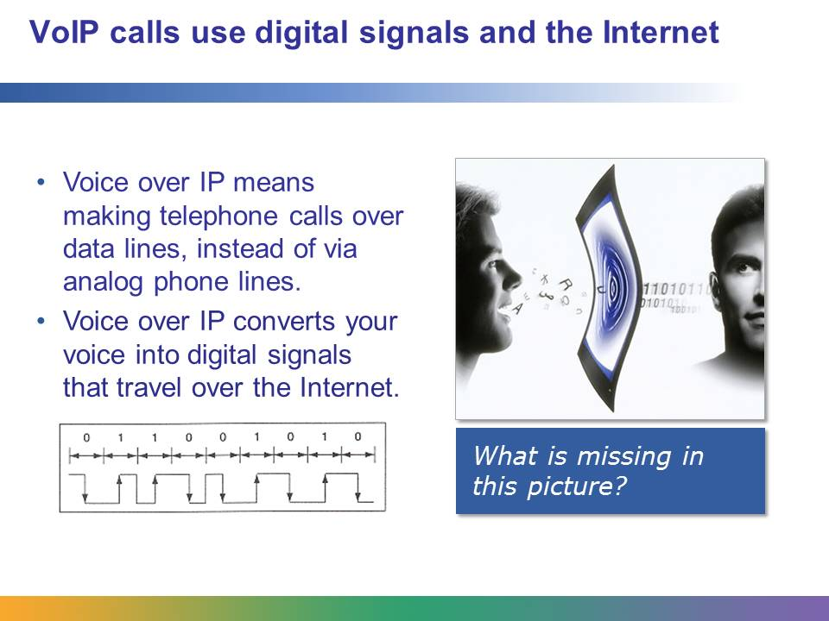
When you place a VoIP call, IP technology changes your voice from an analog to a digital signal. This signal is sent across the Internet, just as it is when you send an email, visit a web page, or do anything else Internet-based. When you receive a VoIP call, the data is changed back again to an analog signal, which is the voice of the caller.
Most VoIP systems are based on peer-to-peer networking.

Image retrieved from http://www.baacs.com/VoIP.html on June 21, 2012, and reproduced here under fair-use guidelines of Title 17, US Code. Image is the property of Beck & Associates Network Solutions (NSI). Copyrights belong to respective owners.
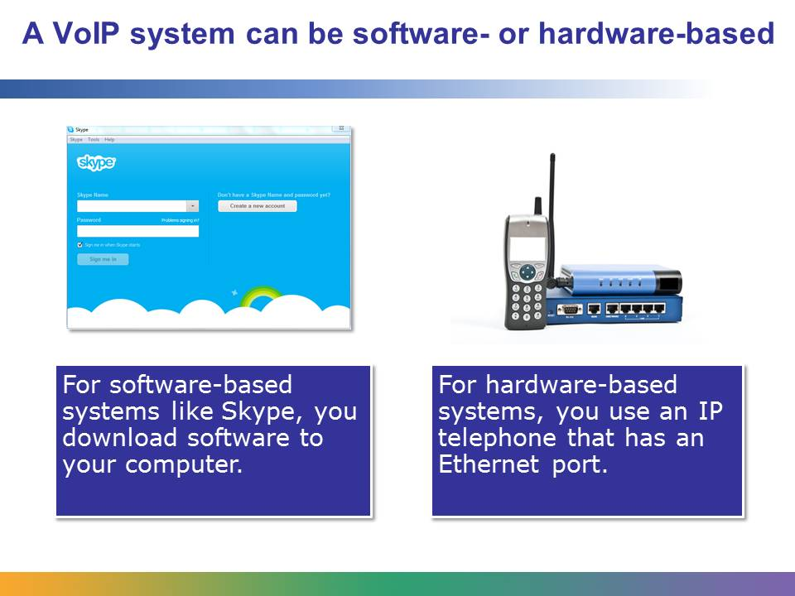
There are several ways to use a VoIP system in your home, including these:
- To use a software-based VoIP system such as Skype, you need to download the software to your PC. You also need a headset to hear and speak. Skype offers free calling to other Skype users worldwide, but you must be connected to your computer. Skype also allows you to place video calls if the computers at each end are equipped with web cameras. Many Apple and Android-based tablets also provide Skype services over Wi-Fi.
- To use a VoIP service provider such as Vonage, you need to pay a monthly fee for the service. This charge is a flat-rate fee, much like the fees charged by regular ISPs.
- To use a hardware-based VoIP system such as Ooma, you must buy a device called a hub, which is connected between your incoming Internet line and your modem or router. Your landline telephone then connects to the hub. Because you can place a VoIP call using any landline phone, you don’t need to be connected to a computer.
- IP telephones look like regular landline phones but have an Ethernet port. You can plug your IP phone into your Internet connection and make calls without a computer or special software.
- If there is electrical interference and noise on the transmission cabling, digital transmission of voice and data will be clearer than analog transmission.

Student Resource 11.6
Reading: What Is the Digital Divide?
In one household, a mom reads a newspaper article on her phone, while a dad checks the family’s bank account and pays their credit card bill. The older child is online, gathering research for an upcoming project; the younger is emailing a question to his teacher about his homework.
In another household, no one has ever seen, let alone touched, a computer.
This difference may seem extreme, but it is the reality of our world today. Despite the importance of the Internet, fewer than 40% of the world’s 7 billion people (as of 2014) have access to the educational, social, and economic opportunities the Internet creates. A digital divide—a gap between the “haves” (those who have access to technology) and the “have nots” (those who do not)—splits the world in two. Access refers not just to physical access to devices but also access to the resources and skills needed to participate in the digital culture.
Not everyone thinks there is a digital divide, and some who think there is such a divide doubt that it’s a long-term problem. Some scientists believe that the digital divide will simply disappear as computers get smarter, smaller, easier to use, and more affordable. They think that in the very near future, people will not need high-tech skills to access the Internet and participate in e-commerce or e-democracy. However, the numbers tell a different story: a shockingly large percentage of the world does not have access to technology, and that impacts their lives in very real ways.
The US Digital Divide
We think of the United States as a leader in the digital culture. It’s hard to imagine someone without a computer, a smartphone, or an email address. But many Americans live just this way. The following chart from the Pew Research Center’s Internet & American Life Project’s Spring Tracking Survey conducted January 9–13, 2014, shows Internet usage broken down by gender, ethnicity, age, income, and location.
It is important to note that, while these figures highlight a divide, they also, in some respects, show that the digital divide is narrowing. (To see more up-to-date statistics, view the most recent data here: http://www.pewinternet.org/data-trend/internet-use/latest-stats/. You can also see stats about US teens: http://www.pewinternet.org/data-trend/teens/internet-user-demographics/.)
 | Internet Users
Total Adults | 87%
Men | 87%
Women | 85%
Race/Ethnicity
White, Non-Hispanic | 85%
Black, Non-Hispanic | 81%
Hispanic (English & Spanish- speaking) | 83%
Age
18 – 29 | 97%
30 – 49 | 93%
50 – 64 | 88%
65+ | 57%
Household Income (Annual)
Less than $30,000 | 77%
$30,000 – $49,999 | 85%
$50,000 – $74,999 | 93%
$75,000 + | 99%
Educational Attainment
High school diploma or less | 76%
Some college | 91%
College + | 97%
This table included under fair-use guidelines of Title 17, US Code. Copyrights belong to respective owners.
The Global Digital Divide
While a digital divide certainly exists in the United States, the global digital divide is much more extreme. The term global digital divide refers to differences in technology access between countries.
In 2013, more than 2.7 billion people were using the Internet. That sounds like a lot, but that is only 39% of the world’s population. The following charts show what percentages of the population in different regions were using the Internet in 2013. The divide is clear: the percentage of Internet users in developed countries is more than twice as high as in developing countries. There is a huge gap between the 16% of Africans who use the Internet and the 75% of Europeans!
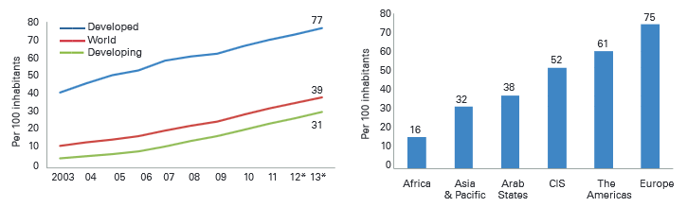
Graphs courtesy of ITU World Telecommunication/ICT Indicators database. Included under fair-use guidelines of Title 17, US Code.

Those who think the gap will close itself, however, point to a different trend. In 2013, there were almost as many cell phone subscriptions as people in the world, with more than half the subscriptions in the Asia-Pacific region. In developed countries (countries such as the United States, England, Canada, France, and so on), there are more cell phone subscriptions than people (128% penetration). Developing countries (parts of South America and most of Africa and Southeast Asia) have 89% penetration. Many scientists think cell phone usage might be the key to bridging the gap, as a smartphone is often cheaper than a computer, and Internet access via the phone might be easier than through the cables required for home use.
The following chart shows how the number of cell phone subscriptions has grown over the past decade.
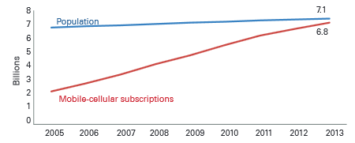
Graph courtesy of ITU World Telecommunication/ICT Indicators database. Included under fair-use guidelines of Title 17, US Code.
Does Technology Really Matter?
Even if we acknowledge that not everyone has the same access to technology, how important is that really? Does technology really make a difference in people’s lives? The research says yes.
Technology improves communities: Studies show that having access to technology greatly increases wealth creation, decreases unemployment, and leads to the evolution of healthier, more stable communities.
Technology increases individual opportunity: Studies show that the access and skills needed to use the Internet improve a person’s education and job prospects. To help new generations benefit from digital culture, schools have taken steps to help close the digital divide in the United States—at least during the school day. However, limited access to computers at home restricts some students’ abilities to do research for reports, explore college scholarships, or just get comfortable going online.
Technology provides access to other significant services. Those of us who live in developed countries enjoy many more Internet services than those who live in developing countries, including the following:
- Affordable and widespread broadband Internet access (either at home, at work, or in public places like the library or Internet cafés), which allows us to search for information and communicate with others easily and quickly
- The ability to use credit cards to securely buy things online with reliable shipping services and/or to securely make online payments for services (such as utility bills or income taxes)
- Detailed virtual globes showing maps and detailed satellite and aerial photography
- Access to newspaper and magazine archive searches online
- Price search engines to find the best online price and/or local availability
Bridging the Digital Divide
There are many programs, sponsored by companies, nonprofits, and governments, trying to close the global gap between people with and without technology access. Here are a few examples:
- One Laptop per Child: The mission of the nonprofit organization One Laptop per Child (OLPC) is to empower learning in children of developing countries by providing one connected laptop to every school-age child. Read more at http://www.laptop.org/en/.
- Digital Divide Institute: Organizes activities around closing the digital divide in order to create equality in the globalized economy. This organization can be found at http://www.digitaldivide.org/.
- Youth for Technology Foundation: Another nonprofit, Youth for Technology provides marginalized people in rural African communities with technology tools as well as training and resources to enable them to realize their potential. Read more at http://www.youthfortechnology.org/.
- USAID: In 2009, the US Agency for International Development (USAID) helped establish community learning and information centers—“CLICs”—in 13 rural communities across Mali.
The Digital Divide and the Future
More than ever before in history, our world is deeply interconnected. The news of war, disease, and poverty travels quickly from distant places to touch our lives here in the United States. Providing meaningful access to the benefits of technology to disadvantaged people means providing opportunity for such people to feed their families, improve their quality of life, and create healthy communities—thus improving global stability and reducing conflict and preventable humanitarian crises.

Student Resource 11.7
Writing Assignment: Blogging about the Digital Divide
Directions: This resource will help you and your partner as you think about the digital divide in your community. Look at the information you have gathered. Together, compose a blog entry based on the plan of action you and your partner have decided to pursue to help bridge the digital divide. You’ll post your final draft on the blog site indicated by your teacher.
You want to be personal and persuasive in your blog. That’s how to make it interesting to read. Explain the steps you would take, the people or organizations you would involve in the action plan, and two reasons why the plan would help you to bridge your community’s digital divide.
What Is a Blog?
A blog—short for weblog—is a website that is regularly updated and written in a casual or informal style. Many blogs are personal, written by one individual or a small group of individuals, talking about their lives. Other blogs are sponsored by businesses or organizations to discuss a specific topic. Blogs are interactive because people can post comments, and discussions can spring up around a specific post.
The Topic
In what ways does our community suffer from a digital divide? Who has access to the Internet and who doesn’t? How could more people gain access to the Internet and to computers, tablets, or smartphones? How could more people be taught how to use these tools? Create a plan of action that answers these questions. If you have been assigned a more specific topic by your teacher, write it here:
__________________________________________________________________________________
How to Organize Your Blog
Think about the most effective way to organize what you want to say with your partner. Here is one way that would work:
- First paragraph: Introduce your topic. Give some examples or cite some research to demonstrate what the problem is. Then say why this problem matters to you.
- Second paragraph: Present your plan of action. Describe what you plan to do and how you would do it.
- Third paragraph: Give a couple of reasons why you think your plan will work.
- Fourth paragraph: End with some comments on how the digital divide has affected you. Or, describe how lessening the digital divide will make a difference in your community.
Writing Hints
Unlike other forms of writing, blogs work well when they are personal and express how you feel about a topic. You don’t have to sound formal or take yourself out of your blog, the way you would if you were writing a research report.
Read some blogs that you like before you get started. They will give you an idea of how you want to work with your partner to write your own.
How Your Work Will Be Assessed
Make sure your assignment meets or exceeds the following assessment criteria:
- The posting includes a clear description of the plan of action, in addition to two reasons the plan would work.
- Facts and statistics back up the reasoning behind the plan for decreasing the community’s digital divide.
- The blog includes personal reactions to the problem.
- The action plan is original. It is not a copy of some other action plan.
- The posting uses correct grammar and spelling.
- The blog entry was successfully posted to the blog.
Recommended Sources
There are many good resources on the web to help you learn more about the digital divide and ideas for bridging the gap. Here are a few reliable sites you can use for research. Your teacher may have other research suggestions for you as well, including resources related to your specific community.
- http://www.youthfortechnology.org/
- http://www.digitaldivide.org/
- http://www.laptop.org/en/
- http://close-the-gap.org/
- http://www.pewinternet.org/topics/digital-divide/
Use the organizer on the following page to help you keep track of the information you find. An example is provided.
Topic | Notes | Source
Poverty in the United States | - It’s often cyclical: people born into it have trouble escaping it.  - It leads to other problems, such as lack of health care, good nutrition, and education opportunities.  - 15% of the US population (approx. 41 million people) lived in poverty in 2012. | http://www.feedingamerica.org/hunger-in-america/

Topic | Notes | Source

