NAF Principles of Information Technology
Lesson 2
The Evolving Role of Information Technology and Computers
Student Resources
Resource | Description
Student Resource 2.1 | Reading: The Evolving Role of Information Technology
Student Resource 2.2 | Note Taking: The History and Development of Computers
Student Resource 2.3 | Reading: The History and Development of Computers
Student Resource 2.4 | Reflection: Information Technology and Its Impact on Society and My Life

Student Resource 2.1
Reading: The Evolving Role of
Information Technology
On August 5, 2010, the San Jose copper-gold mine in Chile collapsed, leaving 33 miners trapped 2,300 feet below ground. Sixty-nine days later, more than one billion people around the world applauded as they watched (via streaming live video) the rescue unfold. Each one of the 33 miners was pulled from the ground alive. This amazing feat has been considered one of the most successful rescue stories of the century and, undoubtedly, the technological innovations of our day helped to save these miners’ lives. From robotic cameras and GPS navigation systems to heart rate and temperature monitors, the importance of information technology to the rescue mission cannot be denied.
The Chilean miners’ rescue story is just one example of the importance of information technology to our world today and provides a framework to comprehend the immense scope of how technology is used. From the common cell phone, which allowed the trapped miners to communicate with the world above, to the amazingly complex NASA-engineered capsule that safely carried the 33 men to the surface, technological innovations of all kinds have become an integral part of our lives.
What Is Information Technology?
Information technology (IT) is a broad topic that deals with all aspects of managing and processing data with computerized systems. This term relates to all of the types of technology used to create, store, retrieve, process, and share information in all kinds of formats. Think of information technology as the “engine” that drives the systems we use to learn, solve problems, and communicate.
Information technology has become intertwined with our daily activities. In fact, it’s hard to separate the two. Obviously, items like computers and cell phones are an indispensable part of our culture, and we depend on them for supporting us in just about everything we do. But what about some of the technological advancements that we may not think about on a day-to-day basis, like geographic information systems (GIS) and magnetic resonance imaging (MRI)? To what extent are these innovations a part of our lives and our world?
Information Technology in the World Today
The scope of information technology is very wide. On one level, the term information technology describes an industry that uses computers, networking, and other equipment to process, store, retrieve, and protect information; on another, it has grown to include everything that delivers information to a user. The term encompasses nearly all fields of work and affects just about every organization, business, and individual.
A quick look at the following examples will enable you to see how information technology has become an essential part of industry.
- The business and finance worlds rely on technological advancements to help manage huge amounts of data and information. Companies depend on computer technology to assist them with such things as data processing, bookkeeping, and inventory tracking. Businesses of all sizes have increased productivity, become more cost effective, and seen larger profits as a result of technological advancements.
- The medical industry uses information technology to assist with many day-to-day activities and procedures. Electronic medical record (EMR) systems are now in place in many health care facilities. EMR systems store patient data and medical history, and this helps to direct medical decisions when a patient enters the health care system. Aside from EMR systems, doctors use information technology to help them diagnose and cure diseases, too. Doctors also use information technology to track patient medications and to submit prescriptions to nearby pharmacies. They use laser medicine and MRI, and they even have special computer software to help them perform surgeries. All of these IT advancements are allowing hospitals to improve the quality of care and extend the lives of their patients. Through data mining, medical researchers are searching for trends in patient data in hopes of identifying cures for diseases such as cancer and diabetes.
- Construction engineering also relies on specific technological systems. Today nearly all project information is entered into software tools that store, analyze, compute, and then help to inform most decisions about a project. Advancements in this area help determine whether a building can withstand an earthquake or whether its aging infrastructure should be redesigned. Further, buildings can be constructed virtually so that people can view the outsides and insides of them and make aesthetic and ergonomic changes before any physical construction takes place. Society has benefited from this industry’s technological innovations in that they have created safer living and working conditions for the world.
- The hospitality and tourism industry relies on various types of technology. Both tourists and tourism businesses benefit from continuous communications and streamlined guest experiences, from reservations to checkout. Many hospitality and tourism businesses are large and dispersed around the globe, so they rely upon complex computer systems to streamline their operations. From marketing and advertising via a company’s own website to online ordering, booking systems, and customer reviews, the Internet has drastically changed tourism in the 21st century.
- Geological science uses technology to aid in the collection and analysis of demographic data, weather reports, and more. Weather forecasters are able to predict more accurately the state of the atmosphere for a specific location and time. Satellite-based communication systems can give warning of tsunamis, earthquakes, and other extreme weather conditions and then convey this information to warning centers using real-time technology. Droughts can be mapped so that planners are warned years ahead of time. Animal migrations can be mapped and studied, as well.
- Agriculture technology now incorporates advanced mapping instruments such as geographical information systems (GIS) and global positioning systems (GPS) to provide information regarding the land and water in a specific area. Farmers have computers linked to solar-powered weather stations that can provide important information about wind speed, humidity, and air and soil temperatures. Some tractors and plows are even equipped with global positioning systems!
As you can see from the examples above, information technology is an integral part of just about every industry. In fact, industries have become dependent upon the efficiency and accuracy of information technology. Technology has increased business production, reduced costs, and improved processing and distribution, in general. Information technology has become inseparable from our daily activities. It drives our world and has changed the way people and organizations accomplish tasks forever.
No matter what career path you choose, a solid background in information technology will put you at an advantage. By taking Principles of Information Technology, you are taking a first step toward equipping yourself with the IT skills you will need to succeed. One of the main goals of this Principles of IT course is to help you become computer literate. Being computer literate means that you understand the concepts, vocabulary, and tasks related to general computer use—the essential knowledge of the basic principles at the heart of everything we do with computers. This foundation will prepare you to build additional information technology skills throughout your life.
Student Resource 2.2
Note Taking:
The History and Development of Computers
Student Name:_______________________________________________________ Date:____________
Directions: As you watch the presentation “The History and Development of Computers,” note the important events or advancements in computer technology in chronological order in the boxes below, writing just one word or short phrase in each box. If you need more boxes, use the back of this worksheet. The first box is filled in for you as an example.
Tally system

Student Resource 2.3
Reading: The History and Development of Computers
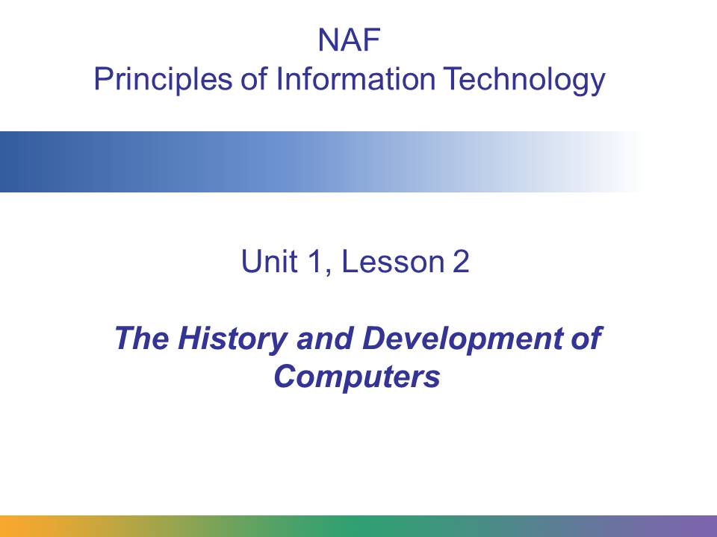
In this presentation, you will explore a few of the early technologies and tools that helped pave the way for modern computers. You’ll then look at some key milestones in computer development.
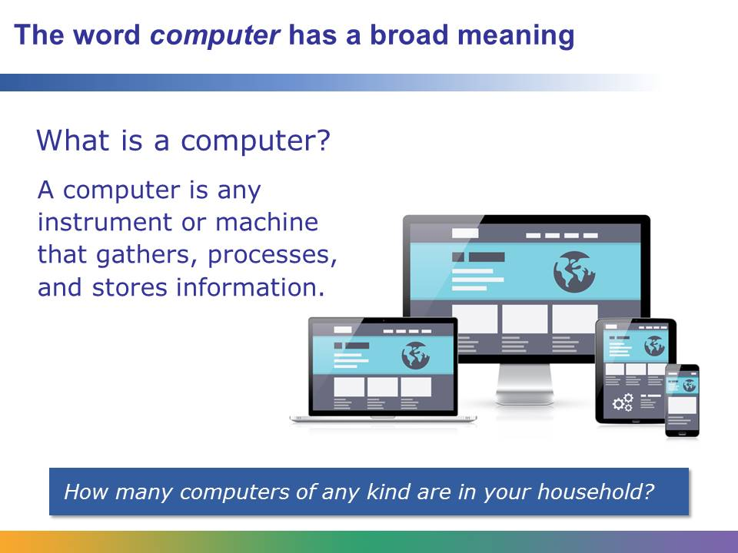
The word computer includes many devices that process and store information. Basically, a computer is a machine that uses hardware and software to respond to and execute instructions. It gathers, processes, and stores information.
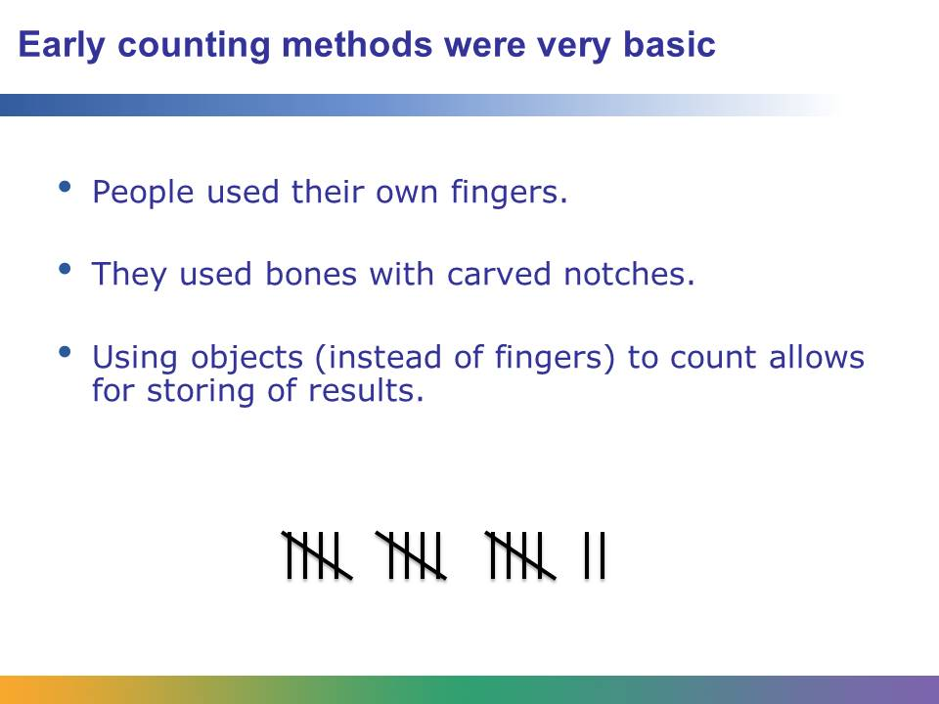
The first counting tools were people’s own fingers. The word digit can refer to a finger (or toe) or to a single character in a number system.
Bones with carved notches have been found in Europe, dated between 30,000 to 20,000 BCE. One had notches in groups of five—early evidence of the tally system. The tally system is still in use today, making it one of humankind’s most enduring inventions.
When you use objects instead of fingers to count, you can store results for later reference. The number shown on the slide is 17.
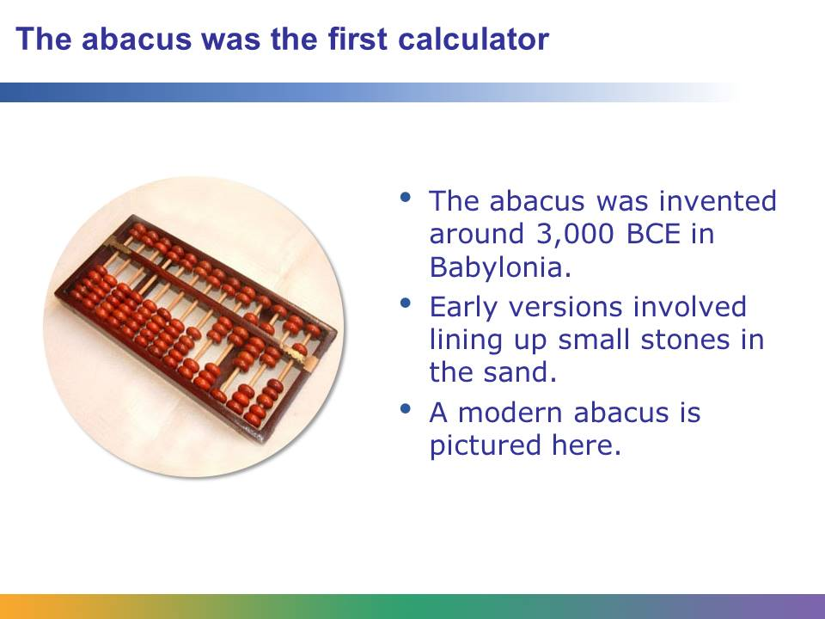
It is believed that the abacus was invented around 3,000 BCE in Babylonia. Others say that the Chinese invented the abacus. (The model shown on this slide is Chinese.) Early versions used small stones or pebbles lined up in columns in the sand. A modern abacus has rings or beads that slide over rods in a frame.
The word calculate is derived from the Latin word for pebble. A standard abacus can be used to perform addition, subtraction, division, and multiplication.
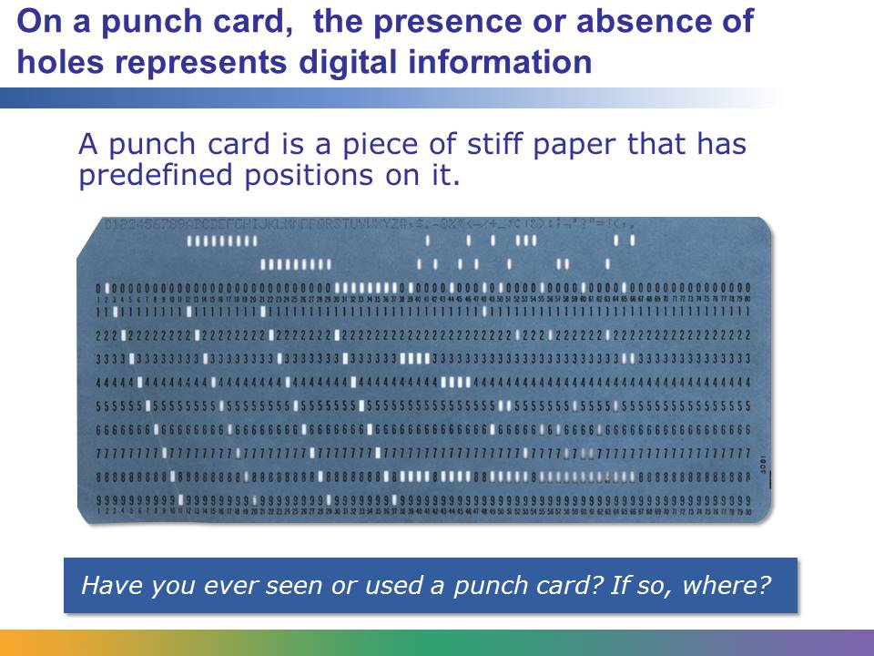
A punch card is a piece of stiff paper that has predefined positions on it. Data is represented by the presence or absence of a hole in each predefined position. Punch cards were first used in the early 19th century to store information for textile looms and player pianos. They were used later to compute the 1890 census.
From the 1900s into the 1950s, punched cards were the primary medium for data entry, data storage, and processing in institutional computing. By 1937, IBM printed five to ten million punch cards every day.
During the 1960s, as more capable computers became available, magnetic tape gradually replaced the punch card as the primary means for data storage. Today punch cards are mostly obsolete, except for in a few legacy systems.
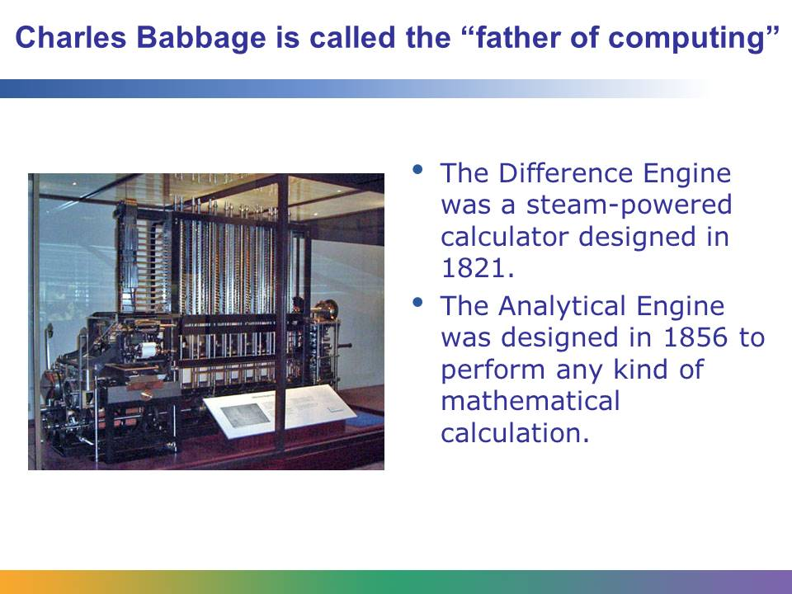
Charles Babbage designed a steam-powered calculator called the Difference Engine in 1821. The purpose of the Difference Engine was to compile mathematical tables. Babbage received British government funding for his project, but when his attempts to build the machine failed, the project was canceled in 1842. The photo on this slide shows a reproduction of the Difference Engine.
His next idea was the Analytical Engine (1856), designed to perform any kind of mathematical calculation. The Analytical Engine used punched cards. Babbage died before the Analytical Engine could be completed, although part of it was built by Babbage’s son in 1910. The entire machine would have used 25,000 parts and weighed three tons.
Image retrieved from http://commons.wikimedia.org/wiki/File:050114_2529_difference.jpg and reproduced here under the terms of the Creative Commons Attribution ShareAlike 1.0 license. Original photograph by Joe D.
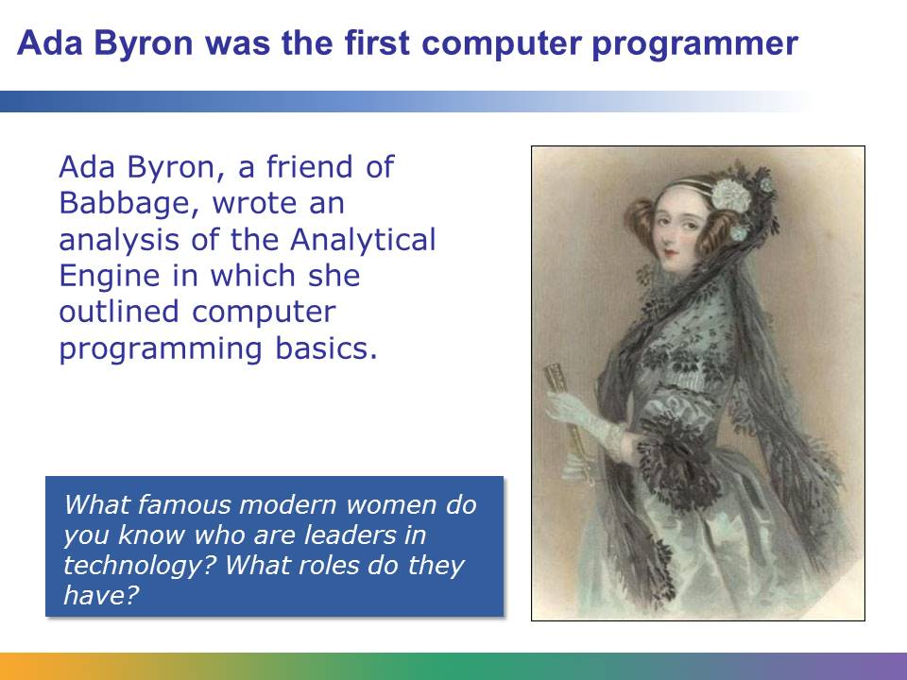
The Analytical Engine utilized logic based on conditions or situations, a characteristic of today’s computers. This meant that while the machine was running, different results could be achieved based on the conditions the machine detected. The Ada programming language is named after Ada Byron.
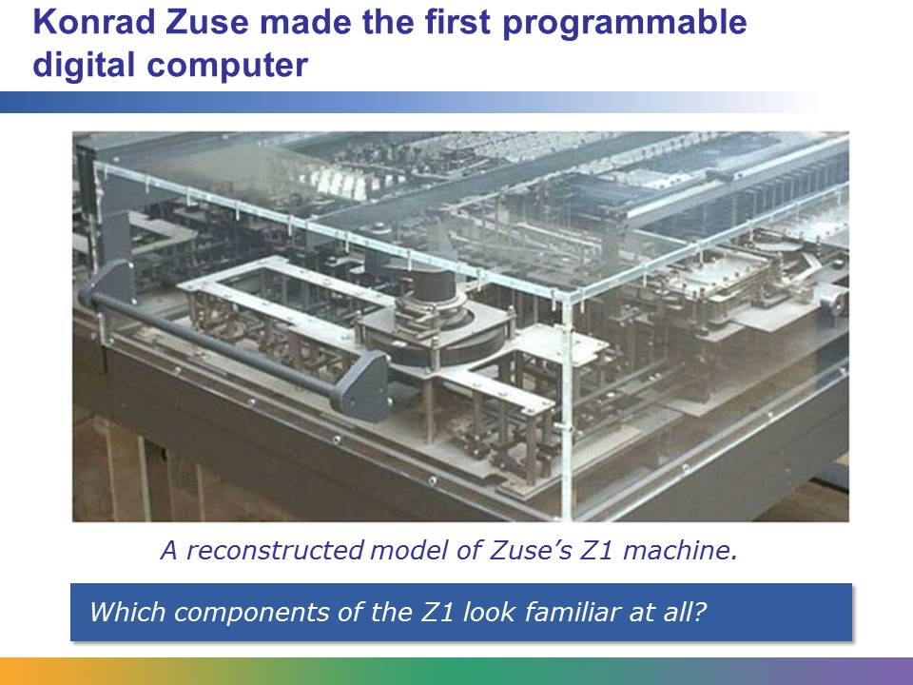
During World War II, Konrad Zuse, a German engineer, created a series of computers: the Z1, Z2, Z3, and Z4.
The Z3 was the first fully programmable, digital computing machine.
The photo on this slide shows a reconstructed model of Zuse’s Z1 machine.
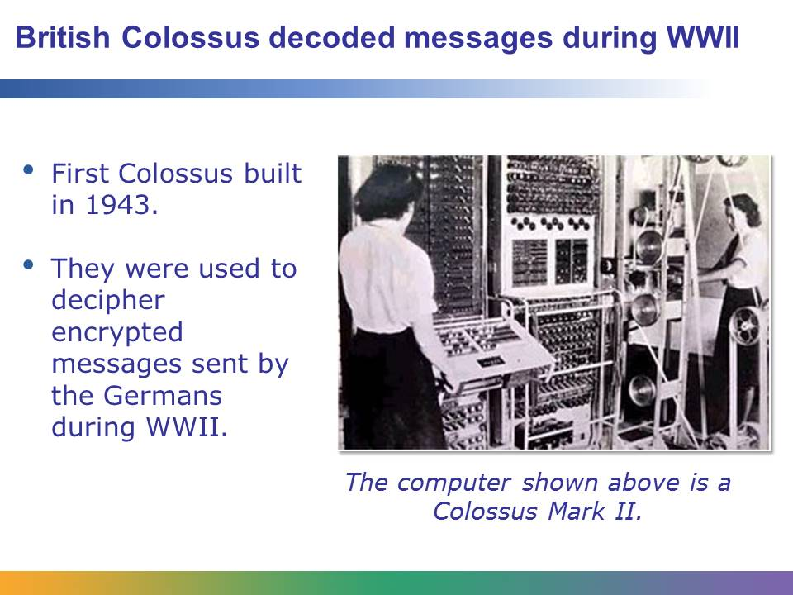
In 1943, the British built the first “Colossus” computer. These machines were used to decipher encrypted teleprinter messages sent by the Germans during World War II. While optically reading a paper tape, the machine applied programmable logic to every character in an encrypted message and then counted how many times the logic function was determined to be “true.” The photo on this slide shows the Colossus Mark II. Notice the slanted control panel on the left and the paper tape on the right. Colossus used vacuum tubes to remember its program. The tube was either on or off (binary). Since valves were the size of a lightbulb, the memory of the Colossus filled an entire room and generated a lot of heat. It was destroyed after World War II.
Information about Colossus was not available to the general public until the late 1970s, after the Official Secrets Act ended in 1976.
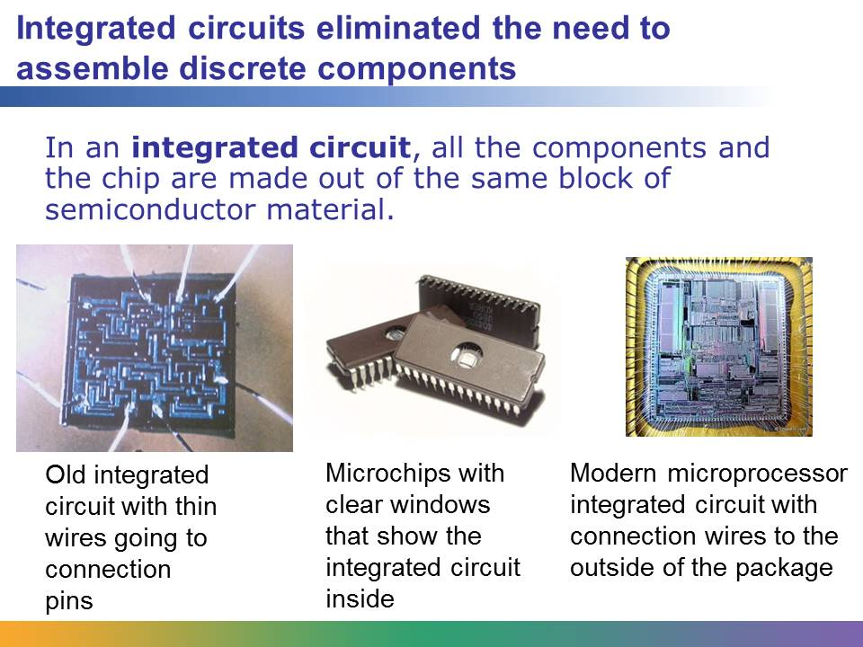
In 1958, Texas Instruments built the first integrated circuit as the key component in computer memory and processing instructions. Integrated circuits replaced the room of vacuum tubes. Although this first circuit had some problems, the idea was groundbreaking. By making all the parts out of the same block of material and adding the metal needed to connect them as a layer on top of it, there was no more need for individual discrete components. No more wires and components had to be assembled manually. The circuits could be made smaller and the manufacturing process could be automated.
The microchips with a “window” (middle photo) were a special type of permanent memory chip that could be programmed but then “erased” and reused by shining ultraviolet light through the window for a few minutes. Most modern chips do not have this window.
Over time, integrated circuits have continued to get smaller in size but larger in capacity. The microprocessor in modern-day computers is an integrated circuit that processes all information in the computer. It keeps track of what keys are pressed and if the mouse has been moved. It counts numbers and runs programs, games, and the operating system.
Integrated circuits are also found in almost every modern electrical device, including cars, television sets, MP3 players, and cell phones.
Images retrieved from wikipedia.org and reproduced here under the terms of the GNU Free Documentation License: http://commons.wikimedia.org/wiki/Commons:GNU_Free_Documentation_License.
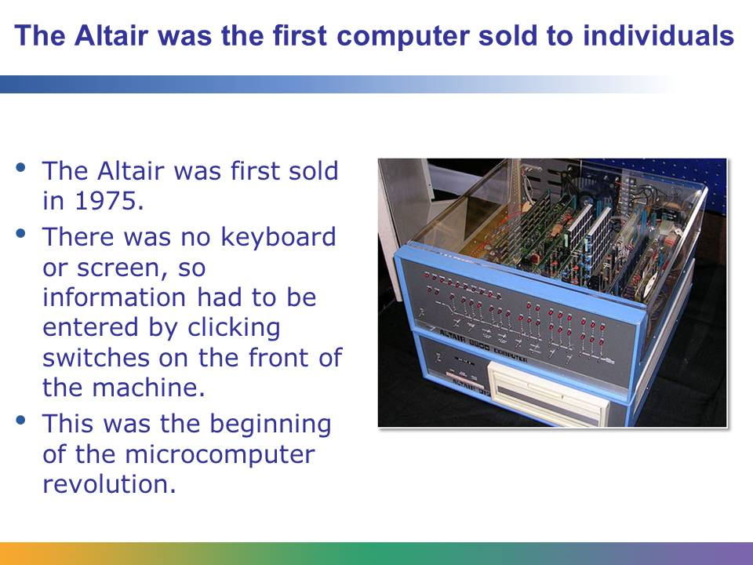
Until the mid-1970s, computers were used only by the government, scientists, large companies, universities, and research organizations. The Altair, designed for hobbyists, was sold by mail order beginning in 1975. The Altair’s computing results were displayed as patterns of small red lights on the front panel. Since there was no keyboard or screen, information was entered by clicking switches on the front of the machine. Hobbyists added keyboards, teletype printers, a television display, and paper tape or audio cassette interfaces to make the machines more usable. Early programming was done in assembler code or a language called BASIC. Floppy disks and hard drives weren’t available for these machines until two or three years later. The Altair was sold as a kit that the customer had to assemble. The kit was about $600.
The floppy disk box shown underneath the main CPU box was not part of the original Altair 8800a but was an option available two years later.
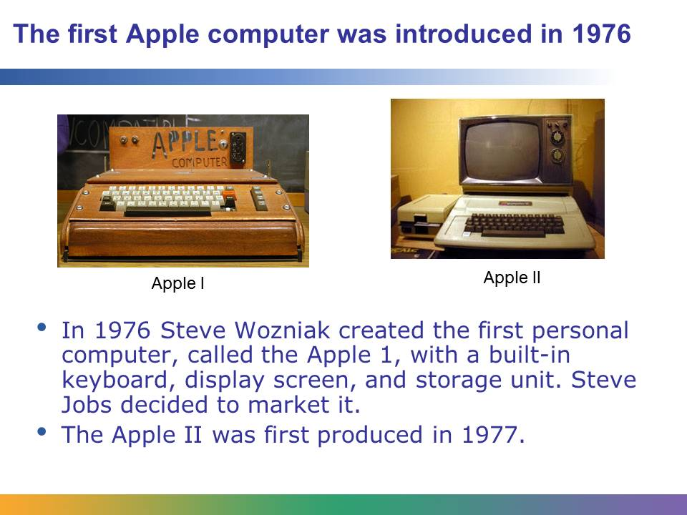
The Apple I was marketed as a fully assembled circuit board containing about 60+ chips. However, to make a working computer, users still had to add a case, power supply transformers, a power switch, a keyboard, and a video display.
The Apple II had 4KB of standard memory, expandable to 8KB or 48KB using expansion cards.
Apple I image retrieved from wikipedia.org and reproduced here under the terms of the GNU Free Documentation License. A copy of the license is available at http://commons.wikimedia.org/wiki/Commons:GNU_Free_Documentation_License.
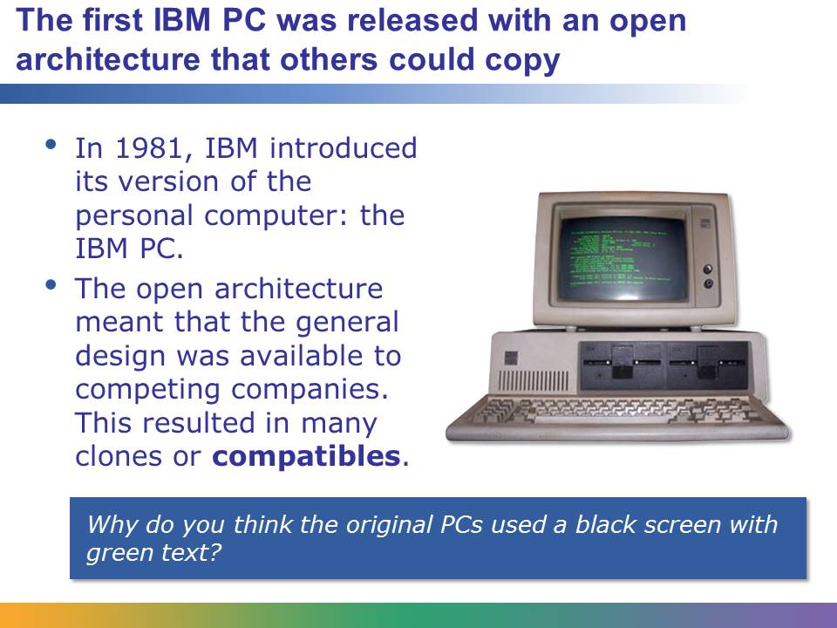
The photo shows an early IBM PC.
The first IBM PC came equipped with 16KB of memory, expandable to 256KB. The PC came with one or two 160KB floppy disk drives and an optional color monitor.
The PC was different from previous IBM computers because it was the first computer to be built from off-the-shelf parts (called open architecture). Also, it was the first IBM computer to be marketed by outside distributors (Sears & Roebuck and ComputerLand).
PC image retrieved from wikipedia.org and reproduced here under the terms of the GNU Free Documentation License. A copy of the license is available at http://commons.wikimedia.org/wiki/Commons:GNU_Free_Documentation_License.
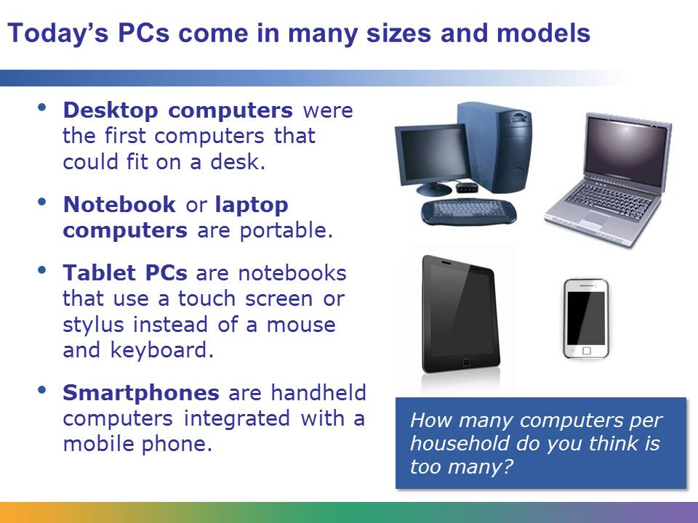
A wide range of personal computers is available; the size and shape of a computer is known as its form factor.
Desktop computers can be stand-alone tower models, or the computer can be built into the monitor. Laptops were the first portable computers.
Tablet PCs may use virtual keyboards and handwriting recognition for text input through the touch screen. All tablet personal computers have a wireless adapter for Internet and local network connection. The iPad is the most well-known tablet PC.
Smartphones usually allow the user to install and run advanced applications. They run complete operating system software, providing a platform for application developers. The next level of mobile phones beyond smartphones have been called “nirvana phones.” These smartphones can be docked with an external display and keyboard to create a desktop or laptop environment.
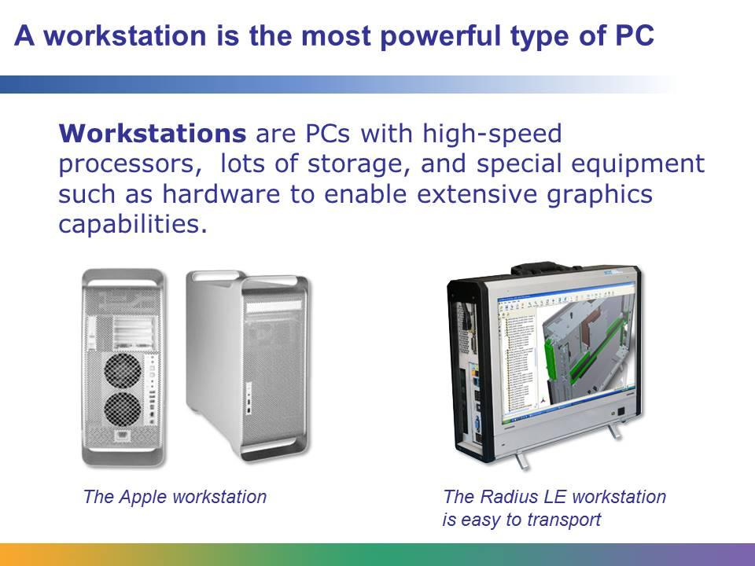
As PCs have become more powerful over the past 30 years, the description of what a workstation is and what a PC is has continually shifted. Workstations are PCs with high-speed processors, lots of storage, and special equipment, such as hardware to enable extensive graphics capabilities. Workstations are commonly used by professionals such as engineers, scientists, and video editors.
Complex capabilities (such as multitasking and the ability to allow multiple users access to the computer at the same time) that were once reserved for scientific and engineering fields have become an integral part of all PCs. Today, scientists and graphics professionals are the main users of workstations, which are much more powerful and more expensive than a basic modern PC. High-speed processors and graphics chips require larger power supplies and better cooling than that available in a typical laptop.
The computer-generated movie Toy Story was made on a set of Sun (Sparc) workstations.

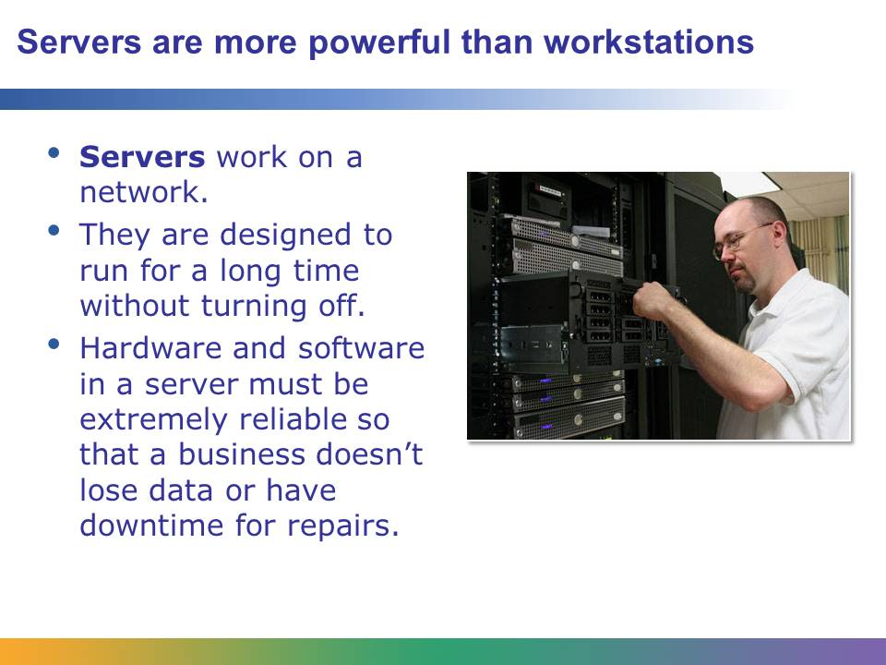
A server is a computer that provides services over a network. It is usually dedicated to a special purpose. For example, a file server is dedicated to storing files and making them available to other people on the network. A print server manages one or more printers; a database server processes database queries. There are also web and email servers.
Servers are typically put in tall racks with other servers. The racks or server rooms require extra cooling because the servers are on all the time.
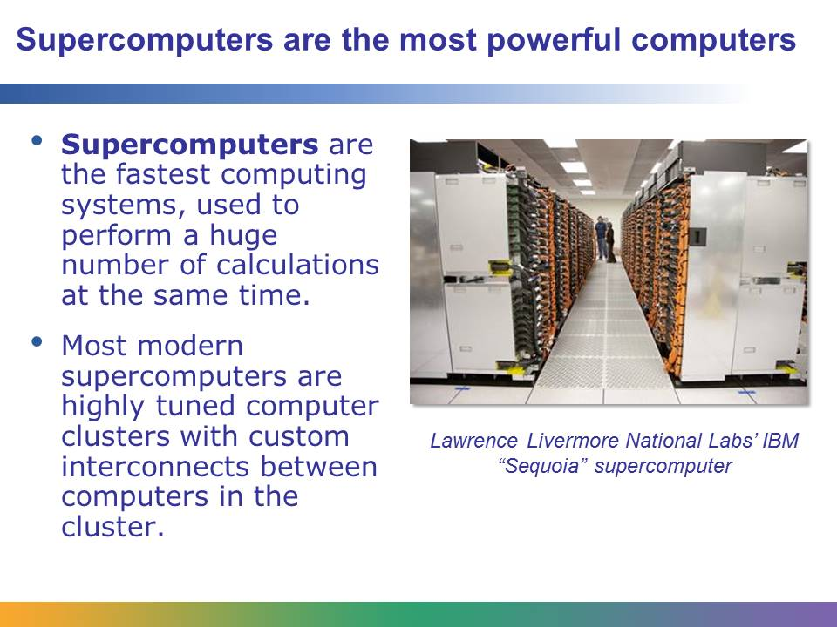
Supercomputers have become indispensable tools in cutting-edge scientific research. These machines are valued for their ability to solve problems critical to national interests in areas like defense, energy, and finance. Governments use supercomputers for tasks such as high-tech military and space programs. Supercomputing technology is also a part of mainstream business. Oil and gas companies use it to find reservoirs. Wall Street traders use it for the quickest automated trades. Meteorologists use supercomputers for weather forecasting. Legacy supercomputers are very large, with many processors inside.
In 2011, IBM supercomputer “Watson” beat two of Jeopardy’s best champions in a two-day match. In June 2012, IBM’s “Sequoia” supercomputer, based at the Lawrence Livermore National Laboratory, reached 16 petaflops (quadrillions of calculations per second), setting the world record. In June 2013, the Chinese supercomputer Tianhe-2 surpassed the Sequoia and other machines with 33.86 petaflops, using a total of 3.12 million computer processing cores. The Sequoia used 1.5 million cores. In March 2013, Blue Waters opened up to the science community at large. It is the first system of its kind to sustain one-petaflops performance—one quadrillion calculations per second—on a range of science and engineering applications. The project was developed at the National Center for Supercomputing Applications, at the University of Illinois at Urbana-Champaign.
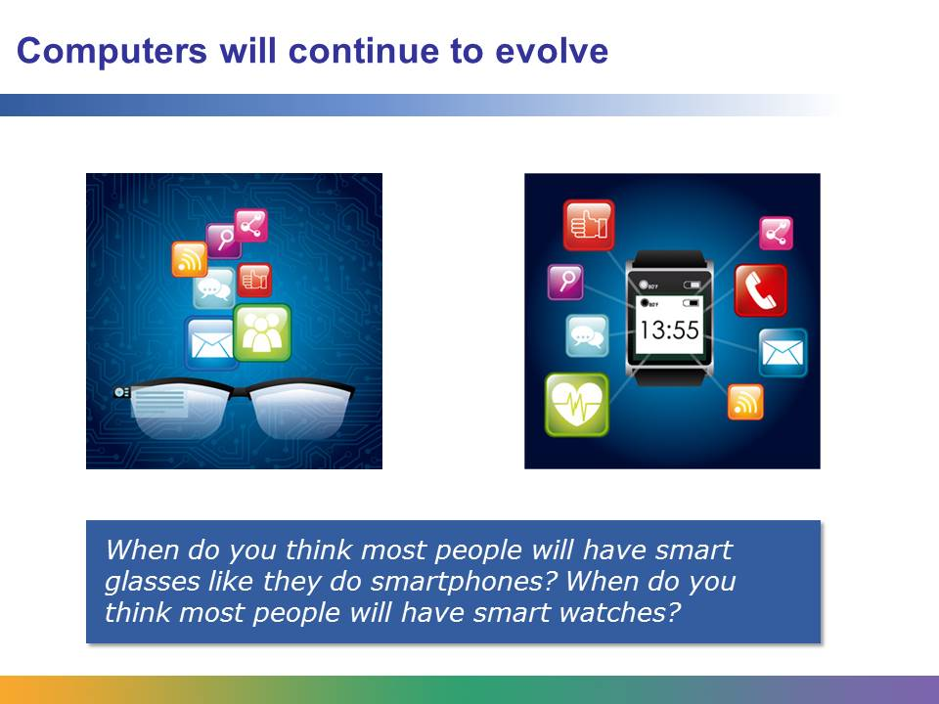
Computers came into widespread use relatively recently—mostly in the last two decades of the 20th century up until today. But as you’ve seen, their history goes back more than 5,000 years to the abacus. From a simple calculator made from beads and wires, to the complex world and number of devices available today, the computer plays an important role in our daily lives. The difference between an ancient abacus and a modern computer seems vast, but the principle—making calculations faster than the human brain—is nearly the same. What might the next generation of computers look like and be able to do?

Student Resource 2.4
Reflection: Information Technology and Its Impact on Society and My Life
Directions: This assignment will help you think about what you have learned so far about information technology. Choose four things that you have learned, and explain why they are important to you and/or how you use them in your everyday life or plan to in your future career. What part of information technology has made the biggest impact on your life? And what part of information technology has had the biggest impact on society? Feel free to look back over your readings and notes when answering this question, and give examples when you are explaining your answers. Before you begin, read the assessment criteria, and make sure you understand how your work will be assessed. Also study the example essay on the next page of this resource and use it as a guide as you write your essay.
Think carefully about the different aspects of information technology when making your choices. Be sure that you give reasons and examples explaining why these things have made (or will make) the biggest impact on your life.
Also mention the parts of information technology that have an impact on society as a whole. Explain your selections and include relevant examples. Consider whether and how this has changed the way people live. Other points to mention include the types or groups of people who have been the most affected, the pros and cons of the technology, and how things look for the future.
Before you start writing, study the example on the following page. Look at how it is structured and how the ideas are presented. Then use the example as a guide as you write your essay.
Organize your writing as you would a traditional essay:
- Begin with an introduction telling what you are writing about.
- Include one paragraph for each of the four things you have learned, focusing on the reasons you chose them.
- Close the essay with a conclusion that recaps your main points and restates the purpose of the essay (to tell which aspects of information technology are most important in your life and which have had the biggest impact on society).

Make sure your essay meets or exceeds the following assessment criteria:
- The essay clearly sets forth how the information technology features you have identified impact your life, with examples presented to support the statements.
- The essay clearly sets forth how the IT features you have identified impact society, with examples presented to support the statements.
- The writing demonstrates an understanding of the material presented in the course thus far.
- The essay is organized in a logical manner, with an introduction, a paragraph that supports each point, and a conclusion.
- The essay is neat and uses proper spelling and grammar.
Example: The Impact of Multimedia on Society and My Life
Multimedia has and will continue to have an impact on my life and society as a whole in four ways. First, multimedia includes a number of different kinds of enjoyable media. Second, multimedia is a good way to learn new things. Third, it is something people—including me—like to do with their free time. Lastly, making multimedia is interesting and challenging.
Multimedia combines different kinds of media that people use every day. I use music, video, text, and pictures almost every day. For example, I listen to my favorite band, watch videos of them, and read song lyrics on their website. Like many people, I access multimedia through both my smartphone and my laptop at home. It is this almost-constant access that allows me and my friends to enjoy exciting combinations of media.
I also use multimedia as a way to learn new things. For example, making a tamale is very hard to learn by reading an article. However, I went on YouTube and watched a video that showed how to put a tamale together and caught on right away. With multimedia, I can easily understand concepts and procedures that were difficult for me before. And it’s not just learning to cook! People can search for videos and podcasts that explain a wide variety of topics. You can find videos discussing home repair projects, crafting how-tos, and step-by-step auto repair. If there’s something you want to learn, someone has probably already posted a video about it on YouTube. Never before has it been so easy to learn something new. Access to all of this information must be a good thing for society.
Multimedia is also very entertaining. For example, I love to come home from school and play video games on my Wii. The combination of the sound, video, graphics, and text keeps my interest longer than watching a movie or reading a book. Entertaining video games, movies, and music are all types of multimedia that are also important to society. People are always talking about what movie they just saw or what new music video they currently love. Because multimedia is so enjoyable, it’s a great and easy way for people from different backgrounds to connect.
A final way multimedia is important to both me and society is that it is interesting and challenging to create. One of my favorite hobbies is creating multimedia presentations on my computer. For example, I put together text, pictures, charts, and music for school reports. Another example is that I created a multimedia scrapbook for my parents’ anniversary using their wedding pictures and the song they first danced to. Everyone has quick access to these really great multimedia tools. These tools also help people save time. Imagine how long it would have taken me to create the scrapbook for my parents if I hadn’t had access to digital photos and an online program to produce the scrapbook for me?
In conclusion, multimedia has an important place both in my life and in society at large. I expect it will continue to be important in my life, both at school and when I get a job. I already use computers nearly every day at school and for homework. I find it exciting to look to the future and the new multimedia technologies that will certainly develop.

