NAF Principles of Information Technology
Lesson 3
Online Research Strategies
Student Resources
Resource | Description
Student Resource 3.1 | Reading: Internet Basics
Student Resource 3.2 | Exploration: Browser Features
Student Resource 3.3 | Note Taking: Evaluating the Reliability of Web Pages
Student Resource 3.4 | Reading: Evaluating the Reliability of Web Pages
Student Resource 3.5 | Evaluation: Web Page Reliability

Student Resource 3.1
Reading: Internet Basics
The Internet is a huge network that links together millions of computers around the world. The Internet as we know it has been accessible to the general public only since 1993. Before then, Internet use was primarily limited to university researchers, the US government, and the military.
Some people use the terms Internet and World Wide Web (WWW) interchangeably, but the web, as it is often called, is not the Internet:
- The Internet is the network (computers and computer resources along with the connections between them) that transports multiple forms of information, including web pages, email messages, instant messages, audio (including phone calls), and data files.
- The World Wide Web consists of all the public websites connected to the Internet worldwide, as well as all the files that those websites store.
The World Wide Web gets its name from the complex web of connections created between computers worldwide. The web uses HTTP (Hypertext Transfer Protocol), one of the standards used to transport data on the Internet, to send web pages from the server where they are stored to the web browser requesting them.
A website is a collection of web pages that are all linked together. Web pages are written in a special language called Hypertext Markup Language (HTML). HTML tells web browsers what text or graphics should look like when they display. An important feature of HTML is hyperlinks, which are used to connect one document to another, or one location in a document to another location in the same document. Clicking a hyperlink (or link for short) enables you to jump to a different location on a web page, to move to another page on the same site, or to go to an entirely different website. Moving, or navigating, from one web page to another is referred to as browsing or surfing. Many web pages today combine HTML and Cascading Style Sheets (CSS); the CSS code describes how the text and any images should be formatted. A single CSS file can be used to describe the format for an entire website. This helps speed up the download of the HTML to your browser within a site using the same style sheet, because the formatting rules are only downloaded once.
Most websites have an entry page known as that site’s home page. The home page is often named index.html (or some variation like index.php or index.shtml). Most web servers will search for the index page if the web address, or URL, does not include a file name. For example, if you enter the URL www.cnn.com, you go to CNN’s home page, which can also be found by going to www.cnn.com/index.html.
A web browser is the program you use to access the World Wide Web. It interprets the elements of a web page, including text, images, hyperlinks, JavaScript, and Java applets. The browser converts the HTML code into a nicely formatted page for display. Microsoft’s Internet Explorer and Edge, Mozilla’s Firefox, Google’s Chrome, and Apple’s Safari are five popular browsers. Although browsers each look a little different, they work in similar ways. As with other programs and apps, you can identify a web browser on your desktop, home screen, or start menu by its icon. Icons are images that represent an application or capability, and they are usually selectable.
Here are some popular browser icons:
Microsoft Internet Explore | 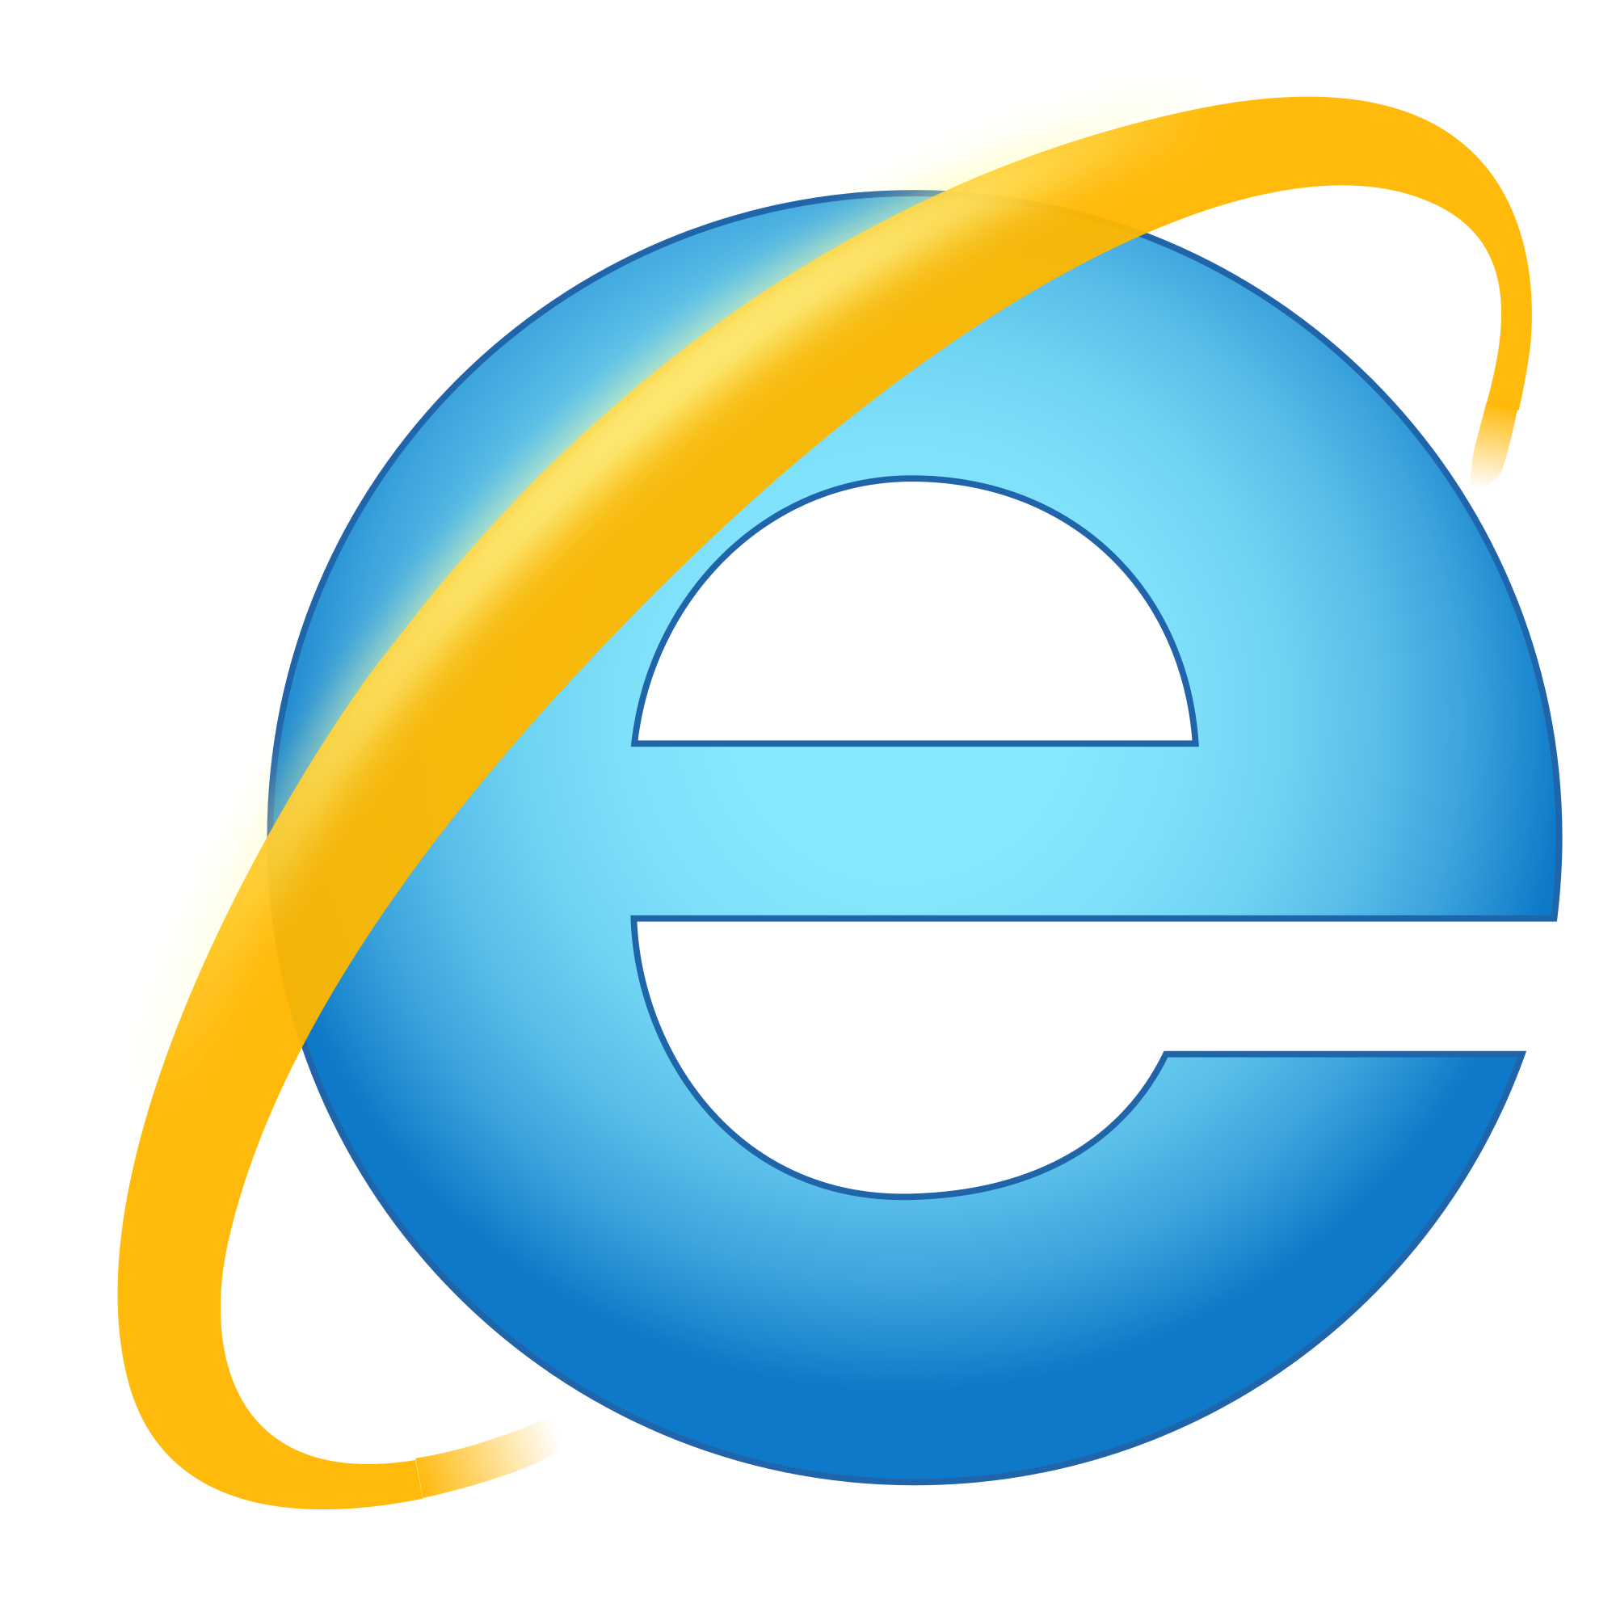
Microsoft Edge
Chrome | 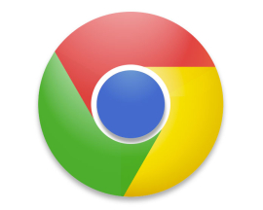
Safari (Apple)
Firefox
Some web pages ask or require that the user enter information—for example, if people want to buy something, they need to provide their shipping address and payment information. Web forms are used to enable users to provide such information. If the information provided is personal or private in nature, the web page usually uses encryption to ensure that the information entered into the form cannot be viewed by someone else if it is intercepted. To assure the user that the website is legitimate, a security certificate is sent from the website to the web browser. You can explore the security certificate by looking at the security options of your web browser.
Troubleshooting Problems Loading Web Pages
When you navigate the World Wide Web, you are likely to encounter some of the following problems. Note the solutions, and try them when you need them.
- Web page displays incorrectly: Click the Refresh or Reload button to reload the page. If this doesn’t help, the problem could be with the web page itself.
- Page not found: Check to see whether you typed the address correctly. If you clicked a hyperlink, the URL specified in the link may be wrong or out-of-date. Try searching for a similarly named site in case the original address was changed or discontinued.
- Server error: In some cases, the server may not be available or may generate an error page indicating a problem with the page you are attempting to access, not the URL you have entered.
- A long delay when you try to access a web page: Be patient; complex pages or pages with lots of graphics may take longer to load. Also, try doing your research at off-peak times when there is less Internet “traffic” (in other words, when fewer people are online). If too many people try to access the same page at the same time, delays in loading the page and error messages are likely.
- Advertisements continually pop up in your browser: Browsers have features for blocking unwanted pop-ups. You can also add on computer security programs specifically created to handle this annoyance. Most of these programs are free. Pop-ups can also be a sign of a malware infection on your computer.
Using Search Engines
You can find information on the web in lots of ways. One of the easiest ways is to use a search engine.
A search engine is a service that allows a user to enter keywords or phrases related to a topic to retrieve a list of websites with those keywords. Google (http://www.google.com/) is the largest search engine on the web today. Globally, as of October 2013, Google had 83% of the query volume, followed by Yahoo! with 9% and Microsoft Bing with 6%. Many of the features of different search engines are very similar. It is worth trying a few of them out to see which one you prefer.
Some search engines do nothing but search other search engines. These are called metasearch engines. They search several individual search engines and their databases of web pages simultaneously. Dogpile (http://www.dogpile.com/) is an example of a metasearch engine. It gives you search results from Google, Yahoo!, and other major search engines.
Keep in mind that search engines do not discriminate between reliable sources and outdated or inaccurate sources. Always evaluate your search results carefully. Also remember that search engines may provide you some links that do not match your search terms.
If you find you are not getting the results you want or you get too many results that are not really about your subject, use a plus sign (+) between the words you enter in the search box. This tells the search engine that all the words must be included in the pages it presents to you. Or, you can put quotation marks around your search words; for example, “American revolution”, which tells the search engine to find pages with that exact multiword term.
Using Wiki Sites
There are other sites that offer content other than hyperlinks. They are not search engines in the traditional sense, but they also can be useful for research. For instance, Wikipedia offers content written by the public on any number of topics, while Wikimedia offers multimedia files that are either in the public domain or available under educational licenses. Because wiki sites are created and edited by users just like you, you’ll need to verify any information you get from them.

Student Resource 3.2
Exploration: Browser Features
Student Name:_____________________________________________ Date:_________________
Directions: Read the information in the left column and follow the directions. Use the right column to record your notes and answers.
Information and Directions | Steps, Notes, and Answers
1. Using the browser available on your school computer, access the World Wide Web.
What is the name of your browser? What does the icon look like?
2. Look at your browser’s menu bar. Click each menu to see what tasks you can perform.  Based on the options you see, summarize the general purpose of each menu.  Note that how the menu is set up and what the options are depends on which browser and browser version you are using. If you don’t see the menu choices listed here at right, replace them with the menu choices you do see, or add additional menu items. In Chrome, for example, all menu items are accessed through a menu icon. | File menu:  Edit menu:  View menu:  Favorites or Bookmarks menu:  Tools menu:  Help menu:
4. Every computer on the Internet has a unique address. Likewise, every document on the Internet has its own electronic address called a uniform resource locator (URL). On the web, URLs most often begin with http:// or https://.  Near the top of your screen is the address field, also called the address bar. | Write the URL of the page that is currently displayed in the address bar.
5. On either side of the address bar, there are several small icons you can use to navigate.  Look for the following icons, and note what happens when you click each of them. (When you position your mouse pointer over each icon, a small text box gives the name of the icon.) | Back  Forward  Refresh  Home  What other icons do you see?
6. If you know the web address of a site you want to visit, you can type that address in the address bar. If you do not know any web addresses, type the following address, and then press the Enter key: http://www.about.com/.
List the name of the site you visited in the box to the right. Then write a one- or two-sentence summary of what the site does.
7. Most sites have a primary page, called a home page, that displays when you enter the home page URL. If the URL you just accessed was a home page, the page probably contains lots of links to other web pages.
Look in the address bar and see if a file name such as index.html has been added to the URL. If so, write down the full URL.
Move your mouse pointer around the screen and note what happens. Then list some characteristics that usually indicate links.
8. For sites you plan to use often, you can set up a Favorites or Bookmarks list in your browser. This saves time because you won’t have to type the URL each time you return to the site.
In your browser’s address field, type the address for Google: http://www.google.com/
When the Google home page appears, try to figure out how to create a new Favorites or Bookmarks folder named Search Engines. Then add Google (your current page) to the new folder.
Write down your notes about how Favorites or Bookmarks work with the browser you are using.
Student Resource 3.3
Note Taking: Evaluating the Reliability of Web Pages
Student Names:_____________________________________________ Date:_________________
Directions: As you read Student Resource 3.4, Reading: Evaluating the Reliability of Web Pages, use the chart below to write down the important questions you need to ask yourself when you are evaluating whether a web page is a reliable source. Ask your teacher any questions you have about the examples given for you below. You will use your list of questions to evaluate some web sources later in the lesson.
Criteria | Questions to Ask Yourself
Authority | Example: Is the author’s email or contact information included?
Accuracy | Example: Does the site have the correct dates for events and correct names of people, places, or organizations, and does it have the same facts as other sites or knowledge that you have?
Objectivity | Example: What is the author’s point of view?
Up-to-Date Information | Example: Can you find a last modification date on the page, or some other indication of when the content on the page was last updated?
Value

Student Resource 3.4
Reading: Evaluating the Reliability of Web Pages
The web is constantly growing. No one knows for certain how many web pages exist, although it is likely more than a trillion. This means that when you turn to the web for research, you are facing over a trillion sources of information. How do you know which sources are reliable and which aren’t?
Evaluating the reliability of web pages is a skill that you will develop over time as you do research on the web. Figuring out if a web page is reliable involves considering several major issues.
Authority: Who Authored the Web Page?
Figuring out who wrote the content (that is, the text and other information) on a site is one of the most important things to consider when determining reliability. The author may be an individual, a group of people, or a company or organization.
- A page or site can be created by a person, a company (home pages of these sites typically end in .com), an academic institution (.edu), a government agency (.gov), a nonprofit (.org), or the military (.mil). A page or site can also be created by someone from another country (e.g., .au for Australia, .fr for France). The domain or web address tells a lot about who created the page.
- A personal site doesn’t necessarily mean that it is unreliable. But if it is a personal site, you’ll want to make sure that the author has the appropriate qualifications.
- Check to see if biographical information about the author is included. Look for the author’s email address or other contact information. Some sites have an About page that gives information about the author.
- Consider what expertise the individual or group that created the content has and if it makes sense that the author wrote about the topic.
- Check to see if the site contains references to support the content.
Accuracy: Are the Facts Accurate?
When you’re doing research, accuracy is critical. You don’t want to use web pages that give you false information.
- Consider if the facts are accurate. Think about where you can look to verify the facts that are given on the web page.
- A web page with a lot of errors is likely not a trustworthy source. Look to see if the web page is free of errors like misspellings or typos or grammatical mistakes.
Objectivity: What Is the Purpose of the Web Page?
Consider why the web page was created. People create web pages to entertain, inform, educate, or persuade.
For example, a web page may have been created with the purpose of trying to sell a particular brand of hard drives. This page may be a good place to look if you’re interested in buying that brand of hard drive. But if you just want factual information about the most popular hard drives on the market, this is probably not the best source for you. The purpose of the page is to convince you to buy the hard drive, not to give unbiased facts about different hard drives.
- Consider why the author created the content on the web page, and what point of view the author has.
- Decide if the purpose of the web page is to provide educational or factual information, to entertain, to advertise or sell something, or to support a certain idea or point of view. Reading the mission statement or statement of purpose on the About page of the site can help you figure this out.
Up-to-Date Info: When Was the Page Created or Last Updated?
Consider the date on the web page. Particularly for IT topics, you want to avoid using out-of-date web pages for research.
- Figure out when the page was created or last updated and if it is current enough for your purpose.
- If you can’t find a date on the page, checking links is one way to determine how current a web page is. Avoid using a web page as a source if its links lead to pages that no longer exist.
- You might also determine the date of a page based on other information found there. For instance, if there are events listed, what is the most recent event? If there are prices, do they seem up-to-date or out-of-date?
- For IT topics, if you can’t find any information about when the page was written, you may need to find a different source.
Value: Is the Page Useful for Your Purposes?
Finally, you want to consider if the web page is valuable to you.
- Use web pages that provide you with the information that you need.
- Overall, if you don’t feel like you can rely on the web page for your research, find another page to use.
Student Resource 3.5
Evaluation: Web Page Reliability
Student Names:_____________________________________________ Date:_________________
Directions: Imagine that you have been assigned a research project in which you must write a biography of Mark Zuckerberg, one of the cofounders of Facebook. Below are five web pages that contain information about Zuckerberg. In the left column of the chart below, describe the information given on each web page. Then in the right column, answer questions about the reliability of the web page. You may use the notes you took during the reading (Student Resource 3.4) to help you. Check your work against the assessment criteria at the end of this resource.
Web Pages for Research:
https://www.facebook.com/zuck
http://en.wikipedia.org/wiki/Mark_Zuckerberg
http://www.britannica.com/EBchecked/topic/1371433/Mark-Zuckerberg
http://www.imdb.com/title/tt1285016/
Brief Description of the Web Page | Questions about the Web Page’s Reliability
Forbes web page | 1. Who authored the web page? How do you know?  2. Does the web page contain spelling or grammatical errors?  3. What is the purpose of the web page? (educate, inform, entertain, persuade)  4. Is the web page up-to-date? How can you tell?  5. Does the web page provide you with the information you need to write a biography?
Facebook web page | 1. Who authored the web page? How do you know?  2. Does the web page contain spelling or grammatical errors?  3. What is the purpose of the web page? (to educate, inform, entertain, persuade)  4. Is the web page up-to-date? How can you tell?  5. Does the web page provide you with the information you need to write a biography?
Wikipedia web page | 1. Who authored the web page? How do you know?  2. Does the web page contain spelling or grammatical errors?  3. What is the purpose of the web page? (to educate, inform, entertain, persuade)  4. Is the web page up-to-date? How can you tell?  5. Does the web page provide you with the information you need to write a biography?
Britannica web page | 1. Who authored the web page? How do you know?  2. Does the web page contain spelling or grammatical errors?  3. What is the purpose of the web page? (to educate, inform, entertain, persuade)  4. Is the web page up-to-date? How can you tell?  5. Does the web page provide you with the information you need to write a biography?
IMDb web page | 1. Who authored the web page? How do you know?  2. Does the web page contain spelling or grammatical errors?  3. What is the purpose of the web page? (to educate, inform, entertain, persuade)  4. Is the web page up-to-date? How can you tell?  5. Does the web page provide you with the information you need to write a biography?
Best Sources
Write a paragraph explaining which web pages you think would be the best sources to use to write a biography of Mark Zuckerberg. Give solid reasons and examples to back up your ideas.

Make sure your assignment meets or exceeds the following assessment criteria:
- The answers to the web page evaluation questions are clear and reflect the critical thinking necessary to evaluate whether resources are reliable for research.
- The paragraph explaining which web pages would be the best sources is sensible and demonstrates an understanding of the concept of web page evaluation.
- The paragraph explaining which web pages would be the best sources is well organized and provides at least one example.
- The assignment is neat and uses correct spelling and grammar.

