NAF Principles of Information Technology
Lesson 5
Inside the Box
Student Resources
Resource | Description
Student Resource 5.1 | Reading: Overview of a Computer System
Student Resource 5.2 | Reading: The Hardware Components of a Computer System
Student Resource 5.3 | Presentation Assignment: Inside the Box
Student Resource 5.4 | Culminating Project Launch: Designing a Dream Personal Technology System
Student Resource 5.5 | Project Planner Page 1: Planning a Dream Personal Technology System

Student Resource 5.1
Reading: Overview of a Computer System
Computers come in a variety of shapes and sizes and have lots of different uses. But in spite of their differences, all computer systems have four main aspects: hardware, software, data, and users.
Hardware
The mechanical or physical parts of a computer system are called hardware. Examples of hardware are a monitor or screen, a keyboard, a mouse or other input device (such as a touchpad), Bluetooth speakers or headphones, a printer, mobile devices such as a smartphone or tablet, and devices inside the computer case, such as memory.
You are likely to come in to contact with two main types of personal computers: laptops and desktops. Laptop computers (also called notebook computers) are portable and designed to be taken wherever a person chooses. They are typically quite thin and lightweight and have a built-in LCD screen, keyboard, speakers, and touchpad. Desktop computers are used in a fixed location. They consist of several parts, usually a CPU box (known as a system unit), a keyboard, a mouse, a monitor, and speakers. Both types of machines are powerful and can suit most users’ needs; deciding which to buy is simply a matter of personal preference.
These days, mobile devices like smartphones and tablets can be just as powerful as some of the latest laptop computers. It is important to know which of these devices sync easily with the rest of your system. Apple products, for example, are designed to work seamlessly with one another. An Apple MacBook Air laptop will pair with an iPad or iPhone with little manipulation from the user. By contrast, an Asus X551 laptop, for example, may have specific requirements to pair with a Samsung Galaxy phone or tablet. While most systems today can pair with any Bluetooth device, it’s important to research which devices work best with each type of hardware.
Software
Software, also called programs, is a set of instructions that tells a computer what to do. Some programs are designed to operate the computer itself, while other programs are designed to help people perform tasks on the computer, such as creating documents or drawing pictures.
Data
Data is the information that a computer inputs, processes, and stores, in the form of binary digits (0 and 1). A computer manipulates data by using software programs and provides users with the processed information in an organized form (output).
Data can be words, numbers, sounds, images, or animated images; no matter what the form, the computer converts this information to binary digits. Because the data is reduced to digits, we call it digital or digitized information.
The smallest unit of data a computer can use is called a bit, short for binary digit. A bit can have only one of two possible values: 0 or 1. A group of eight bits equals one byte. The 0s and 1s in a byte can be combined in 256 different ways. All of the characters on a keyboard, including upper- and lowercase letters, numbers, punctuation marks, and symbols, are easily converted into binary. For example, below is the greeting “Hello!” converted into bytes:
H 01001000
e 01100101
l 01101100
l 01101100
o 01101111
! 00100001
Character sets are systems for coding letters, numbers, and symbols in a way that computers can understand. The code used for the greeting above is called ASCII (pronounced “ASK-ee”), which stands for American Standard Code for Information Interchange. ASCII uses 7 bits (but stores each character in 8 bits, disregarding the first, or leftmost, bit). There are 128 variations of bits that are used in ASCII, which is enough for languages that use the letters A to Z to have upper- and lowercase letters, numbers, punctuation, and special symbols. But 128 variations is not enough to represent all the other characters found in languages like Greek, Hebrew, Arabic, Chinese, and so on. A system called Unicode solves this problem by using 2 bytes (16 bits) instead of 1 byte to encode characters. This results in more than 65,000 possible code variations.
Users
Users are the people who operate computer systems. You might say that some computers can operate without the help of people. Although that may be partly true, no computer is totally self-sufficient. At some point, people still have to write computer programs, enter data, and design, build, and repair the physical computer components. In addition, the computer has no goal or desire of its own. It is the user who instructs the computer of what to do and when.
Basic Actions Performed by a Computer System
A computer system changes information from one form to another through four basic actions: input, processing, output, and storage.
Input
Input is the data that is entered into a computer. Input can be letters or numbers or more complex items such as videos or music. Keyboards and digital cameras are examples of input devices.
Processing
A computer completing a task or tasks when following instructions in a software program is said to be processing. Computers can process data very fast, performing billions of operations every second. This is expressed as CPU speed in gigahertz (GHz).
Output
Output is the data produced by a computer after processing. Output can take many forms, such as text and/or images displayed on a computer screen or printed on a piece of paper.
Storage
When a computer saves data, we say it “stores” the information. Storage refers to media and devices used to record and hold data and program instructions permanently. A computer has two forms of storage: short-term memory that is used during processing, and long-term storage for permanence. When the computer is turned off, data in short-term memory is generally lost. This is partially why we also need long-term storage.
A byte is 8 bits, enough to store a single ASCII character such as the letter A, 01000001. Since a byte is such a small amount, storage and memory are usually measured using the units of measure listed in the following table. The exact size of these units depends on the context.
Unit | Abbreviation | Number of Bytes of Data (Computer Storage) | Number of Bytes of Data (Computer Memory)
kilobyte | K or KB | 1,000 | 1,024
megabyte | MB | 1 million (or 1,000KB) | 1,024² = 1,048,576
gigabyte | GB | 1 billion (or 1,000MB) | 1,024³ = 1,073,741,824
terabyte | TB | 1 trillion (or 1,000GB) | 1,024⁴ = 1,099,511,627,776
Disk storage capacities differ from memory capacities in that the units in disk storage are “rounded off.” For instance, 1MB of disk storage is literally 1,000,000 bytes while 1MB of memory storage is 1,024² or 1,048,576 bytes. This is shown in the above table, where you can compare how 1KB, 1MB, 1GB, and 1TB are expressed as an amount of disk storage versus main memory. The reason for this difference is that memory capacities are based on powers of 2 (1,024 is 2¹⁰ and 1,048,576 is 2²⁰) while disk storage is based on powers of 10.
Computers store different types of information on different types of hardware:
- Instructions and data the computer needs to use immediately to process information are stored in random-access memory (RAM). The amount of RAM a computer has helps determine how quickly it can work. There are two types of RAM. Static RAM (SRAM) is a faster but more expensive technology. Main memory, or dynamic RAM (DRAM), is used to back up the limited SRAM. DRAM is slower but far cheaper.
- Computers also have read-only memory (ROM). The ROM chip stores information in the computer that does not need to change, such as the information needed to load the operating system at start-up. It is read-only because its contents are permanent. And so, unlike the various forms of RAM, ROM never changes. But because the contents are permanent, it is a form of nonvolatile memory (it never loses its contents whether power is on or off).
- Data that you want to store, such as documents you create, images you have uploaded from your camera, or music you have downloaded, is stored on the computer’s hard drive or on an external device, such as an optical disc or a flash drive. You’ll learn more about these in Lesson 6.
- To get a better idea of storage capacities, the following table compares how much storage space you might need to store different types of data.
Size | Type of Data
1 bit | 0 or 1 (true/false, pixel on or off)
1 byte | A character or part of a number
1KB | A page of text
1MB | A small, compressed color image file or a modest-sized black-and-white image file, or a portion of a song file
1GB | Several CDs’ worth of high-quality audio or a compressed movie
1TB | A library of hundreds of movies

Student Resource 5.2
Reading:
The Hardware Components of a Computer System
To understand how computers process data, it is first important to learn what the major hardware components are and how they work. As you will see, the following components are closely interrelated, both in how they work and in their effect on computer performance.
The Motherboard
The motherboard is a flat piece of insulating material inside a computer on which electrical components are mounted. It is also known as the system board. Because the motherboard is the main circuit board inside a computer, it unifies all of the computer’s electrical pathways or circuits.
Most modern circuit boards have circuits that are “printed,” rather than hand-soldered, on one or both sides. Instead of wire, lines of copper or aluminum are laid into the board’s hard plastic surface through a process called photolithography. These metal lines are so narrow that dozens of them can squeeze into a single inch. There can be several layers of these metal lines separated by insulation layers so that the lines won’t touch each other.
Electrical components are either “seated” on circuit boards in sockets or attached to the surface by soldering. Sockets are preferred for items that are likely to be upgraded in the future, while surface mounting is used for components not likely to be replaced.
Motherboards have various slots and sockets so that other components can be inserted onto the motherboard. These include a CPU socket, memory circuit boards, and slots for expansion cards.
The Microprocessor (CPU)
The microprocessor is often referred to as the central processing unit (CPU), or “brain,” of the computer. The CPU is the computer’s main “chip”—a single piece of silicon etched with billions of tiny transistors. It can fit in the palm of your hand.
The microprocessor carries out instructions from software programs and the computer’s user. It also performs calculations and controls the flow of information through the computer system.
Types of CPUs
Each motherboard has a particular type of CPU socket. So, only a CPU that fits in that socket can be used on that motherboard. Some types of CPUs include Intel’s Core i5 and i7 chips and AMD’s A6 and FX chips. Both lines are made for Windows-compatible PCs. Apple computers use Intel processors. Mobile devices primarily use Intel and ARM processors.
How CPUs Affect Processing Speed
The design, or architecture, of a CPU chip is related to the number of instructions per clock cycle and the speed of its system clock. The system clock is a vibrating crystal that generates a steady stream of electronic pulses. In other words, the system clock sets the work pace for the microprocessor and other components. (Keep in mind that the system clock is not the same as the clock/calendar that keeps track of the time and date in the computer.) The CPU cache memory described later in this reading also affects the processing speed of the CPU.
A clock cycle or clock rate is the time it takes to turn the transistors in the microprocessor off and back on. Thus, the speed of microprocessors is measured in gigahertz (GHz), which are billions of cycles per second. The higher the system clock’s speed, the more instructions the computer can potentially follow per second. When purchasing a computer, though, keep in mind that the faster a computer can operate, the more expensive it usually is. Also keep in mind that a number of other factors will impact processor speed and thus the speed of the computer.
Multicore Processors
A multiprocessor system requires a motherboard with two or more CPU sockets. It tends to be more expensive than a system that can accept only one CPU chip. On the other hand, a multicore processor acts like a multiprocessor system, offering the same kind of increased performance advantages using a single chip with multiple processing “cores.” It requires only the usual single socket on the motherboard. Quad-core processors are very common, and more expensive six- and eight-core processors are also available.
Memory
The CPU contains basic instructions needed to operate the computer, but it cannot store software programs or large amounts of data. So, the computer uses “work areas” called memory where it can quickly “read” (retrieve) or “write” (change) programs and data while they are being used.
Types of Memory
There are two main types of memory built into a computer: ROM and RAM.
Read-only memory (ROM) contains data that can be retrieved but not changed. An example is the basic input/output system (BIOS) chip that contains the CPU instructions used to test and start up the rest of the computer hardware when the computer is first turned on. ROM is nonvolatile memory, meaning that it does not lose its contents when the power is off. ROM is required because the computer needs a start-up process, called the boot process, when it is turned on.
The primary type of computer memory is random-access memory (RAM). It has data that is volatile, which means it does not stay in memory when the computer shuts down. The information in RAM can be changed because RAM can be written to as well as read from.
All computers use RAM, but the type of RAM varies. Two types of RAM are SRAM (static RAM) and DRAM (dynamic RAM). The most common form of DRAM today is double data rate synchronous dynamic random-access memory (DDR SDRAM). It currently has three variants: DDR1, DDR2, and DDR3, with 3 being faster than 2, and 2 being faster than 1. Note that RAM is used not only by the CPU but by other hardware devices, too. For example, expansion boards such as video cards and sound cards have their own built-in RAM. An expansion board (also called an expansion card) plugs into an expansion slot. Expansion boards/cards are small circuit boards used to add extra functions or resources to a computer.
Cache (pronounced “cash”) memory is a form of SRAM. It is much faster than all forms of DRAM memory and is used in a slightly different way. Moving data between DRAM and the CPU is very time-consuming because DRAM is slower than the CPU. Cache memory is built into the CPU chip itself. The cache improves processing performance by storing the most recently used data and program instructions in its high-speed memory. The next time the CPU needs that same data or instructions, it finds it in the cache memory, saving the time it would have taken to “load” or access the data from DRAM.
How Memory Affects Processing Speed
Memory is one of the factors that determine the speed of a computer. Not having enough memory can slow down processing speed, because when memory runs out, the system needs to start storing and retrieving data from something called a swap file, which is located on the hard drive—and the hard drive is much slower than either cache memory or DRAM. The more memory a computer has, the more expensive it is. Although new personal computers come with a substantial amount of DRAM (measured in gigabytes), you can typically add more DRAM (although not usually SRAM). Modern computers typically have 8GB to 16GB of DRAM.
Storage Devices
The hardware components that read and write data to and from storage are called storage devices. Storage technology can be divided into three main categories: magnetic, optical, and flash. The main types of storage devices found in today’s computers are hard drives, solid state drives, and optical drives.
Hard Drives
The terms hard disk, hard disk drive (HDD), and hard drive are often used interchangeably. These terms refer to a group of thin, rigid, platters (disks) coated with a magnetic material that spin on a central spindle inside a sealed metal box. Although these disks can be made out of metal, they are more often made from some other substance such as aluminum, glass, or a form of ceramic. The magnetic coating allows the disk to retain magnetized information. A hard drive uses magnetic energy to write information on the disks. Because of this, be sure that you never place a magnet on or near your computer’s case.
Hard disk capacity today is measured in terabytes (one half TB up to 3TB or more). And keep in mind that whereas RAM memory is used for temporary storage, a hard drive is a permanent storage device. Most computers come with a hard drive inside the computer case. You can also purchase external hard disk drives to be added to and removed from your computer as needed.
Solid State Drives
A newer type of hard disk drive called a solid state drive (SSD) doesn’t use a spinning disk, magnetic energy, or any moving parts. It uses flash technology and stores data on integrated circuits. Solid state drives can load the operating system and application programs much more quickly and are more reliable than traditional hard disk drives. The tradeoff is that SSDs currently have a much higher price per gigabyte, and they don’t yet come in comparable sizes (5TB hard drives are now available, but SSDs don’t come bigger than 1TB). A similar type of drive that merges solid state drive features with those of a traditional hard drive is called a hybrid drive. These new types of drives are designed to speed up the slow response and slow data transfer of a traditional hard disk drive.
Flash memory is also used in flash drives, which are also called memory sticks or USB drives. This form of memory plugs in to your computer via a USB port, so it is removable and portable. Flash memory today is far cheaper than it used to be. A flash drive might cost as little as $15 for 32GB of storage space (which is probably twice as much storage space as your computer’s DRAM).
Optical Drives
Optical drives read and write data using lasers instead of magnetic methods. The common formats of optical disks today are digital video disc (DVD) and Blu-ray Disc (BD) drives. Most desktop PCs have either a DVD drive or a Blu-ray drive. Some laptops and notebooks do not have an optical drive, but you can purchase an external DVD or Blu-ray drive to connect to a laptop. Older computers have compact disc (CD) drives. Both DVD drives and Blu-ray drives can read CDs.
A DVD can store more data than a traditional CD and is also faster at reading and writing data. Blu-ray allows information to be stored at a greater density than is possible with the lasers used for DVDs. A DVD uses a 650-nanometer red laser, and a Blu-ray disc uses a 405-nanometer blue laser. The shorter wavelength of the blue laser enables a Blu-ray disc to store over five times more data per layer than a DVD.
There are several types of optical drives:
- DVD-ROM drives only read data (ROM stands for read-only memory).
- DVD-R drives can write data to a disc only once (R stands for record) but can read it many times.
- DVD-RW drives can write data to the same disc many times (RW stands for rewritable).
- Most Blu-ray drives can read CD and DVD discs as well as Blu-ray. BD-Rs can be written to once, whereas BD-REs can be erased and re-recorded multiple times.
Note that while you can erase files from a hard disk drive or flash drive one by one, erasing files from a DVD-RW (or BD-RE) disc requires erasing the entire disc at one time.
Expansion Cards
As you know, computers can be used to complete all sorts of tasks. To perform certain tasks, you may need to install an expansion card. Some of the more common expansion cards are video cards, sound cards, modems, and network adapters.
Different cards come in different sizes, so motherboards often feature expansion slots of different sizes, allowing almost any card to be plugged in to the motherboard to expand the computer’s capabilities.
Looking Inside a Computer
Look carefully at the following photographs to identify the computer hardware parts you’ve been reading about.
Inside the PC Case
This picture shows inside the case of a Dell OptiPlex 7010 MT computer.
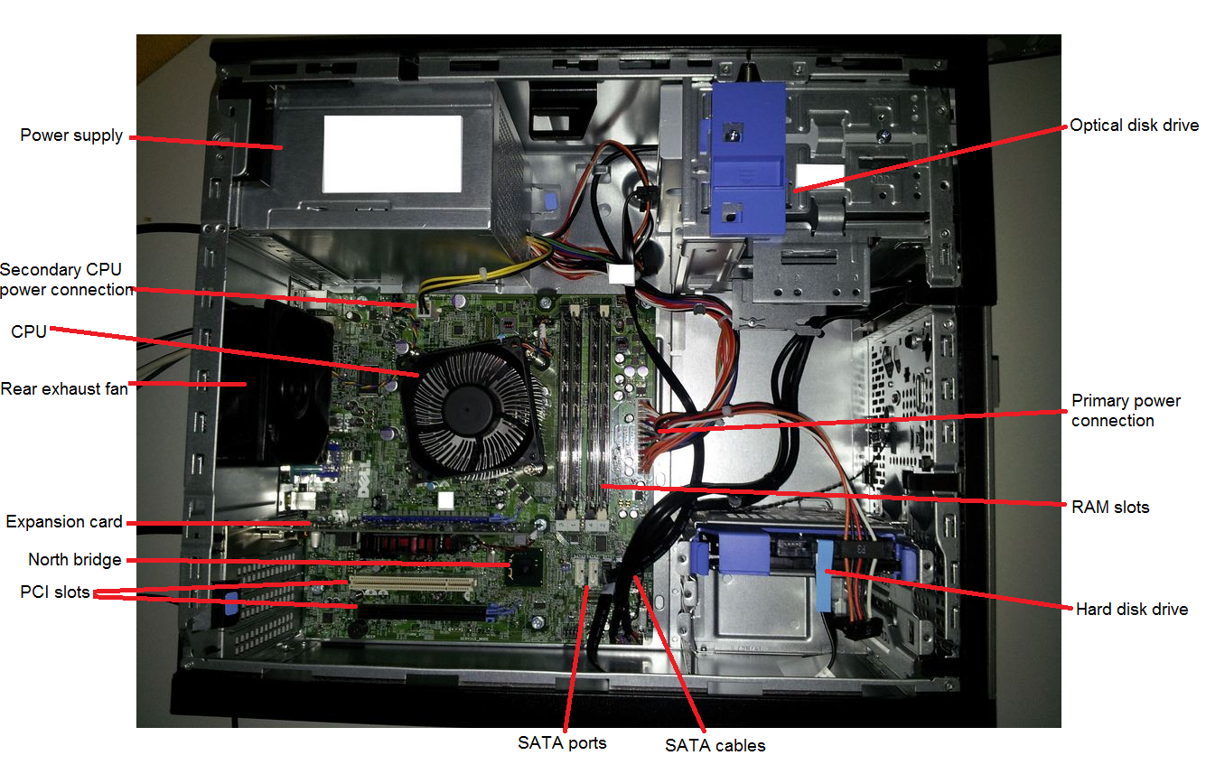
Note that the CPU itself is not visible beneath the CPU cooling unit, which sits on top of the CPU to keep it from overheating.
Image retrieved from http://www.rozmazat.cz/public/images/Dell-OptiPlex/Dell-OptiPlex7010MT.jpg and reproduced here under fair-use guidelines of Title 17, US Code. Copyrights belong to respective owners. Image courtesy of Libor Dušek.

Components of a Motherboard
These pictures show the components of a typical motherboard on the market in 2013.
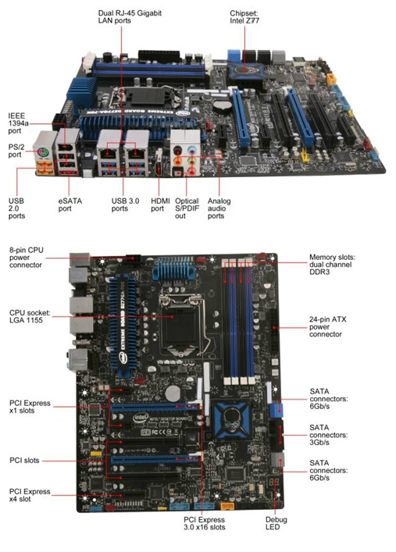
Student Resource 5.3
Presentation Assignment: Inside the Box
Directions: With your group, create a presentation that illustrates what you find inside when you open up a computer. Base your poster on the information you’ve gathered from your reading and from viewing the different components. Read through the assignment before you begin work, and make sure you understand how your work will be assessed.
Your presentation should include the following:
- An illustration of at least one example of each of the five hardware devices you have just read about (motherboards, microprocessors, memory, magnetic storage, and optical storage). Assign one device to each group member, or distribute the assignments as best fits your group makeup.
- A label that identifies each device.
- A sentence that explains the purpose of each device.
To make best use of each group member’s time, have each member draw one of the components and then neatly and attractively add it onto the presentation.
Each group member’s drawing should be accompanied by the purpose sentence that the person has written to explain the device’s use. Make sure that whatever you write would make sense to someone who knows nothing about computers.

Make sure your work meets or exceeds the following assessment criteria:
- The presentation’s graphic elements correctly illustrate a motherboard, a microprocessor, memory, magnetic storage, and optical storage.
- The components are labeled correctly.
- The presentation’s text accurately communicates the purpose of each component.
- The completed presentation is neat and uses proper spelling and grammar.

Student Resource 5.4
Culminating Project Launch:
Designing a Dream Personal Technology System
Project Overview
Before making a major purchase, it is a good idea to think about what you want, what you need, and how much money you have to spend. It is also important to research and compare the options available and then evaluate how well those options match your purchase criteria. Sometimes, you may not even be entirely sure of what you want or need before you start, and you will have to figure things out along the way.
Buying a personal computer system is a major purchase decision that deserves careful consideration. In this project, your group will design a dream personal technology system. You will begin by deciding the most important things you want your computer to be able to do. Video games? Graphic design? Web design? Blogging? Photography work? Music? What peripherals and mobile devices would help you round out your system, making it productive, functional, and fun? The exact kinds of hardware and software you need are tied to what you want to be able to do with your computer. As you work through each lesson of this course, you will analyze what you are learning and apply it to determining what your needs are for your dream system. For example, in this lesson, you will analyze what hardware you need for your computer. In Lesson 6, you will analyze what peripherals you need. For each analysis, you’ll fill in a project planning sheet documenting your needs. As you work through the project, you’ll compile these planning sheets into a report that you can refer to. Since you will have a generous but limited budget for your project, you will also need to keep track of how much the different parts of your system cost. You will do this using an Excel spreadsheet. Once you have gathered all of your information and completed your analysis, you will create a PowerPoint presentation featuring your recommendations for your dream system. You will present your dream system presentation to an invited audience and your class members at the end of the course.
Project Objective
The primary objective of this project is to answer the following question:
- How do we design a “dream” personal technology system that best meets a specific purpose and budget?
In the process of completing this project, your group’s goal is to design the right product and present it on time and at cost. You will have to balance these three main factors:
- Time: As with most projects, there is a limited amount of time in which to formulate your final design recommendations. The best way to meet your deadline is to work on each step of the project and do a thorough job on your project planning sheets in each lesson. Then when it comes time to create your presentation, you will have the information you need.
- Budget: Your group has a budget of $5,000 for this project. You will have to research how much hardware components and software packages cost, and in some cases, you may have to make hard decisions based on cost.
- The right product: You want to come as close as possible to addressing all of your group’s wants and needs. One good way to do this is to establish a set of priorities before making any firm decisions about your group’s dream system.

Project Tasks
As you work on your project throughout the remainder of this course, your group will perform the following tasks:
- Create a project planning sheet for each aspect of your computer, including:
  - Hardware and mobile devices
  - Peripherals
  - Application software (such as Microsoft Office)
  - Graphics and media software
  - Gaming and simulation applications
  - Networking hardware
  - Internet connectivity packages
  - Operating system
- Create a report in Microsoft Word that compiles your project planner pages. You will then analyze the content you have collected to determine the best choices for your system.
- To make sure you don’t exceed your budget, research component pricing and create a Microsoft Excel spreadsheet that details your costs.
- Design a PowerPoint presentation featuring your recommendations.
- Present your proposal to an audience of information technology professionals, NAF advisory board members, class members, school administrators, and family members at the end of the course.
Project Assessment
There are four main assessments for the project:
- Your project planning report will be assessed at the end of the project using assessment criteria.
- Your Excel spreadsheet will be assessed at the end of the project using assessment criteria.
- A reference sheet you create as a tool for putting together your dream system PowerPoint presentation will be assessed using assessment criteria.
- Your dream system PowerPoint presentation will be assessed using a rubric.
Student Resource 5.5
Project Planner Page 1:
Planning a Dream Personal Technology System
Student Names:____________________________________________________ Date:_________
Directions: This is the first page of the project planner that you will use to help plan your group’s dream personal technology system. In future lessons, you will add additional project planner pages to describe items such as an operating system, productivity software, and the software you need for activities such as creating graphics or listening to music. Be sure to keep track of all your project planner pages for the remainder of the course. Your group will collect and submit these resources at the end of the project.
Answer the questions below to identify and plan the hardware components of your dream personal technology system. Note the factors (such as processor speed, ease of use, type of graphics card, compatibility of mobile devices, and so on) to keep in mind while designing the system, and consider your group’s stated purpose when making choices.
When describing the hardware you would choose, don’t worry about specifics such as model numbers, the exact amount of RAM you’ll need, or hard drive size. You will be able to return to this later and make specific decisions about these elements as your other plans for the system take shape.
What this computer system will be used for:

Given how we plan to use our dream system, what do we need to consider about the following?
- Speed (e.g., type of processor):

- Reliability (e.g., durability of components, susceptibility to viruses, and so on):

- Cost comparisons:

- Ease of use (e.g., user friendliness of the system):

- Graphics and streaming media capabilities:

Hardware we need to purchase (including possible mobile devices like smartphones and watches, or tablets):

Why we made these choices:

Additional notes:

