NAF Principles of Information Technology

Lesson 8

Graphics, Multimedia, and Games

Student Resources

|  |  |
| --- | --- |
| Resource | Description |
| Student Resource 8.1 | Media Product Analysis: What Are Your Impressions? |
| Student Resource 8.2 | Reading: Working with Graphics |
| Student Resource 8.3 | Reading: Desktop Publishing Basics |
| Student Resource 8.4 | Flyer Assignment: Creating an Invitation Flyer |
| Student Resource 8.5 | Reading: Introduction to Multimedia and Computer Games |
| Student Resource 8.6 | Reading: Making Presentations That Get Attention |
| Student Resource 8.7 | PowerPoint Slides: Culminating Project Presentation |
| Student Resource 8.8 | Project Planner Page 4: Planning a Dream Personal Technology System |

Student Resource 8.1

Media Product Analysis: What Are Your Impressions?

Student Name:\_\_\_\_\_\_\_\_\_\_\_\_\_\_\_\_\_\_\_\_\_\_\_\_\_\_\_\_\_\_\_\_\_\_\_\_\_\_\_\_\_\_ Date:\_\_\_\_\_\_\_\_\_\_\_\_\_\_\_\_

Directions: Answer the following questions about the media representation/product (advertisement, brochure, commercial, etc.) chosen by you or your teacher. Work with your group to identify the ideas behind the decisions that were made in its creation. Use correct English and complete sentences.

1. What is the key point (or points) that the media product is trying to express?

2. What are the emotions or the general “tone” depicted?

3. Why do you think the producers of the media chose these particular images?

4. What visual layout or sequence was used?

5. Were any icons or logos used? If so, what do you think they are meant to represent?

6. Based on your answers above and where the media product was found, who is the probable target audience?

Additional notes and thoughts:

Student Resource 8.2

Reading: Working with Graphics

# A graphic is a visual presentation used to inform, illustrate, or entertain. Graphics often combine text, illustration, photographs, and color. Examples include a photo, logo, map, chart, symbol, and diagram. The following are examples of graphics:

|  |  |
| --- | --- |
|  |  |
| **Logo graphic:  Combining color, shape, and type** Images included under fair-use guidelines of Title 17, US Code. Copyrights and trademarks belong to respective owners. | **Map graphic:  Combining color, shape, and type**  This image included under fair-use guidelines of Title 17, US Code. Copyrights belong to respective owners. |
|  |  |
| **Photographic graphic:  Combining photo, color, shape, and type** This image included under fair-use guidelines of Title 17, US Code. Copyrights and trademarks belong to respective owners. | **Diagram graphic (aka line-art graphic): Combining shape and type**  This image included under fair-use guidelines of Title 17, US Code. Copyrights belong to respective owners. |

Technical Considerations When Creating Graphics

Color Model

When you are creating computer graphics, you must choose a **color model**, or color range. A color model tells devices using your graphic how to show the colors you selected for your design. The two most important color models are RGB and CMYK:

* RGB, which stands for red, green, and blue, is used to display color on scanners, digital cameras, and computer monitors. In addition, desktop, digital, and other printers usually print RGB images without problem. In most day-to-day personal, academic, and business applications, RGB is typically used because it’s the most common color range in the digital space.
* CMYK, which stands for cyan (blue-green), magenta, yellow, and black, is used in commercial offset, four-color printing. When your end product is going to be printed in this manner, graphics must be created as (or converted from RGB to) CMYK images.

Resolution

**Pixels per inch** (ppi) refers to the number of pixels on a linear inch of an image when the image is viewed on a monitor. A pixel is the smallest piece of information in an image. The more pixels per inch, the higher the resolution. An image with a higher resolution will look sharper.

**Dots per inch** (dpi) refers to the number of dots on a linear inch of a **printed** image. Dots are the smallest piece of information that printers use. The more dots per square inch, the higher the resolution and the sharper the image. A dpi measurement is used only for printed images.

|  |  |
| --- | --- |
| This example shows an image with a portion greatly enlarged. The individual pixels are rendered as little squares and can easily be seen.  *Image retrieved from* [*http://commons.wikimedia.org/wiki/File:Pixel-example.png*](http://commons.wikimedia.org/wiki/File:Pixel-example.png) *on June 27, 2012, and reproduced here under the terms of the GNU Free Documentation License.* |  |

Make Sure the Resolution Is Correct for Your Project

The higher the resolution, the sharper the graphic will be. The lower the resolution, the more likely your image will appear fuzzy, jagged, and blurry. Two identical graphics can be the same size but look different if they have different resolutions.

* For web (on-screen) graphics, the standard is 72 ppi.
* For print design, resolution needs to be at least 300 dpi when the image is the actual size of the print.

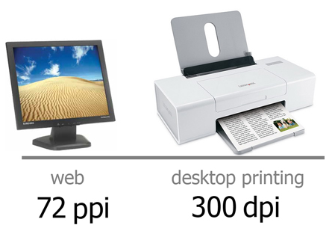

There are exceptions to these rules of thumb, but if you keep these basic rules in mind when you create graphics, you won’t be too far off.

File Size

File size is the amount of space your graphic takes up on your computer. Most graphics fall within the size range of kilobyte (also written KB or just K) and megabyte (MB or MEG or just M). The file size of a graphic depends on three elements:

* Graphic dimension when viewed at 100% on the screen. Two examples:
  + A friend sends you a photo that is 4 inches wide by 6 inches tall.
  + The YouTube logo on the YouTube site is about 1 inch tall by 1.5 inches wide.
* Graphic resolution, which refers to the number of dots/pixels per inch.
* Compression, which is a way to reduce file size. Two types of compression:
  + Lossy compression causes the file to lose image quality that cannot be restored.
  + Lossless compression does not diminish image quality, but it is not guaranteed to effect much, if any, reduction in size.

The larger the dimensions of the graphic and the higher the resolution, the bigger the file size will be.

File size is important, especially since more and more graphics are being used on websites. Graphics with big file sizes take more space on your computer and take longer to load on your web page for visitors to view. However, reducing file size too much can affect the quality of a graphic.

Balancing Quality and Transfer Speed

As you create and prepare graphics to be used, it’s important that you balance quality (determined by resolution) and transfer speed (determined by file size). Much of this balance comes from understanding how the graphic will be used. Here are some general rules of thumb:

* Graphics published on a website or sent via email typically have smaller dimensions and have a resolution of 72 dpi. This combination usually results in a file size that transfers quickly.
* Graphics you intend to keep on your desktop, share with friends via a thumb drive or other media, and/or print on a desktop printer should be at least 150 dpi. Base the dimensions of the graphic on the size that suits your project best (for example, chart, report cover, and so on). In this case, quality is more important than transfer speed, as sharing is less widespread than on a web page.
* Graphics you are having professionally produced by a commercial press or digital printing provider should be at least 300 dpi. Again, base dimensions of the graphic on the size that suits your project best (newsletter image, poster image, and so on). In this case, quality is most important because you’re investing money in a printing process, requiring graphics with very high resolutions for the best outcome. Additionally, transfer speed is less important because the files can be delivered on a flash drive or via FTP over the Internet.

The following are some examples of graphics that balance quality and speed based on how they are used.

|  |  |
| --- | --- |
| This image included under fair-use guidelines of Title 17, US Code. Copyrights and trademark belong to respective owners. | **Use: Web page  main logo**  Actual size:  276 x 110 pixels  (3.8 x 1.5 in.)  Resolution: 72 ppi  File size: 2.6KB  File format: GIF |
| _DSC0058_2 | **Use: Emailed photo**  Actual size:  288 pixels square  (4 in. square)  Resolution: 72 ppi  File size: 243KB  File format: JPEG |
| C:\Users\Natalie\Google Drive\Pearson\2015 Course Updating\Principles of IT_From Ingrid\__Fotolia\PoIT_Lesson8_page7_edited.jpg | **Use: Flyer to be printed on a desktop printer**  Size: Reduced to 10% of the original  1275 x 1659 pixels (8.5 x 11 in.)  Resolution: 150 dpi  File size: 8MB  File format: JPEG |
| sippy_2 | **Use: Print for photo album**  Size: Reduced to 25% of the original  2100 x 1500 pixels  (7 x 5 in.)  Resolution: 300 dpi  File size: 9MB  File format: JPEG |

Graphic File Formats

Once a graphic is created in a software application, you select a format to save it in. Most software applications will automatically save a graphic as an application file (for example, if you’re using Adobe Photoshop, it will save the graphic as “.psd”—a Photoshop file). This is fine if you’re not ready to use the file on the screen or print it out. However, when you’re ready to use the graphic, you’ll have to save the graphic in—that is, convert it into—a format that is supported by your end-use application.

A file format is simply a way to compress and transport the data that makes up the graphic. There are more than 100 graphic file formats. They differ in two ways:

* *How* they compress the data, which gets very technical very fast.
* *Which* applications are able to “use” the format. For example, web browser graphics are mostly JPEG, PNG, and GIF. Browsers cannot read most other file formats unless you first install additional plug-ins.

Common File Formats and Their Uses

| Format Full Name File Extension(s) | Application/Preferred Use | Real-World Example |
| --- | --- | --- |
| EPS  Encapsulated PostScript  .eps | Usually created using software specifically made for designing graphics, such as Adobe Illustrator.  Allows for enlarging images without loss of clarity. Ideal for print publishing use; not used on websites. | **Computer-generated graphics for print:** Graphic designers output their design as an EPS file so that it can be printed clearly no matter what the size—from keychain to billboard. |
| TIFF  Tagged Image File Format  .tiff, .tif | Usually created from a digital scan using a flatbed scanner or some other digital scanning device.  Ideal for print publishing use; not used on websites. | **Scanned images/photos:** Images and photos that exist only in hard copy are scanned into a digital format as a TIFF. The image can then be converted to another format. |
| GIF  Graphics Interchange Format  .gif, .gfa | Used for graphics, but not photos, on web pages.  Best viewed on-screen; not meant for print publishing. | **Graphics for the web:** Web designers output, or convert, a graphic to GIF to use it on a website and display it on-screen. |
| JPEG  Joint Photographic Experts Group  .jpg, .jpeg, .jpe | Used for graphics, including photos, on web pages. A very common format for photos taken from a digital still camera.  Best viewed on-screen; not meant for print publishing. | **Photos for the web:** Web designers output, or convert, a photograph to JPEG to use it on a website and display it on-screen. |
| PNG  Portable Network Graphics  .png | Used for graphics, but not photos, on web pages. An alternative to GIF and TIFF that provides some technical compression advantages.  Best viewed on-screen; not meant for print publishing. | **Logos for the web:** Web designers output, or convert, a logo to PNG to use it on a website and display it on-screen. |

Examples of Software Programs Used for Graphics Creation

Proprietary Software

This is a list of software available for purchase to create graphics with or without photographic elements.

|  |  |  |
| --- | --- | --- |
| Name | Ideal For | Approximate Cost |
| Adobe Creative Cloud (includes Photoshop, Illustrator, Fireworks) | Film, video, and multimedia professionals  Professional photographers  Serious amateur photographers  Graphic and web designers  3-D editing | Latest version (CS6) available as a Creative Cloud subscription ($20/month for student/teacher edition) |
| Adobe Photoshop Elements and Premier Elements 14 | Amateur photographers, movie makers, and graphic designers | $100 |
| Corel Painter 2016 | Amateur and professional graphic designers | $406 |
| Corel Painter Essentials 5 | Amateur graphic designers | $45 |
| Microsoft Paint | Beginning graphic designers | Part of Microsoft Windows OS |
| Microsoft Office Picture Manager | Beginning photographers and graphic designers | Part of Microsoft Windows OS (Windows Vista, 7, 8, and 10) |
| iPhoto | Beginning photographers and graphic designers | Part of Apple Macintosh OS |

Freeware and Open Source Software

These applications are free and available on the web. Before downloading, be sure to read carefully the rights and responsibilities associated with each application. Here are a few of the more popular ones:

* GIMP (<http://www.gimp.org/downloads/>) is an open source video editing program available for Windows, Mac, and Unix/Linux. *GIMP* stands for GNU Image Manipulation Program. It is similar to Photoshop.
* Paint.NET (<http://www.getpaint.net/download.html>) is an open source graphics program for Windows. Paint.NET has evolved from a replacement for the Microsoft Paint program (included with Windows) into a more powerful graphics tool, often used as an alternative to the costly Adobe Photoshop packages.
* Adobe Photoshop Express (<http://www.photoshop.com/tools>) is a free, web-based photo editor that allows you to crop, rotate, tweak, correct, and share photos on the following sites: Photoshop Express, Flickr, and Facebook.
* IrfanView (<http://irfanview.com/>) is a free graphics editor for Windows workstations.
* Inkscape (<https://inkscape.org/en/download/>) is an open source vector line drawing program available for Windows, Mac, and Unix/Linux.

Getting Started

Smart designers do some planning before they begin creating a graphic. They consider the following:

* How will the graphic be used? Will it be used beyond this one time? Graphics to be viewed on-screen via the Internet, printed in a Microsoft Word document, or printed in a high-end marketing brochure have different requirements (in terms of color, resolution, file size, and file format, as described earlier). In general, it is best to create a graphic in a large resolution and size. Then, when you’re ready to use it, you can downsize a copy of the graphic, matching resolution and dimensions to meet your specific need. If you take a small graphic and enlarge it, you’ll get a blurry result both on-screen and in print.
* Which software application should I use? What tools do I have? Which would be the best to create the highest-quality graphic? While most operating systems include some basic tool to create or edit graphics, using a more robust, professional one will result in a better, clearer, cleaner image.
* How will I distribute or transfer the graphic? Graphic files can very quickly eat up memory and disk space. Large graphic files are hard to share with others, can slow your computer processing speed, and eat up network bandwidth. It is important to balance the need to create a high-resolution, quality image with the amount of space such an image uses—especially if you plan to use the graphic anywhere else but the computer you create it on.

Student Resource 8.3

Reading: Desktop Publishing Basics

Desktop publishing (also known as DTP) combines inexpensive personal computers and page layout software to create a document. This document can then be sent to a commercial printer for millions of copies or to the office printer for 10. Additionally, you can save the document as a PDF file and electronically send it to others without ever touching a piece of paper.

Desktop Publishing Software

Let’s begin by understanding the difference between word processing tools and desktop publishing tools.

A word processor (WP), such as the popular Microsoft Word, is a computer software application used to compose, edit, format, and print (usually to a desktop printer) any kind of document. Examples include memos, letters, and school reports. Although they provide basic page formatting and allow some graphic creation and insertion, word processors focus on manipulation of text. Because WP tools are designed around a single element (text), trying to create a WP document with complicated graphics and formatting gets to be frustrating and rarely turns out looking professional. However, because WPs are used in a variety of fields, most people are familiar with how they work.

A desktop publishing tool is a computer software application that focuses on layout—that is, how a number of elements, such as text, graphics, photos, and other visuals, are positioned on a page or in a given space. To enable us to manipulate a variety of assets (text, photos, graphics, and so on), DTP tools treat each asset as a “layer.” A designer moves layers around the page to position them and indicates which layer should appear “in front” of another.

|  |  |
| --- | --- |
| This invitation has seven elements and, therefore, seven layers, which sit near or on top of each other.  The background layer is the light green rectangle. Sitting on top of that layer are the other layers. Notice on the far right, how three layers overlap: the brown tree sits on top of the slim dark green bar, which sits on top of the light green rectangle. | C:\Users\Natalie\Google Drive\Pearson\2015 Course Updating\Principles of IT_From Ingrid\__Fotolia\PoIT_Lesson8_page12-edited.jpg |

DTP tools require a fair amount of training and practice. People who specialize in the areas of graphic and web design typically use these tools, such as QuarkXPress, Adobe InDesign, Microsoft Publisher, and the free Scribus. If you are using Microsoft Office, you may already have Microsoft Publisher installed.

The term *desktop publishing* is commonly used to describe page layout skills. However, uses for DTP skills and software are not limited to books or even to paper. The same skills and software are used to create flyers, billboards, and T-shirts as well as online graphics used across the web.

Desktop Publishing Basics

1. **Consider the final product first.** In DTP, you must “start with the end in mind.” That is, you have to know exactly how your final file will be used so that you can set up the file appropriately *before* you begin laying out the document. Specifically, you need to know the following:
   * **Size.** Before you open your application, you need to know what the final size of your document should be. If it is going to be printed, are you creating a single letter-size document? Or a multipage newsletter? If your layout is for the web, you’ll need to know the exact pixel width and height.

|  |  |
| --- | --- |
| This ad, published on Amazon.com, is a fairly typical size for an online advertisement. It is 300 pixels wide and 250 pixels high.  This image included under fair-use guidelines of Title 17, US Code. Copyrights and trademarks belong to respective owners. | at&t |

* + **Printer.** If it will be printed, how will it be printed (large commercial printer or your desktop printer)? This is important to consider so that you don’t have to redesign your page later, which is time-consuming and frustrating. Knowing the printer, you’ll be able to determine the color model, image resolution, and other elements to ensure your design comes out the way you expect.

1. **Set guidelines and styles.** Professional desktop publishers define some general guidelines for their document, which include the following:
   * **Margins.** Well-designed documents don’t run images or text right up to the very edge. They leave an even space, or margin, around each edge. Margins vary depending on the size of the document but usually range from a quarter-inch to an inch. As a general rule, the larger the size of the layout, the larger the margin around its edges.
   * **Columns.** For some documents, you may also want to set up columns to guide your layout. For example, most newsletters have at least two columns, which make it easier on the reader to view large amounts of text.
   * **Color palette.** To create an attractive and well-organized visual document, designers usually limit the colors they use for text and graphics. Defining a specific palette of three to five colors before you begin speeds design as you lay out the document.
   * **Text styles.** To create a unified look, you’ll want to select one style (font, size, color, and so on) for headlines, another for body text, and so on. These visual cues help readers follow your document.

|  |  |
| --- | --- |
| Invitation within a desktop publishing application showing document edge, margins, colors, and type. | C:\Users\Natalie\Google Drive\Pearson\2015 Course Updating\Principles of IT_From Ingrid\__Fotolia\PoIT_Lesson8_page14_edited.jpg |

1. **Collect your components.** Next, you want to collect the components (also called **assets**) you’ll use in your layout. This includes images such as logos, photos, maps, and so on. It also includes the text you’ll use for headlines and body text.

|  |  |
| --- | --- |
| Layout Examples  Left: The cover of a newsletter. Finished size  8.5 x 11 in. Components include graphic logo, headline text, body text, abstract shapes, photograph, etc.  Right: Screenshot of InDesign application open to inside newsletter spread. | indesign_datasheet-2 |

1. **Create the layout.** Layout is the process of adding each component to the page in a precise and aesthetic way. Some DTP applications give you the option to use a template that has a professionally designed look and feel to it with places for you to “drop in” your image and text assets. These can be a quick and painless way to produce a newsletter or web page. A more customized approach is to place each item using your own sense of design. Many designers follow these conventional notions of layout, or composition:
   * Line: The visual path that enables the eye to move within the piece
   * Shape: Areas defined by edges within the piece, whether geometric or organic
   * Value: The lightness and darkness throughout the piece, characterized by tint, tone, and shade
   * Texture: Surface qualities, which translate into tactile illusions
   * Color: Hues with their various values and intensities
   * Direction: Visual routes, which take vertical, horizontal, or diagonal paths
   * Size: The relative dimensions and proportions of images or shapes to one another
   * Perspective: Expression of depth showing foreground, middle ground, and background
2. **Prepare the final file.** There can be a number of steps involved in preparing your final file. This step greatly depends on how your final layout will be used. Professional commercial printers will need other files in addition to your DTP file, such as fonts used and possibly original source photo images. Fortunately, most DTPs have a process to make prepping the file relatively easy.

Student Resource 8.4

Flyer Assignment: Creating an Invitation Flyer

Directions: Your group is working very hard during this course to prepare for your culminating project, the design of a dream personal technology system. As the course draws to a close, you and your classmates will have a chance to present your projects to the NAF academy advisory board, your fellow students, your family, and friends—but no one will know about the presentations if they aren’t invited. Using what you have learned about desktop publishing, design an eye-catching invitation to your culminating project presentation day.

Think of the following as you design your flyer:

* What is the event?
* Who is invited?
* When is it?
* Where is it?
* Why should people want to come?

Your teacher will tell you when and where the event will take place—or, if that has not yet been decided, you can include a placeholder, something as simple as “Month XX, 2016” or “Site Name Here.” You can save this version with a placeholder now, and then when you know the specifics, you can add that information before printing the final version of the flyer.

Think about the reading and discussions you’ve had in class about desktop publishing. Feel free to look at your notes and reading anytime while you are working on this flyer.

Keep in mind some basic tips:

* Create a background color for the first layer.
* Insert the graphic image that you have already prepared.
* Choose an appropriate font, and write your text on a third layer. Think carefully about the font color, size, and style that you use. You want to make the flyer interesting and eye-catching but also very easy to read.
* Be original! Being inspired by something is a good thing, but don’t copy a design you’ve seen used somewhere else. Be sure that the work you do here is entirely your own.
* Spell-check your work. It would be a shame to create a beautiful flyer with a spelling mistake in the middle of it.
* Have fun! Your enthusiasm will come through in your finished product and will make others feel excited about the event you are promoting.

Make sure your assignment meets or exceeds the following assessment criteria:

* The description of the event is accurate and shows understanding of what will go on at the event. Relevant details (who, what, when, where, why) have been included.
* The flyer uses at least three layers, with a background, a picture, and text.
* The flyer is original and creative—it is not a copy of some other flyer or poster design.
* The text, colors, and graphics in the flyer complement each other.
* The flyer is neat and uses proper spelling and grammar.

Student Resource 8.5

Reading: Introduction to Multimedia and   
Computer Games

Computers have given us many ways to share information and experiences. Unlike older styles of communication, which usually reach people through just one medium, multimedia has become the standard. *Multimedia* means using different kinds of media, such as text, images, audio, and/or video, to communicate or express ideas.

Think about places where you may have seen multimedia in use. Many websites use audio, video, and/or animation to go along with text. The PowerPoint presentations you have seen in this course are also a kind of multimedia, using images and text together.

Interactive multimedia lets viewers or users input data, which then alters the media’s output. A virtual reality computer game is an example of interactive multimedia.

Uses of Multimedia

You’ve already thought about several places where multimedia is used, but there are more uses for it than you may think. Almost all areas of communication now use some multimedia features.

Businesses use multimedia in lots of ways. Presentations, internal communications, and employee training are often delivered using multimedia these days. Businesses also like to use multimedia when communicating with the public, especially online. Websites and online ads often include audio or video.

There are also lots of educational uses for multimedia content. From encyclopedias to textbooks, many traditionally text-based educational tools have begun to use multimedia. Where a print edition of the *Encyclopedia Britannica* had entries that were text with occasional pictures, the online version mixes video and audio to go along with the words and pictures. Multimedia also allows teaching tools to involve many of the senses at once—for example, a flight simulator can incorporate video and audio, and a computer-based language learning program can show images and play sound to teach vocabulary.

The entertainment industry has also benefited from the rise of multimedia. Multimedia is used in everything from special effects to video games. As technology continues to develop, interactive virtual reality games will become more common.

Creating and Viewing Multimedia

Multimedia presentations can be made on almost any computer; all you need is the right software. Serious multimedia work requires several software and hardware components. A sound card is needed to play high-quality audio, but computers can also take inputs from several external audio devices for high-quality recording and playback.

You can create video using a digital video camera and then upload the footage to your computer using its FireWire port. Other media can be created directly on a computer using tools such as Flash and HTML5, which you can use to create animation or games. Online ad creators often use Flash and HTML5 to liven up the feel of a dry ad or to make an ad somewhat interactive. Once you’ve created your digital audio or video file, you can then use video and audio editing software to create your final file. Sony Movie Studio, Avid Media Composer, Audacity, and WavePad are just a few examples of popular editing software.

There are also many different software programs designed to play back multimedia content. Chances are that any computer you’ve used has had some combination of Windows Media Player, QuickTime, or RealPlayer installed. Each player is capable of handling several different kinds of multimedia files, but each one also has a special file type associated with it. As you create multimedia files, think about what kind of audience you want to view them. It may be best to use a generic file type such as MPEG-4 or use more than one special file type, such as MOV for QuickTime or RAM for RealPlayer.

Computer Games

Computer games might be the type of multimedia you are most familiar with. Although computer games were relatively rare and considered a hobbyist activity a few decades ago, electronic gaming today represents a multibillion-dollar industry in the United States. Gaming has grown to become a very diverse field, with thousands of unique titles meant to suit a number of different tastes. Dedicated game consoles such as Nintendo’s Wii U, Microsoft’s Xbox One, and Sony’s PlayStation 4 and a multitude of handheld gaming devices are extremely popular. Computer games also have uses beyond just entertainment and are sometimes used as educational tools.

Interacting with the Computer

Something common to all computer games is that the player interacts with the computer using different devices. The methods have evolved over time, but they are all used to transmit information between the player and the computer. Even the simplest handheld gaming devices are computers with specialized and customized features in the underlying microprocessor.

Inputs

A device that has been used since the beginning of computer gaming and is still used today is the keyboard. Because there are so many keys, a keyboard offers flexibility over how to control the game. In some games, each key might represent a specific action; for example, pressing the arrow keys might navigate a ship. With other games, the player might type keyboard commands; for example, typing *go north* might cause an on-screen adventurer to travel north.

Another device used commonly today for gaming is the mouse. In games where there is a graphic world to explore, it is common for movements of the mouse to change the perspective being displayed on the screen. Players can also use the mouse to control the mouse pointer, with the mouse buttons allowing interaction with whatever the pointer is selecting.

Some computer peripherals, called **game controllers**, are designed specifically for playing games. There is a wide variety of game controllers, and they have undergone many changes over the course of computer history. Most early game controllers were joysticks. Used with one hand, a joystick consists of a stick that pivots on a base and usually has a few buttons. Modern controllers, usually used with both hands, often have in excess of a dozen buttons, along with analog sticks, which are like mini joysticks. Some modern controllers are also capable of vibration and other tactile (or touch) responses. These are sometimes called **haptic feedback**. Certain games also use specific controllers; for example, a racing game might have a controller shaped like a steering wheel, and a dancing/rhythm game might have a controller on the floor that detects where you step.

Outputs

The computer also needs to communicate information to the player during the interaction of the game. Although monitor and speakers have been used almost exclusively for this purpose, the nature of the display varies depending on the game.

The earliest computer games used text to display information. In order to play, you read about your character’s situation and visualized the character’s environment. This type of output is the least taxing on computer hardware because displaying text is a simple operation.

Later, games began to use images to display what was happening in the game world. Two-dimensional   
(2-D) graphics allow representation of a game space—and allow for faster gameplay, since it takes significantly less time to interpret a picture than it does to read a page of words. Although 2-D graphics are definitely not the cutting edge of technology, it is still common for them to be used in games today. Some reasons a game might use 2-D graphics are that they are cheap to produce, they do not have heavy system requirements for the user, and they can achieve certain aesthetics easily. There are 2-D games for all modern computers.

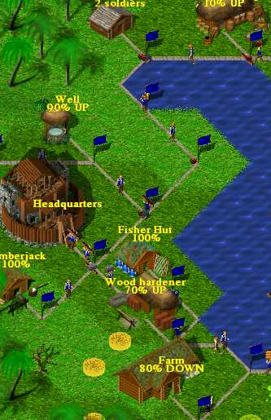

**This game uses 2-D graphics to display what is happening in the game world.**Image source: Wideland Developers (GPL license).

Three-dimensional (3-D) graphics are frequently used for modern games. These graphics allow a gaming experience that is closer to reality. Many 3-D games allow the player to explore the game world, giving the feeling that there is actual space associated with the game. But 3-D games can be very taxing on computer hardware. Games with realistic lighting, water, fire, and other effects require high-performance PCs to run. The job of rendering graphics to the screen falls to the video card, also called a**graphics processing unit** (GPU). Modern GPUs are designed for mathematically intensive operations and are more powerful and deliver higher performance than the CPU that runs all the other functions in the same computer. (Many supercomputers actually use GPU cores rather than CPU cores for high-speed mathematical computing.)

Games require a system with the power to run a video card properly. More basic, less complicated games can run with the components found in most computers. But the more demanding and complicated games can require a multicore 3 GHz processor, 4GB of RAM, and a video card with 1GB or more of onboard memory.

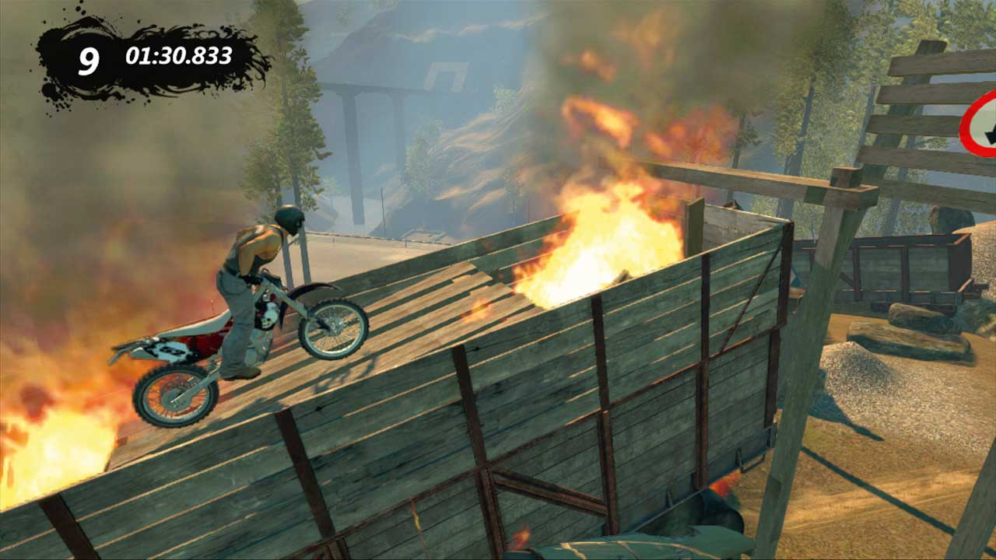  **This game world is displayed using 3-D graphics.**   
**The illusion of depth invites the player to explore the space.**  
Image source: Image retrieved from Trials Evolution Gallery, included here under fair-use guidelines of Title 17, US Code. Copyrights and trademarks belong to their respective owners.

Virtual reality is another output method. Virtual reality uses goggles instead of a traditional monitor, and the controllers are usually attached to the body. A player might wear gloves that communicate finger movements to the computer or might wear a vest that communicates when the player is leaning to the left or right. The goal of virtual reality is to immerse the player in the virtual world completely, more so than a 3-D game can. The game reacts to body movements in such a way that the character is performing the same actions in the game as the player is performing in real life. Virtual reality games have hardware requirements similar to those for games using 3-D graphics; the difference lies in the peripherals that are necessary to play a virtual reality game.

Types of Computer Games

Many different types of games exist, and some of the different genres are listed here. This section is not definitive; many games can’t be categorized easily because they contain elements from multiple genres. There are also many genres not covered here; this is only a basic overview.

**Action games** are probably what first come to mind when you think of computer games. They test a player’s reflexes and dexterity, because obstacles must be dealt with in real time. There is a great variety of action games; the only element that ties them together is the fast-paced gameplay. Action games are usually played by pressing buttons to command an on-screen avatar. An avatar might have to run, jump, and pick up objects in order to avoid obstacles and locate a door that allows the player to advance to the next level. *Super Mario World* is an example of an action game you are probably familiar with.

**Strategy games** are another common type of computer game. In these, players must make decisions that influence their level of success. Some strategy games also incorporate randomization or luck, and some integrate action elements by having choices come in quick succession. Strategy games usually give players an overhead view so that they can consider what is occurring and make a decision based on what they observe. Players usually interact with strategy games by selecting objects on the screen with a mouse pointer and then selecting actions for them. Chess is an example of a strategy game, although many computer strategy games are much more complicated.

**Role-playing** is a genre in which the player assumes the role of another person and dictates that person’s actions in the game world. In role-playing games, outcomes of events usually depend on attribute values assigned to the player’s character, not on the skill of the player. Also, there is almost always a large focus on the narrative of role-playing games, because the game is generally designed so that the player becomes drawn in to the story of the character he or she is controlling. Role-playing games are usually played by selecting an action from a list of available options for your character. This might include how to respond in dialogue or how your character will react to aggression from a rival. *Dungeons and Dragons* is a good example of a role-playing game.

**Puzzle and word games** are another common type of computer game. They are usually simple, where the objective is for the player to solve a problem or to identify words. Puzzle games are usually played by pressing buttons to manipulate objects on the screen. *Tetris* is a well-known puzzle game in which falling shapes can be rotated and moved left or right by the player. The objective is to arrange the shapes so that full rows form. Word games can help improve vocabulary and may involve rearranging letters to form as many words as possible or to identify words within a board of letters.

**Simulation** is a genre in which games try to re-create some aspect of reality. There are many types of simulation games, such as games where you run a business and attempt to maximize your profit or where you run a city to attract as many citizens as possible. There are flight simulators and racing games that simulate piloting a vehicle. There are even life simulators, such as *The Sims*, where you control a family of virtual people and monitor their social interactions. The large variety of simulation games leads to many different ways to play them. A racing game might be played like an action game, whereas a city-running game might be played like a strategy game.

**Multiplayer games** have become very popular, thanks to the proliferation of the Internet. In multiplayer games, the player interacts with other players, not just the computer. Multiplayer games act as a medium through which people can interact, sometimes competitively and sometimes cooperatively. Similar to simulation games, multiplayer games can be played in a number of ways.

Massively multiplayer online role-playing games (MMORPG) have become extremely popular with the release of games like *World of Warcraft*. These games combine elements of role-playing and multiplayer games, but they differ in that even when all the players sign off, the game world remains persistent. MMORPG’s usually require a monthly subscription to play, plus the cost of purchasing the game itself.

**Board games** and **games of luck**are games that are based on actual games such as Monopoly, Snakes and Ladders, or card games. Games of luck may involve gambling with real or fake money.

Beyond Entertainment

Mainly used for entertainment, games can be very fun—but there are other uses for games as well.

Some games are used for educational purposes, because it is very helpful for some people to learn with assistance from the interactive situations that computer games can provide. Word games can help students build a vocabulary. Math games can help reinforce mathematical skills even if the games are not overtly mathematical in nature. Other games, like Tetris, can help build spatial understanding. Hidden-object games can improve observational skills.

Some games are transparently educational; for example, a game may display equations, and the player must type in the correct answer as quickly as possible. Other games are more discreet: *Oregon Trail* is a game in which the player leads a family of settlers in a covered wagon across the United States. The player must make decisions about which path to take, what supplies to buy, and how to deal with obstacles. Through the course of the game, the player learns about pioneer life.

Many simulation games can also be important tools for professional training. A pilot in training might use a flight simulator to become comfortable with the basics of landing before undertaking the challenge of landing a real plane with no previous experience. Microsoft’s Flight Simulator, which was introduced with the original IBM PC in 1981 and has evolved with PC technology, is still considered one of the best flight simulators ever produced. It is now called Microsoft Flight. Similarly, a game that simulates the outbreak of a disease can be used to train health workers in how best to respond if the real situation should occur. The US military uses realistic battlefield simulations to train its troops for real-life combat.

Games are becoming more and more complex, with millions of dollars being spent on their development. In the future, we will likely see games become more advanced and more realistic, and the potential for what they can do—even beyond entertainment—will expand drastically.

Student Resource 8.6

Reading: Making Presentations That Get Attention

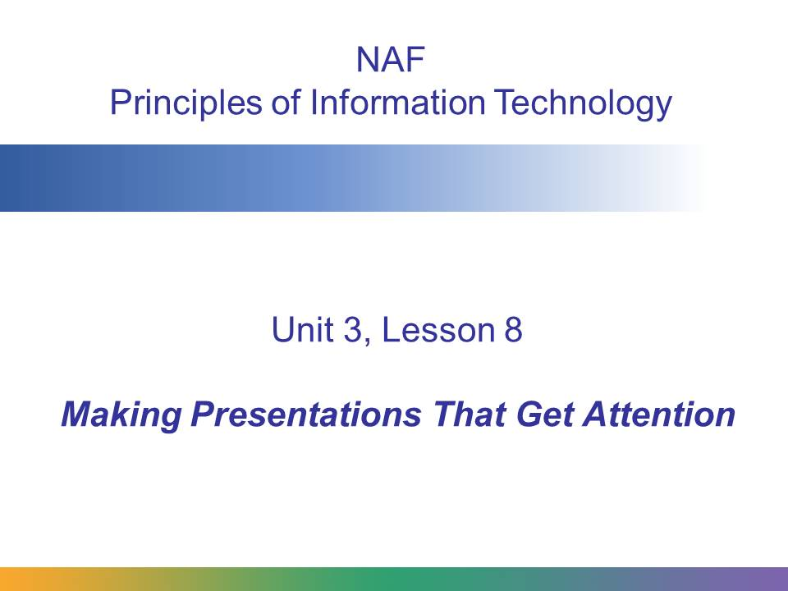

This presentation introduces:

* The purpose of presentations
* The use of PowerPoint presentations
* Tips for good presentations

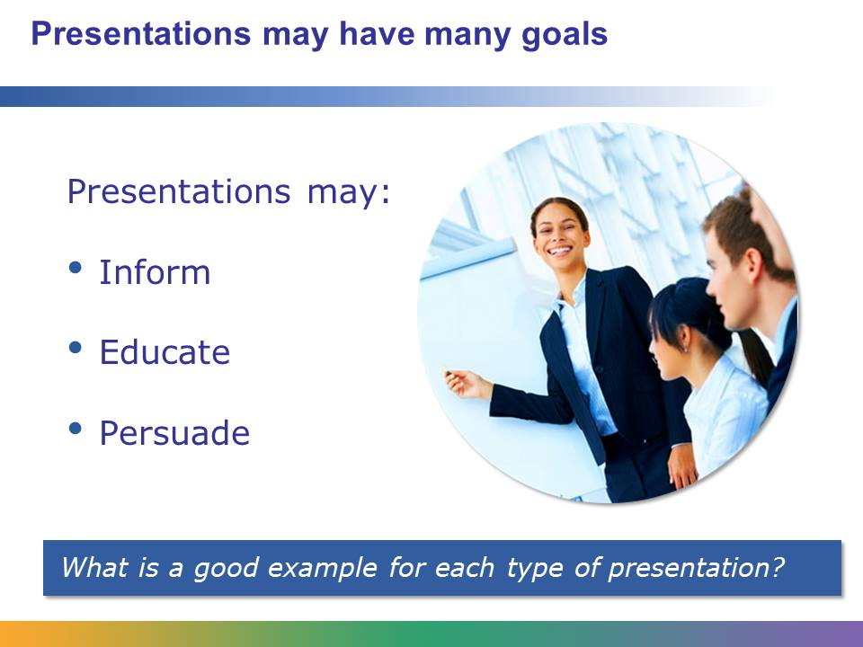

Making presentations is an important part of communicating with other people. You deliver presentations in school to teachers and other students. You’ll also present to people in a business context. Presentations can be delivered to just one person, to 500 in a large conference center, or to thousands of people over the web.

There are many reasons to give a presentation. The most common are to inform, to educate, and to persuade. Presentations can also entertain, or invoke introspection.

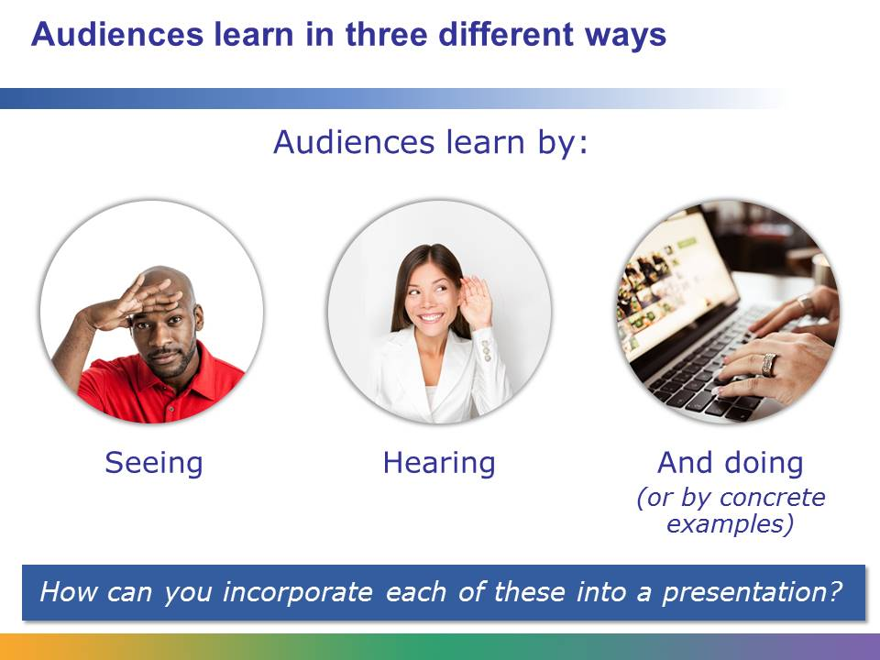

Good presenters understand that people learn differently. Some people learn best through seeing: words, or images on screen or in a book. Some people learn by hearing; still others by doing or by imagining that they’re doing through concrete examples. The best presentations try to balance what people hear, see, and experience during the presentation. This helps ensure that everyone in the room “gets” the point of the presentation.

This is why good presenters add visual aids that directly support what they will say during their presentation. Visual aids should guide, enhance, and reinforce.

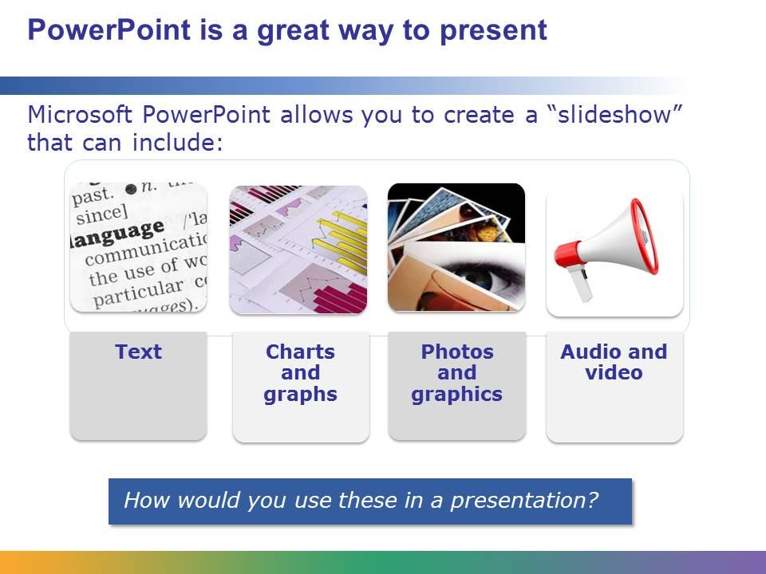

Microsoft PowerPoint is a powerful and widely used software tool for presenting information. It is part of the Microsoft Office suite of software tools.

PowerPoint uses a slideshow format. Usually, you create one slide for each major point or element in your presentation. You can shuffle the slides around and reorder them.

PowerPoint can incorporate a number of types of objects, including text, charts, graphs, photos, graphics (TIFF, JPEG, GIF, or PNG format), audio, video, and sound and video effects.

Once you’re done making your “stack” of content slides, PowerPoint makes it easy to polish and prepare for the actual presentation. We’ll learn about these steps next.

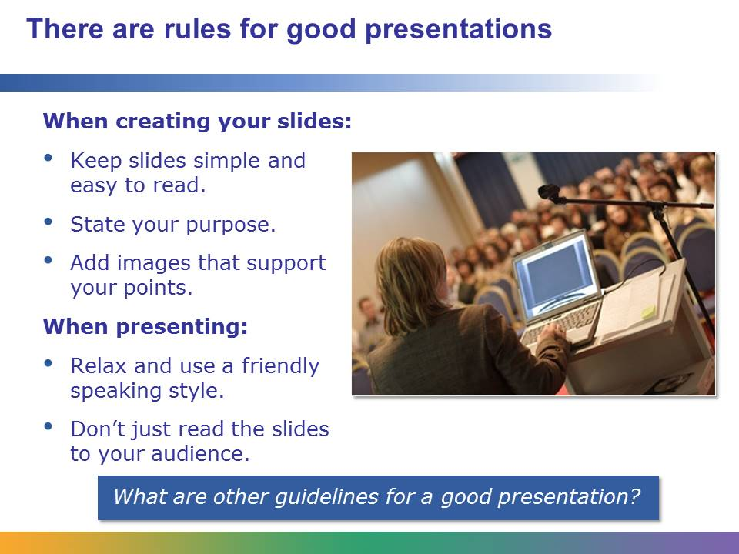

Let’s review some basic tips that make for a good presentation. These are five really important things to remember.

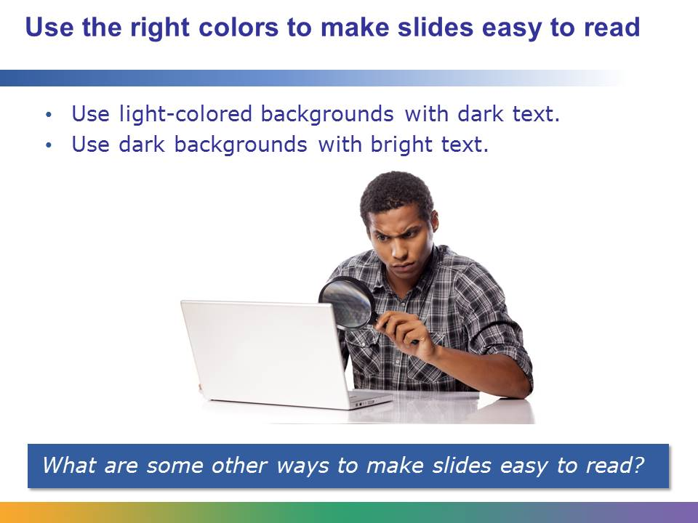

Slides do not help your audience if they are hard to read.

Contrast makes type easier to read. If the venue for the presentation will be dark, choose dark backgrounds with bright text.

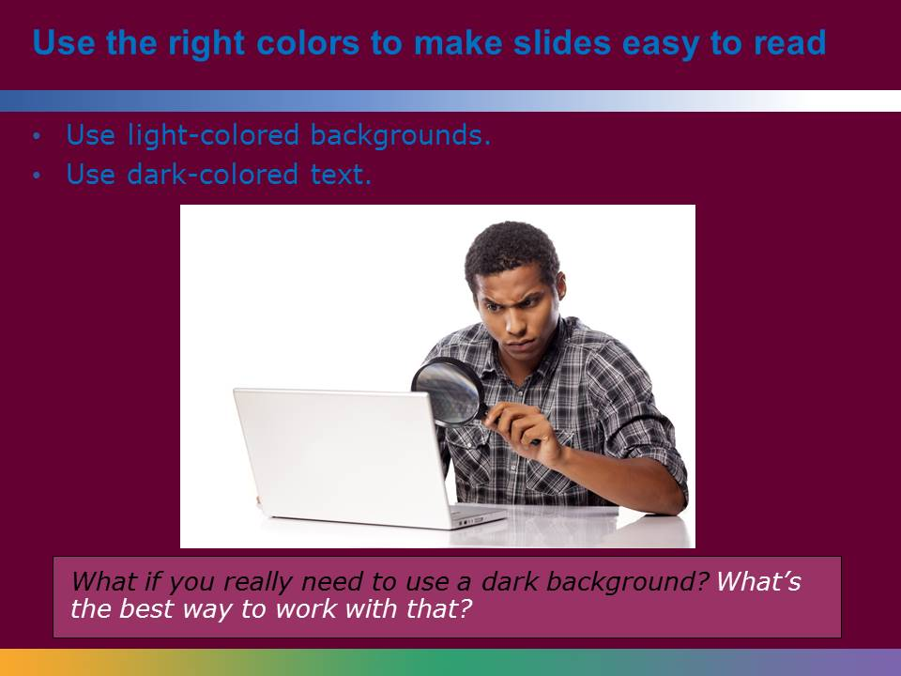

See what happens when the background changes to a dark color? There is less contrast and it’s harder to read.

But what if you really need to use a dark background? The best thing to do in that situation is to make the text light-colored or even white.

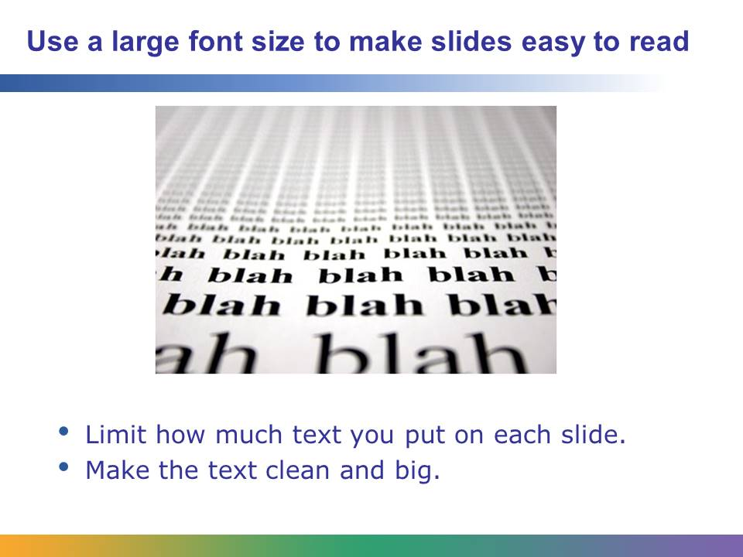

Next, make sure you don’t put too many words on a slide. Save the detail for your speaker notes. Just put the most important points on the slide.

Also, make sure that your font size is big enough for the people in the back of the room to read it—at least 20 points. And skip the fancy fonts that are hard to read. Use clean, clear typefaces.

Be consistent with your formatting. Don’t place the text in different locations on each slide (such as changing from left to right or center justification, or placing text above some figures and to the right of others).

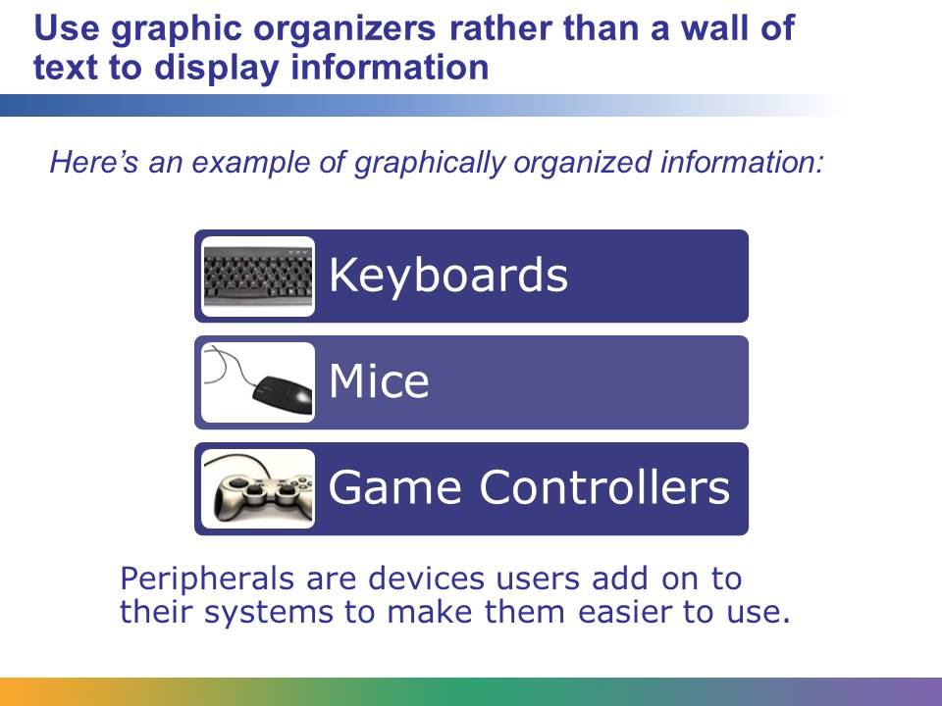

Notice how this slide has an informative title: a simple statement telling the main points of the slide and including pictures to ensure that the audience knows exactly what the speaker is talking about. Even if no one was presenting this slide, a viewer could look at it and learn what a peripheral is.

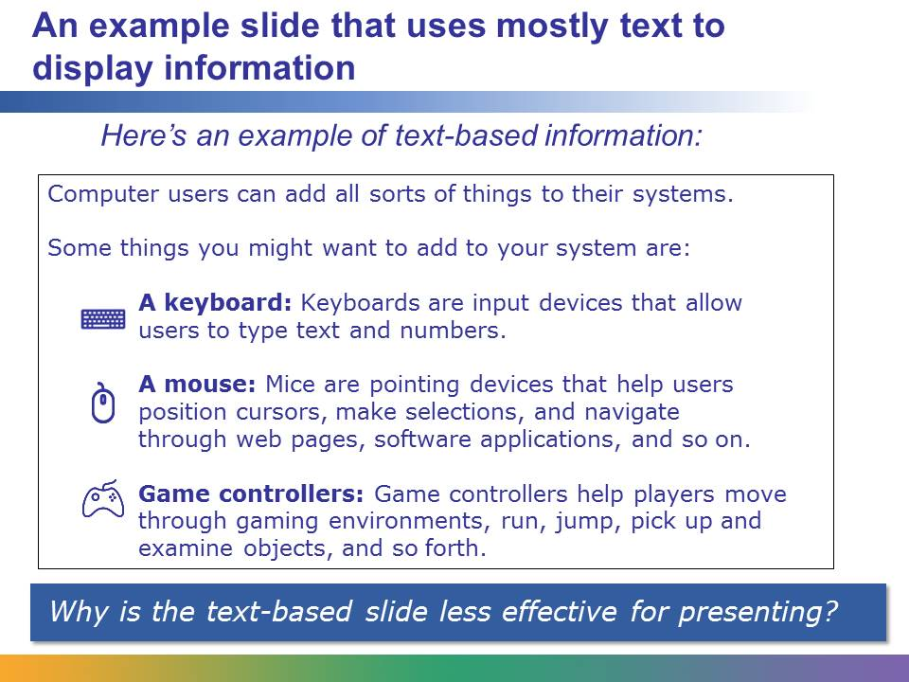

Now, consider this slide. It’s not at all user-friendly. What would make this slide more appealing to your audience?

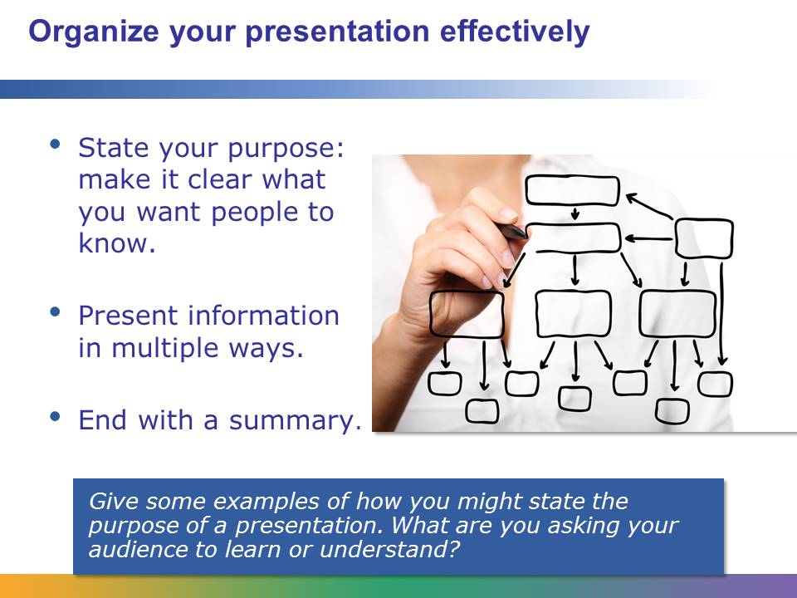

Good presentations are organized so that they’re easy for the audience to follow.

At the start, tell people what the purpose is of the presentation. What do you want them to know?

Remember that different people understand material in different ways. To emphasize important points, make sure they are listed on the slide and encourage the audience to take notes.

End your presentation with a summary of your points that directly relates to your presentation. Do not be afraid to repeat important information. Remember, people will leave the presentation with no more than three main points. Know in advance what three “takeaway” messages you’d like them to remember.

When you are done creating your presentation, use the slide sorter feature to organize the slides if any need to be moved to different places in the presentation.

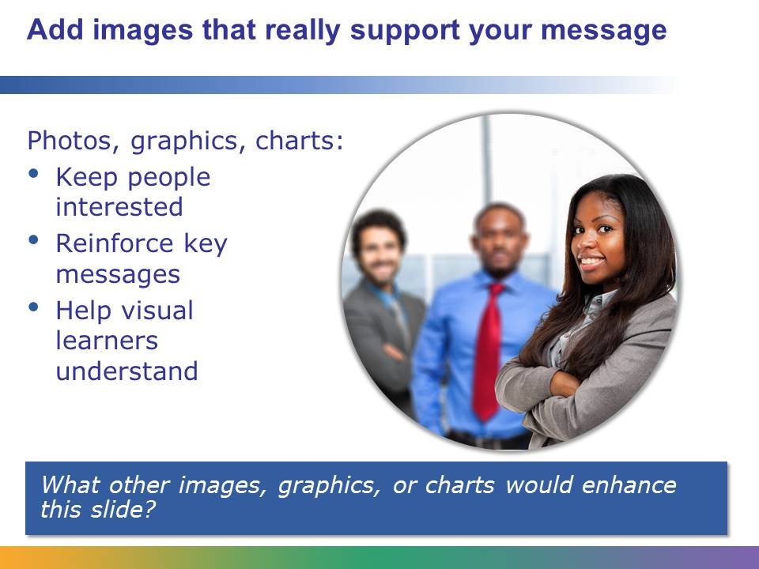

Use graphs and charts to illustrate numerical data; use pictures and clip art that enhance the information.

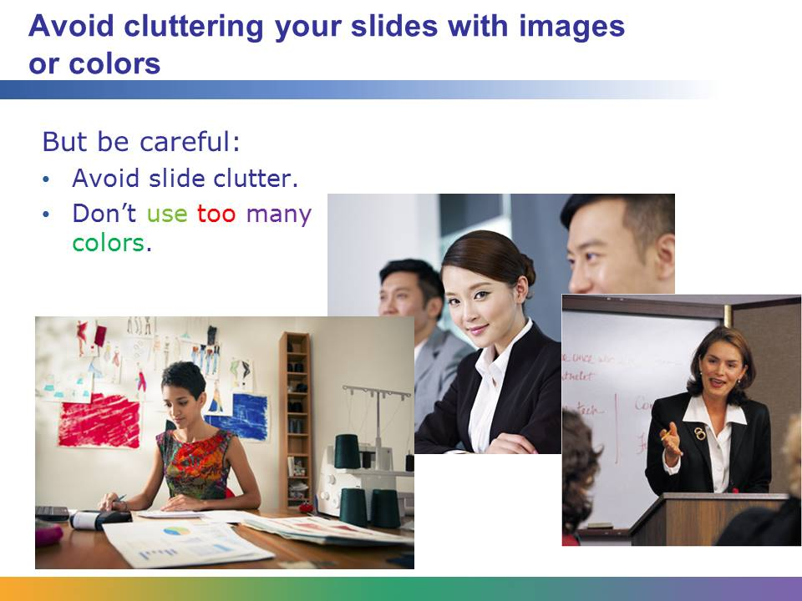

While it can be tempting to make slides with lots of graphics, fancy fonts, and animation, remember that the purpose of a PowerPoint slide is to convey information clearly. This slide is a perfect example of excessive image use.

Also remember that images can have large storage requirements, which then increase the storage requirements of your presentation. Fewer images will take up less disk storage space. Clip art and JPEG images take less space than bitmaps.

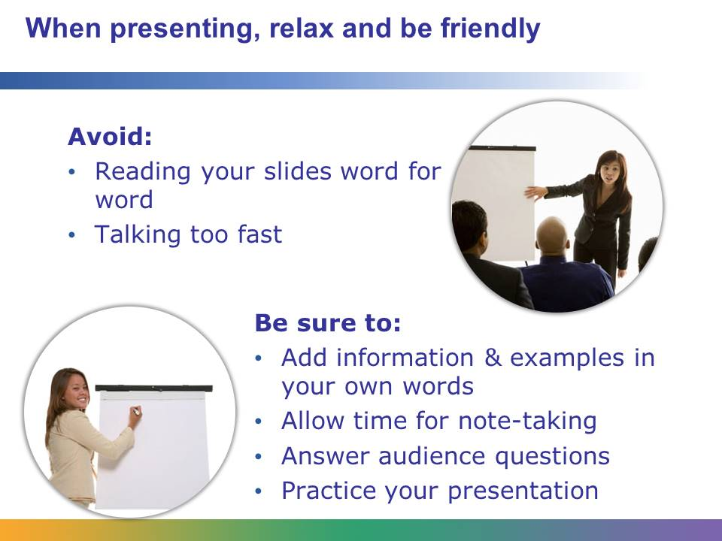

How you give your presentation is just as important as what your presentation is about. It’s important to relax and be friendly. Look at the two women in the photos. Which one would you rather listen to?

When you give your presentation, remember to:

* Use your own words—don’t just read the slides.
* Slow down and breathe in between each statement.
* Pause after each slide to give your audience time to take notes.
* Ask your audience, “What are your questions?” instead of “Do you have any questions?” after each slide. Often when we ask, “Do you have any questions?” people automatically say no. Also, if you have time, you can ask your audience to share information that will enrich the discussion.
* Good presenters practice their presentation with slides in front of at least one other person before their big day. This will help you relax and feel comfortable in front of an audience discussing your topic.

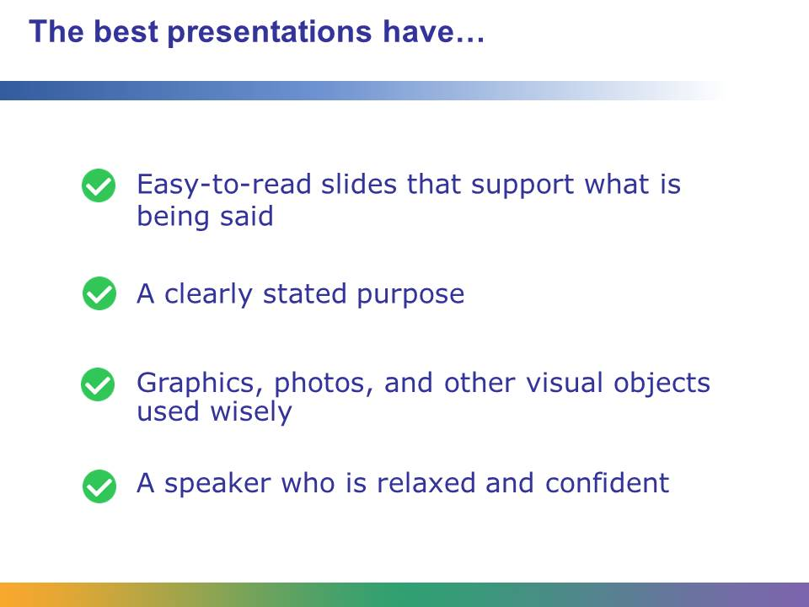

In summary, a good presentation:

* Has slides that are simple and easy to read
* Begins with a stated purpose or objective
* Includes appropriate graphics, photos, and other visual elements
* Is given by a confident and well-rehearsed speaker

Most important of all, use the slides to support what you say. Don’t just read your way through the slides!

Student Resource 8.7

PowerPoint Slides: Culminating Project Presentation

Directions: When the time comes to present your culminating project, you will want your presentation to be as smooth and professional as possible. Getting started on your PowerPoint slides now will help you to achieve this goal.

You have already been working with your culminating project group to decide which peripherals you will include in your dream system. Now you need to create three or four slides: one to introduce your project and two or three others that tell about the peripherals. Refer back to Student Resource 6.5, Project Planner Page 2: Planning a Dream Personal Technology System, to help you remember which peripherals your group chose.

Because your culminating project will be presented as a PowerPoint presentation, it is very important that you develop good PowerPoint skills. Use the step-by-step procedure in Teacher Resource 8.3, QuickStart Guide: Creating PowerPoint Presentations, as you create these first slides for your presentation.

Keep the following in mind as you create your slides:

* Use just one slide theme so that all slides match.
* Choose an attractive color palette, one that is both interesting and easy to look at.
* Use a title at the top of each slide to tell what that slide is about.
* Use short bullet points rather than long sentences.
* Use graphics that are meaningful and well sized for the slide.
* Don’t forget to include “white space” (empty space) so that the slide does not look cluttered.
* Include speaker’s notes: the script you will present as your audience looks at the slide.
* Check your spelling and grammar to ensure that the slides are free of mistakes.
* Save your work often so that you don’t have to worry about losing anything you’ve created.

Make sure your assignment meets or exceeds the following assessment criteria:

* The slide set includes three or four slides that provide an effective introduction to the culminating project and clearly present the peripherals the group has chosen.
* All slides use the same template, which is appealing to the eye and easy to look at.
* The text presents the main points and is not too cluttered.
* The graphics are sized correctly and are meaningful to the presentation.
* The notes provide useful information.
* The slides are neat and use proper spelling and grammar.

Student Resource 8.8

Project Planner Page 4:   
Planning a Dream Personal Technology System

Student Names:\_\_\_\_\_\_\_\_\_\_\_\_\_\_\_\_\_\_\_\_\_\_\_\_\_\_\_\_\_\_\_\_\_\_\_\_\_\_\_\_\_\_\_\_\_\_\_\_\_\_\_\_\_\_\_\_\_\_\_\_\_

Directions: This is the fourth page of the project planner you’ll use to help plan your group’s personal technology system. Later, you will add items such as the operating system, Internet access, and other software you might need. Remember that you should be keeping track of all of your project planner pages for the entire course. Your group will collect and submit all of these resources at the end of the project.

Answer the questions below to identify and plan the graphics, desktop publishing, and multimedia applications—including any games—you would purchase and include in your dream system. List the factors (such as ease of use, compatibility, features, and so on) you will keep in mind while outfitting the system. Remember to think about how your system will address your group’s specific set of needs when you are making these choices.

When telling about the applications you would choose, be as specific as you can, but don’t worry about the exact version you might buy. For example, if you know you will need a desktop publishing application but have not yet chosen it, you can come back to this later and add that information as your other plans for the system take shape. If you do not believe that your system needs any of these applications, be sure to explain this and justify your reasoning.

When your group has completed this planning sheet, add the information to the culminating project report you created in Lesson 7. Be sure to keep that report up-to-date—including adding a line to your project planning summary table!

What this system will be used for:

Graphics, desktop publishing, and multimedia software we need to buy (be as specific as you can):

Why did you make these choices?

Additional notes: