NAF Principles of Information Technology
Lesson 9
Introduction to Networks
Student Resources
Resource | Description
Student Resource 9.1 | Reading: Introduction to Computer Networks
Student Resource 9.2 | Reading: Network Topologies
Student Resource 9.3 | Note Taking: Network Topologies
Student Resource 9.4 | Defining Format Chart: Networks
Student Resource 9.5 | Reading: Comparing Types of Network Architecture
Student Resource 9.6 | Network Design Assignment: Peer-to-Peer and Client/Server Networks
Student Resource 9.7 | Project Planner Page 5: Planning a Dream Personal Technology System

Student Resource 9.1
Reading: Introduction to Computer Networks
What Is a Computer Network?
A computer network is formed when two or more computers are connected. A network can be made up of two computers or hundreds of thousands of computers—there is no maximum size.
The two main types of computer networks are local area networks (LANs) and wide area networks (WANs). In a LAN, computers are close together, typically in the same building or office. When connected computers are far apart—in different buildings, different cities, or even different countries—we call the network a WAN. The Internet is the largest of all WANs, made up of many smaller networks.
Many organizations set up their networks as an intranet, which is a private network that looks and acts a lot like the Internet but is available only to the employees of the organization. If a company decides to allow certain customers or other “outsiders” to access areas of its intranet, those areas of the network are then called an extranet.
Networks can be connected using cables, or they can be wireless networks that use Wi-Fi technology.
Why Use Networks?
There are many reasons for connecting computers in a network:
- Accessing web pages, email, and social network sites such as Facebook transforms our means of communication.
- Sharing information such as data files and software programs saves time and allows people to work together more easily.
- Sharing peripheral resources such as printers and fax machines saves money on buying equipment.
- Managing a group of computers becomes easier when they are connected.
How Do Networks Operate?
As you just learned, similar to people in conversation, computers interacting on a network have a way to transmit a signal, a transmission medium, and a receiver.
A computer network is controlled by its network operating system (NOS), a set of programs used to manage and secure a network. The NOS controls access to the network and everything about how the network is used.
For computers to share data and communicate, rules are in place to tell when and how communications can occur. For example, in a room full of people trying to have a conversation, there are “rules” we follow (yet might not even notice) that make it possible for people to speak without being interrupted—or that permit an interrupted speaker to finish a point as the conversation continues. Classrooms also have rules; for example, students typically raise their hands and take turns speaking. With computer networks, the rules of initiating, interrupting, and continuing communication are known as network protocols.
We measure the communication rate over a network in bandwidth. The bandwidth is the number of bits that can be transmitted or received per second. Early network bandwidth was around 300 bits per second (bps). Today, with broadband Internet connections, we often measure bandwidth in megabits per second (Mbps). Note that this is not megabytes per second. To put this in perspective, a small image file might be 1MB in size. To receive such a file at 300 bps, it would take over 26,000 seconds (12 hours), but with a speed of 1.5 Mbps, it would take about 5 seconds.
Network Hardware
A network has several physical components that, together, make it possible to send signals, provide a medium across which signals are transmitted, and make it possible to receive signals. The physical elements of a network are as follows.
Network Interface Cards (NICs)
A network interface card makes it possible for a computer to send data to and receive data from another computer. A NIC has a port that extends outside the computer, usually in the back. The most common port looks like a large version of a telephone jack and is known as an RJ-45 jack.
Cable
Cable is the transmission medium by which computers in a network usually send and receive data. Different kinds of cables have varying speeds and limitations in sending signals clearly. If you were to study the history of cabling, you would see how technological breakthroughs have increased transmission speeds, made it easier to send signals clearly, and brought costs down.
The most common cable used in LANs today is Ethernet twisted-pair cabling. Industry-standard specifications categorize cables according to performance characteristics and test requirements. Category 5 (CAT5) cable sends signals at 100 megabits per second; CAT5e cable is an enhanced version of CAT5 that reduces interference. CAT5e replaced CAT5 and is the most widely used type of network cable. Category 6 (CAT6) cable has a top speed of 1,000 megabits per second. CAT7 has a top speed of 10 gigabits (10,000 megabits) per second and includes heavier shielding than CAT6 for even less interference. These cables are also all backwards-compatible, which means that CAT6 can be replaced with CAT7, CAT5e can be replaced with CAT6, and so on. The most common way to connect all flavors of CAT cable is with an RJ-45 jack.
You may also come across fiber-optic cable, which uses light guided through thin glass tubes to send data. Fiber-optic cable sends data at faster speeds and for longer distances than CAT5 cable can, but it is also more expensive. It is primarily used to connect distant network segments over longer distances than you would find in a building. For example, if you had networks in two buildings across the street from each other and wanted to tie them together into one LAN, you would more than likely bridge them with fiber-optic cable. Now that fiber-optic cable has become cheaper, it is a popular choice in many cities for connecting households to Internet service providers.
Wireless Networking
Wireless networking, as its name implies, doesn’t use cables. Instead, it uses radio frequencies to send data. Wireless networking is limited by its ability to send signals over short distances only, and certain walls and structures can prevent signals from being sent and received at all. Wi-Fi is a popular implementation of this technology.
Other forms of wireless communication are used in longer distance communication. One example is cellular telephones broadcasting and receiving to and from cell phone towers. Other examples include the use of high-frequency radio signals to transmit to a microwave tower or into orbit to bounce off a satellite. Both microwave and satellite communications have been used to connect networks together across greater distances, such as across a city or across an ocean. Satellite communication in particular is very expensive, so long-distance communication has mostly been achieved with cables laid underground or underwater.
Hubs, Switches, and Routers
A hub is the central point where all of the computers on a network connect. All data is sent first to the hub, which then sends it on to the other computers on the network. In other words, when Computer 1 sends a message to Computer 23, the message from Computer 1 travels along the cable to the hub, which then sends the message out to the computers on the network. Computer 23 receives the message and sends back an acknowledgment. All of the other computers ignore the message.
As you can imagine, there is a lot of unnecessary traffic on the network as a result. A switch is a type of hub that uses a table to keep track of destinations so that the message from Computer 1 to Computer 23 is sent directly to Computer 23, and not to every other computer on the network, too. Switches are the most common way to connect computers that are physically near each other.
Whereas switches manage communication on a network, routers connect networks. A router links computers to the Internet, so users can share the connection. A router acts as a dispatcher, choosing the best path for information to travel so that it’s received quickly.
Wi-Fi
In the past, hardwired cable connections were roughly twice as fast as Wi-Fi. Although a wired connection is still a very good option for optimum speed and security, some new Wi-Fi technologies are faster than traditional cable.
Wireless didn’t become a reliable method for computer networking until the late 1990s, when the 802.11 standard for wireless networking was developed by the IEEE (Institute for Electrical and Electronic Engineering). Several versions of this standard for communication have been released. They are labeled a, b, g, n, and ac. The data rate has increased over time from 54 Mbps (802.11a in 1999) to 1,000 Mbps (802.11ac in 2014).
The wireless networking standards use two unlicensed frequencies, at 5 GHz or 2.4 GHz, to communicate. Using 2.4 GHz, for the 802.11b and g standards, can cause interference from appliances like microwave ovens and cordless telephones that use the same frequency. The b and g standards can’t communicate with 802.11a devices, because they operate at a different frequency. The 802.11n standard uses both frequencies, so it’s compatible with all previous standards.
The network doesn’t always perform at the speed and range advertised. This is because walls, trees, and appliances can cause interference with the signal that slows the network and prevents the signal from traveling as far. Other wireless devices broadcasting in the same area can cause interference, too. And when the computer is farther from the wireless router, the network speed slows considerably.
One aspect of Wi-Fi that users should be aware of: It is an insecure form of communication. In other words, it’s easy for someone to sit nearby and intercept Wi-Fi signals. This is why most Wi-Fi users set up a login and password mechanism. This means that any transmission—for instance, from laptop to the household modem—is done using encryption.
Network Speed
One of the considerations for your dream personal technology system is how you will connect to the Internet. A fast cabled or wireless connection will still be limited by the connection speed provided by the service provider. It does no good to have a fast NIC if the speed of your home or school connection is slow. You may want to check with your teacher about what the native speed of your school’s Internet connection is. This might typically be in the 12 to 50 Mbps range but can be significantly slower if multiple people are using the bandwidth at the same time. The same applies for a home computer network or the network you might use at the public library.
Types of Networks
Local area networks (LANs) are used to connect computers that are relatively close together. Many LANs operate using an architecture called a client/server system. In this arrangement, one computer or one set of computers, the servers, are assigned a specific task—to handle all email, for example. The other machines on the network, called clients, communicate with the server(s) but do not communicate with each other. The server sends and receives data and directs it to each client machine as needed. There are many types of servers, such as email servers, web servers, print servers, and File Transfer Protocol (FTP) servers.
When computers on different LANs or in different geographic locations want to communicate, something larger than a LAN is needed. Wide area networks (WANs) make this possible. The largest WAN in the world is the same one that you use when you want to connect to computers or servers outside of your immediate area: the Internet.
Purpose of a WAN
WANs connect smaller networks together. In addition to the Internet, there are many other WANs that are smaller and more specialized. Some organizations have built their own for private use, and Internet service providers (ISPs) have their own that they use to connect their clients’ LANs to the Internet.
WANs are what make global communication between computers possible. Thanks to WAN technology, you can send an instant message to talk to someone on another continent in real time, or use FTP to access files on a server hundreds of miles away. The Internet also makes it possible for you to connect with other, more specialized WANs—for example, your bank’s WAN allows you to bank online.
How WANs Are Created
A variety of technologies are in use to connect WANs. The simplest kind of WAN is built on a leased line, which is a fixed and dedicated line that provides a direct connection between two LANs. This type of connection is purchased from telecommunication companies and uses a permanent path through the company’s infrastructure, from one site to another. For instance, a telephone company might use the public telephone lines, and a cable company might use the coaxial cable used for cable television delivery. The speed and security of these WANs are excellent, but they are expensive to establish. 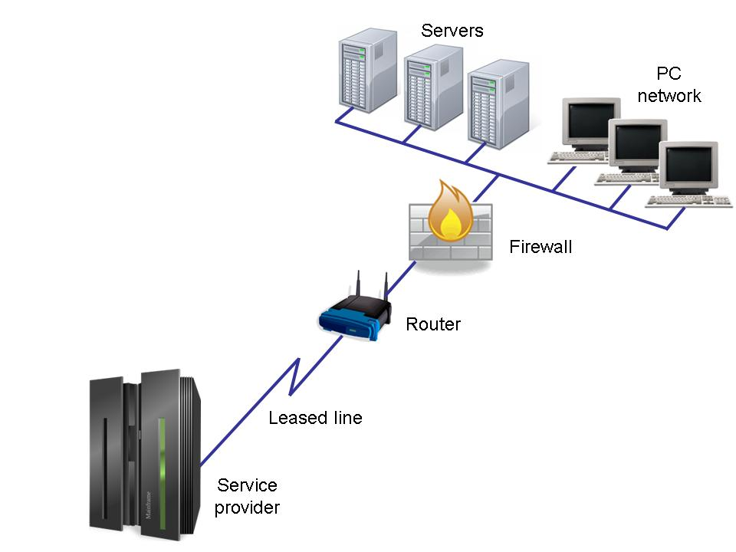
Virtual private networks (VPNs) can also be considered a type of WAN, although they don’t stand on their own. VPNs are built using another network, but they may have their own security settings and modifications to user connectivity. For example, a business may set up a secure VPN for its employees to use when they want to work from home. The VPN will use the standard Internet connection, but it will then add on its own security measures or restrictions, commonly making it so that the user is connecting to the Internet through the VPN instead of directly through the user’s own ISP. A VPN tunnel, as shown in the figure below, is a network service that is not directly supported by the Internet but is created by running specialized software. In this case, the VPN will use its own encryption technology so that communication between the hosts and clients is secure.
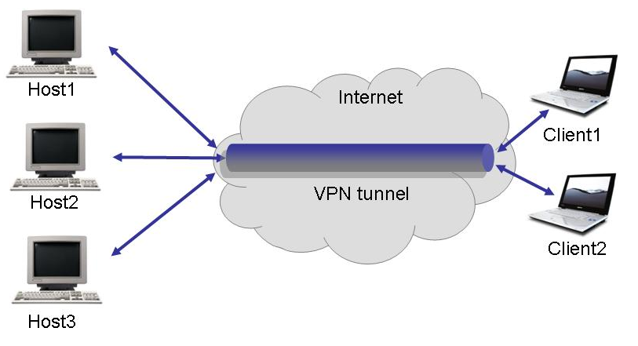
Satellites can also be used to send data across a WAN.
How Data Moves Across a Network
At the most basic level, computer networks move data from one place to another. How the data moves, however, is not so simple.
Computer networks use packet switching. When you send information, the data must first be broken down into smaller bits of information called packets. Packets travel across the network in no special order, and can even take different routes to the same destination. Each packet has a flag to tell where it should be delivered. Once the packets arrive at their destination, they are put back together in the right order and can then be interpreted.
Breaking each transmission into several small packets allows for the most efficient use of bandwidth, since data is constantly being transmitted. It also helps networks avoid collision, which is what happens when more than one transmitter tries to pass data along at once. Complicated and fine-tuned routing protocols are used to make sure data goes across the network as efficiently as possible.
Summary
A network is made up of both hardware and software. The rules, or “language,” that computers on a network agree to use is called a protocol. The physical pieces of a network include network interface cards, the cables, and hubs or switches. In addition to the physical hardware, networks need an operating system to communicate. The services that can be shared by the computers on a network include file, printer, email, and media services. A network for a small geographic area, such as a house, an office, or a building, is known as a local area network, or LAN. A wide area network, or WAN, serves a larger area.
Student Resource 9.2
Reading: Network Topologies
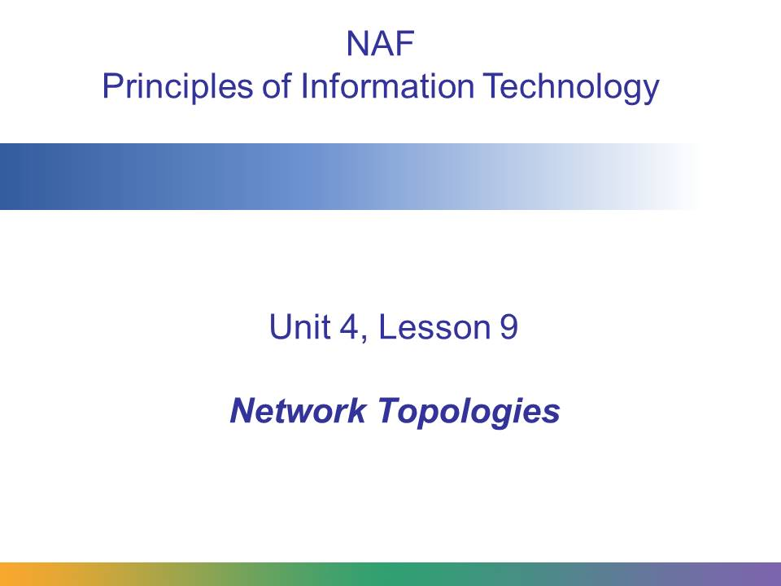
This presentation explains the basics of network topology.
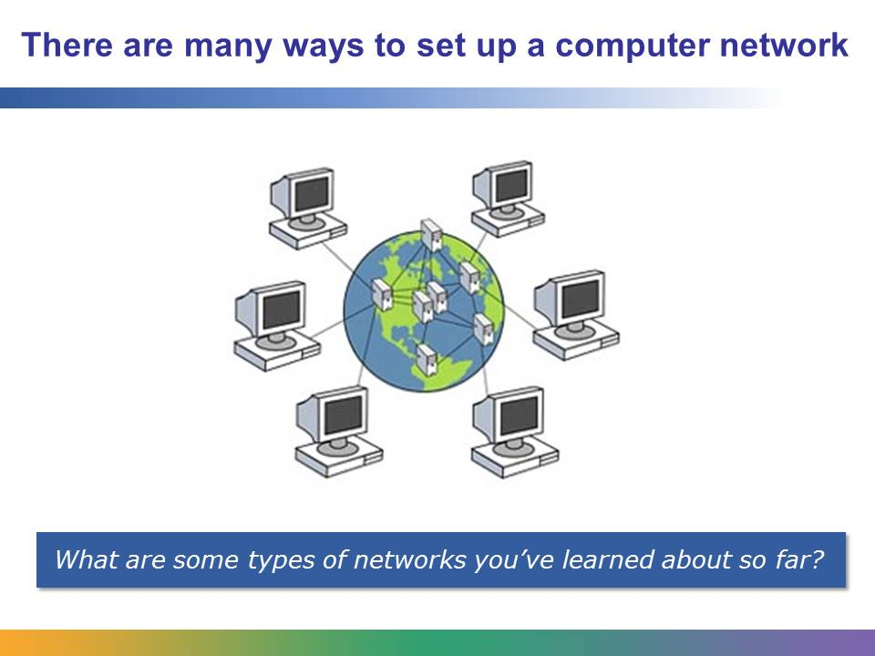
There are many ways to set up a computer network. In this presentation, we’ll talk about the most common ways to organize a network.
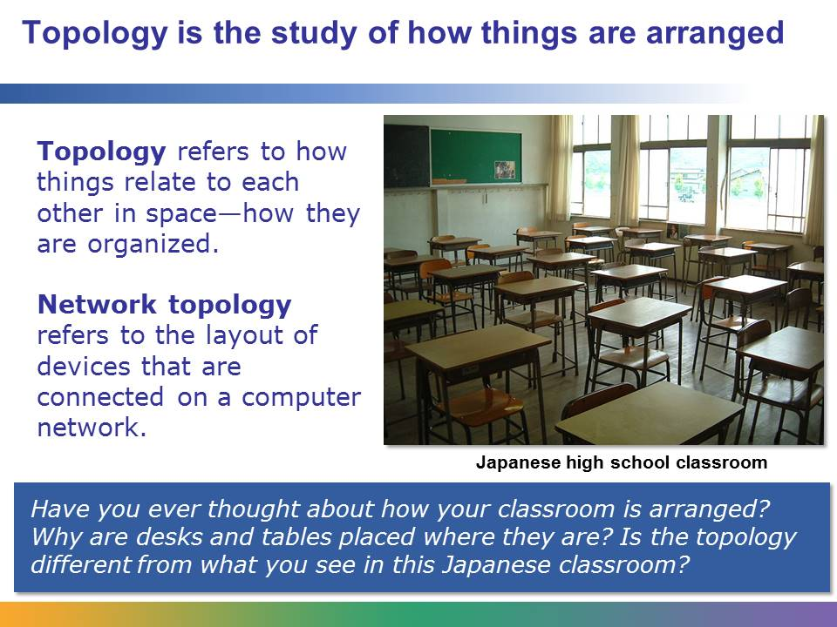
Network topology is a way to describe the “shape” of the interconnections between computers.
Image retrieved from http://commons.wikimedia.org/wiki/Image:Japanese_classroom.jpg on June 21, 2012.
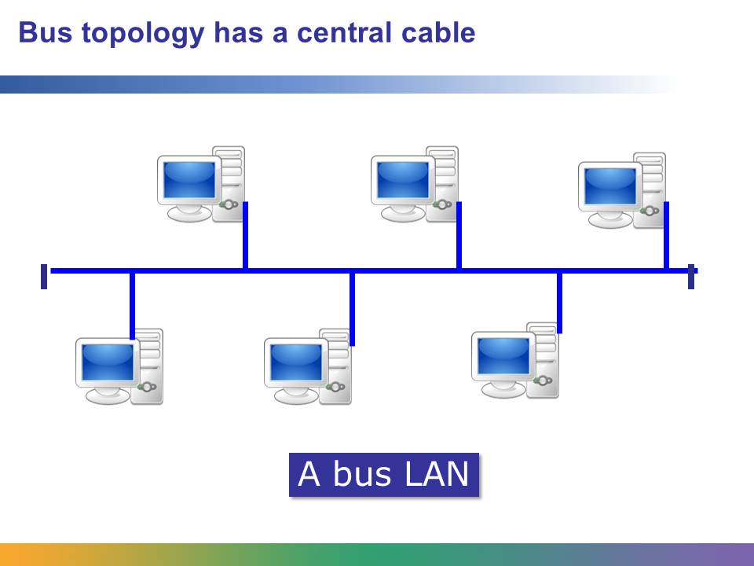
In a bus topology, every computer is connected to a central cable that has a terminator at each end. It is easy to connect computers to a linear bus, and it requires less cable than a star topology.
However, if the central cable breaks, it divides the network into two separate sections. This gap will mean that computers on opposite sides of the break won’t be able to communicate. Also, if the entire network shuts down, it’s difficult to locate the problem. In addition, since there is only a single network line, any message sent from one computer to another must travel over that one line. As more and more devices are connected to the bus, the chance increases that more than one device needs to use the network at a time. This creates message contention—another main drawback of a bus network. If two devices attempt to use the bus at the same time, it creates a collision that must be handled, as neither message is able to make it across the bus. These factors make the bus less desirable than other topologies.
Today, this type of network topology isn’t used very often except on large-scale networks connecting many smaller networks. Even then, this is only a conceptual picture of what a bus topology looks like; bus topologies are almost never physically configured this way.
The World Wide Web employs this topology, connecting major service providers together. The central cable is called the “backbone.”
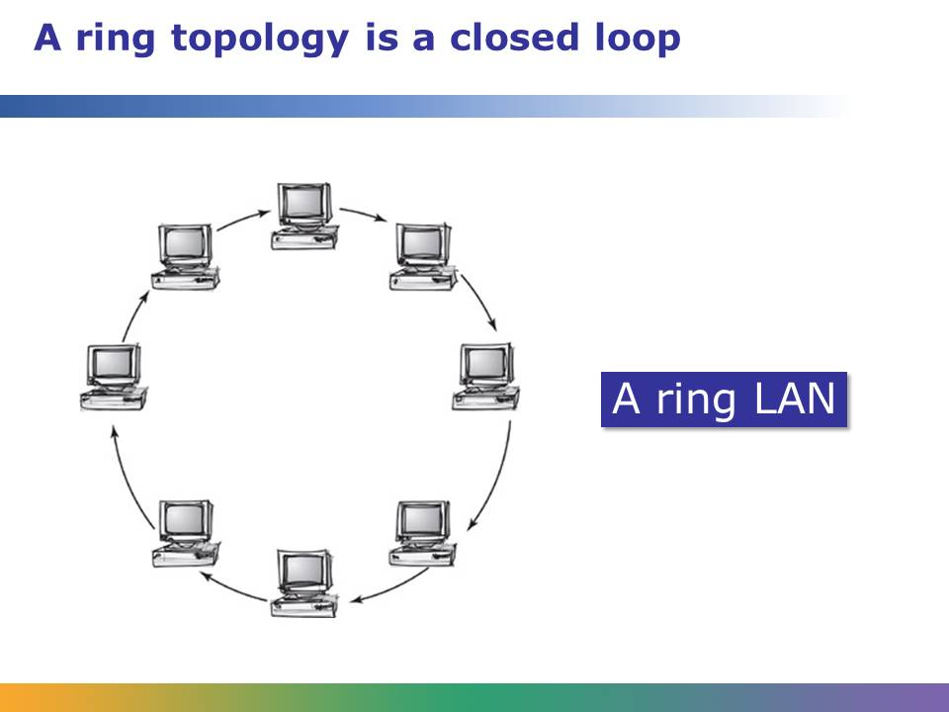
This is a ring network topology. Each node connects to exactly two other nodes. This forms a continuous single path—a ring—for signals to travel through each node. A main benefit of this setup is that it is very organized. And since the data travels all in the same direction, it can travel at high speeds. A main disadvantage of this type of network is that if one computer goes down, the entire network is impacted and cannot function. Because of this, ring topologies are less popular today than they once were.
Image retrieved from http://commons.wikimedia.org/wiki/File:Topology_ring.jpg on May 25, 2015, and reproduced here under the terms of the Creative Commons Attribution-Share Alike 4.0 International license (http://creativecommons.org/licenses/by-sa/4.0/deed.en). Image courtesy of Thanakorn rakkusan.
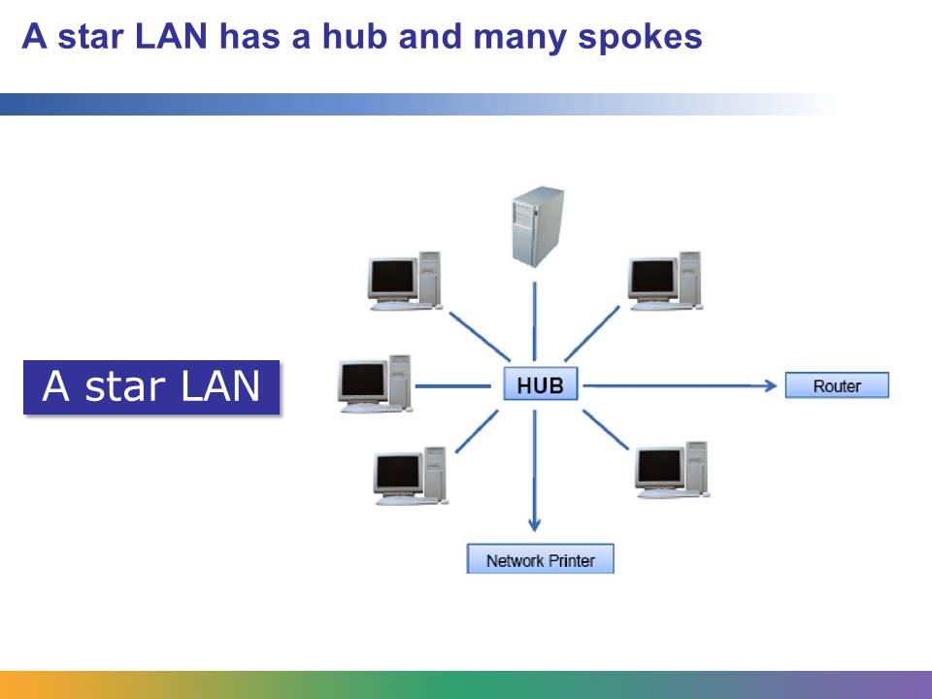
This is a star network topology. This is the most common network topology today. It’s easiest to think about this layout as the hub of a bicycle wheel and the spokes. There is one central node (the hub), and each computer and network device is attached to that hub individually. All data first goes into the central node and then is sent out to its destination.
One benefit of this setup is that if there is a problem with one node, that node is isolated and can be separated off from the network easily without any of the other nodes suffering as a result. Also, unlike a ring topology, data doesn’t go to nodes that don’t need it. This kind of network is easy to expand—the only limitation on how many computers can be added is the maximum number of computers that can be attached to the hub—and it is easy to set up and understand. Most home computer networks employ this topology, where the hub and router are a single device and the cabling is replaced by Wi-Fi connections.
The main downside is that if the central hub stops working, the network goes down completely. You should note that the hub is the center of the star, but it does not have to actually be a network hub, it can also be a network switch. Another drawback of the star topology is that it is more expensive than either the ring or bus because a dedicated device (the hub or switch) must be purchased. Local area networks in a ring or bus topology do not need such a device.
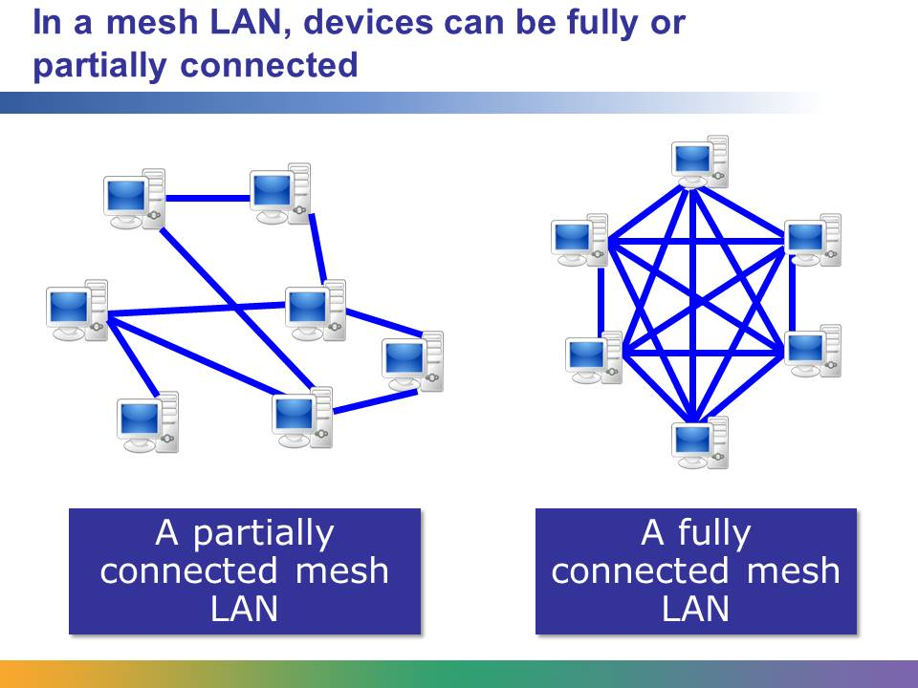
In a mesh LAN layout, each device in the network can act as a router.
In a fully connected mesh network, every device is connected directly to every other device. A network in which some devices connect only indirectly to others is a partial mesh network.
Messages sent on a mesh network can take any of several possible paths, or routes, from source to destination. A mesh network enables connections around broken or blocked paths to be continually remade by “hopping” from device to device until the destination is reached.
The Internet is an example of partial mesh routing.
The advantage of using a mesh network is that it provides redundancy, which makes it more reliable. However, it is expensive. A fully connected mesh is the most expensive of the topologies.
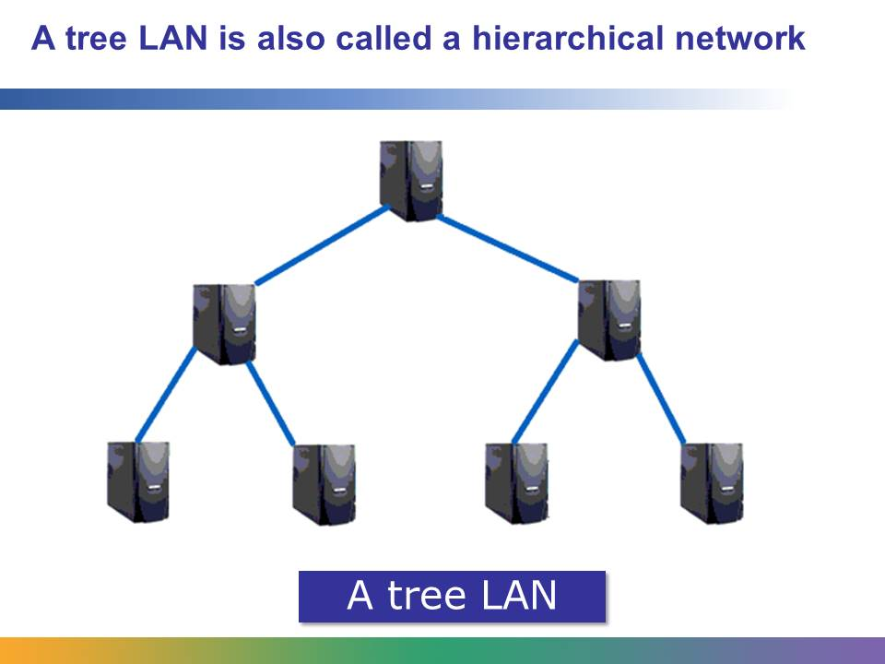
In a tree LAN, groups of devices are connected to a linear backbone cable. A tree LAN is also called a hierarchical network or an expanded star.
In a simple tree LAN, a central “root” device or hub is connected to other devices that are one level lower. There is a point-to-point link between each of the second-level devices and the top-level central “root” device, and so on throughout the tree. Each device in the network has a specific number of devices connected to it at the next lower level in the hierarchy. The hierarchy of the tree is symmetrical.
Tree topologies enable you to expand an existing network as needed as the network grows.
Advantages of a tree topology include:
- Point-to-point wiring for individual segments.
- Support of several hardware and software vendors.
Disadvantages of a tree topology are:
- The length of each segment is determined by the type of cabling used.
- If the backbone line breaks, the entire segment goes down.
- It is more difficult to configure and wire than other topologies.

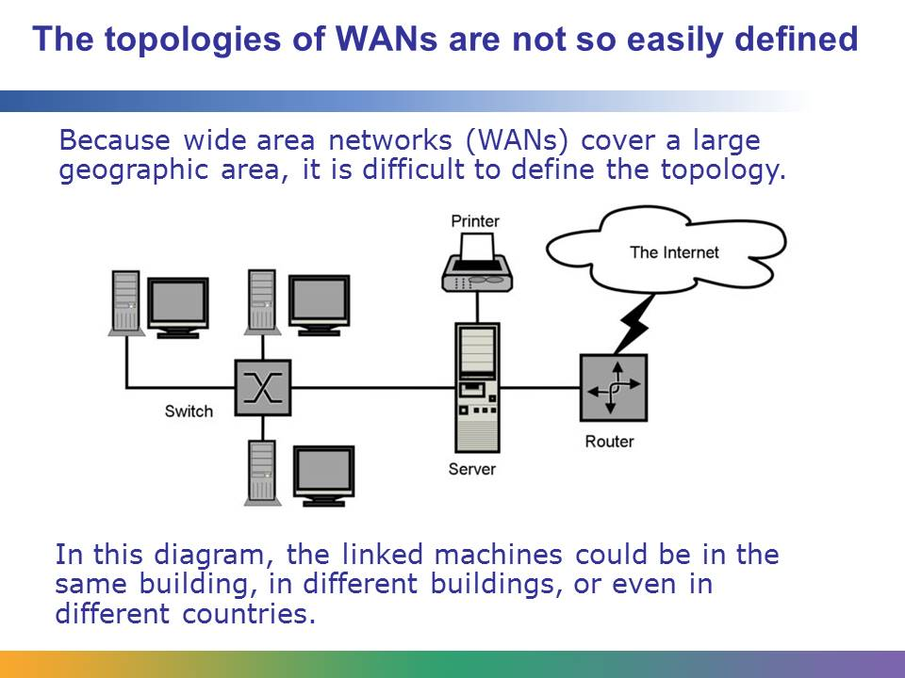
Wide area networks (WANs) work very much like LANs, but they connect machines separated by distance. Device connectivity encompasses city to city, state to state, and country to country. This is much different from a LAN, which is limited to a small geographic area like a school campus or a single building.
Diagram retrieved from http://en.wikipedia.org/wiki/Image:Sample-network-diagram.png on June 21, 2012, and reproduced here under the terms of the GNU Free Documentation License. Authored by SilverStar.
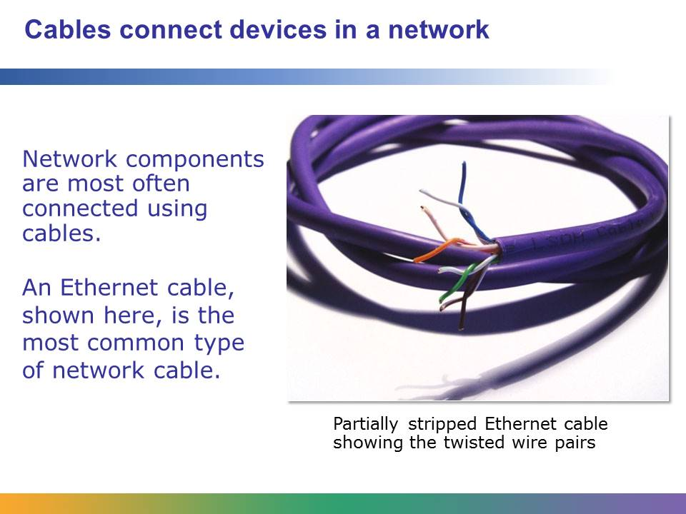
Ethernet is the primary type of LAN technology in use today. In addition to standardizing other aspects of networks, it sets standards for the addressing of packets and data and also has a method for avoiding data conflicts on the network.
Image retrieved from http://en.wikipedia.org/wiki/File:CAT5e_Cable.jpg on June 21, 2012, and reproduced her under the terms of the GNU Free Documentation License. Photo by Richard Wheeler.
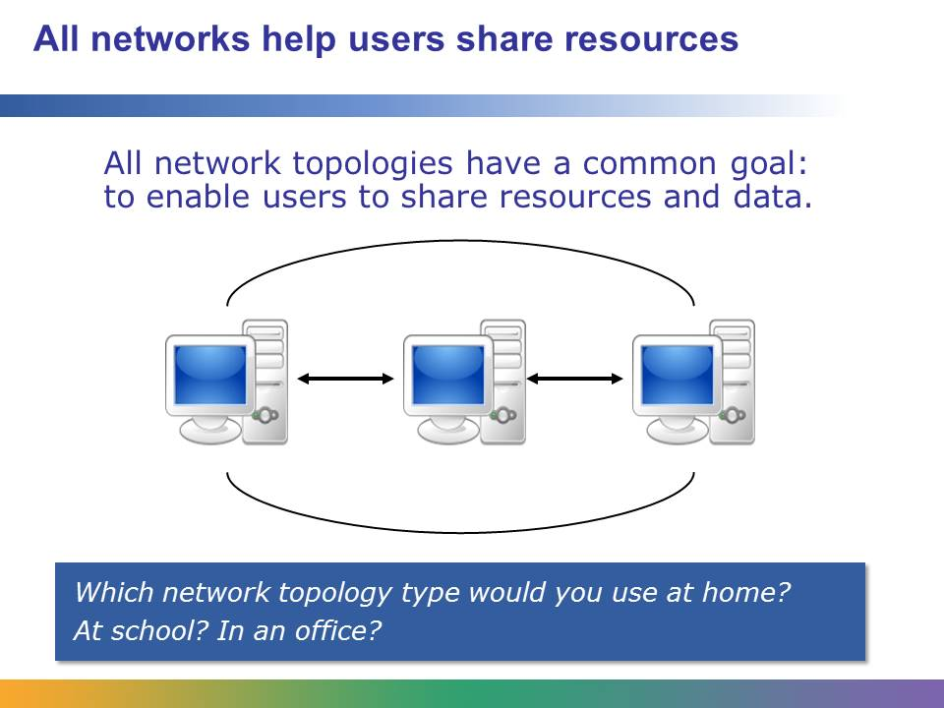
Think about when you would need a LAN and when you would need a WAN.
For your networking needs, would a star LAN, a mesh LAN, or a tree LAN be the best choice?

Student Resource 9.3
Note Taking: Network Topologies
Student Name:_______________________________________________ Date:____________
Directions: Use this resource to take notes as you view or read the presentation on network topologies.
Topology means . . .

Some of the most common network topologies are . . .

What happens if a cable breaks in a star topology?

How are computers physically linked? What is the most common type of material to do this?

Additional notes:

Student Resource 9.4
Defining Format Chart: Networks
Student Name:_______________________________________________ Date:____________
Directions: Fill in the characteristics for each term, using the example below as a guide.
Term | Category | Characteristics
Ethernet | is a type of data cable that | - is made up of twisted pairs of wiring or fiber-optic cable.  - can connect to computers, printers, routers, hubs, and so on.  - is the most common type of network cabling in use today.

Term | Category | Characteristics
A computer network | is a data communication system that | 1.  2.  3.
A local area network | is a data communication system that | 1.  2.  3.
A wide area network | is a data communication system that | 1.  2.  3.
Student Resource 9.5
Reading: Comparing Types of Network Architecture
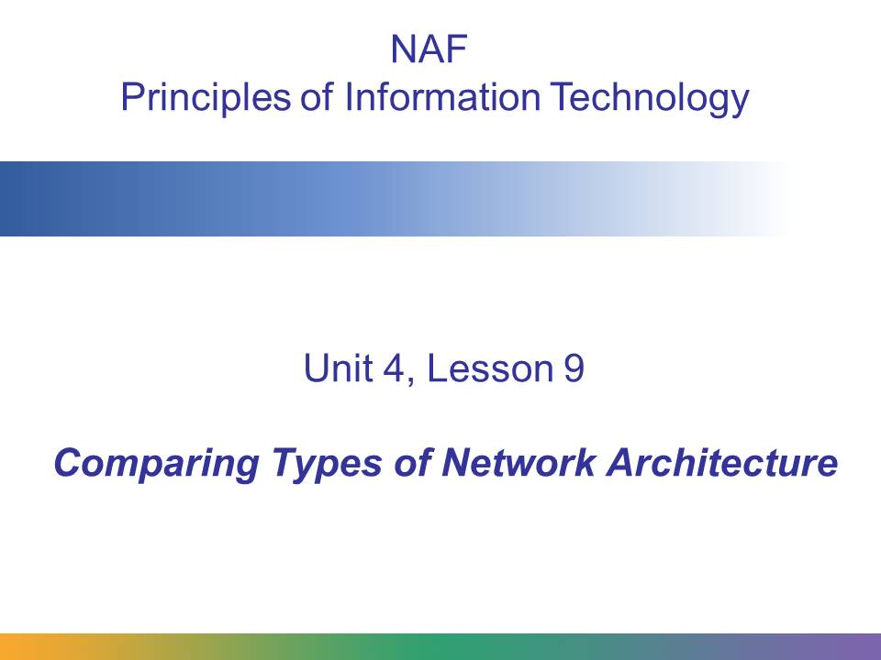
Just as there are different ways to organize a network (topology), so are there different ways to link computers. Some networks have an architecture with clients and servers, while others are designed so that all nodes (parts) of the network connect to each other.
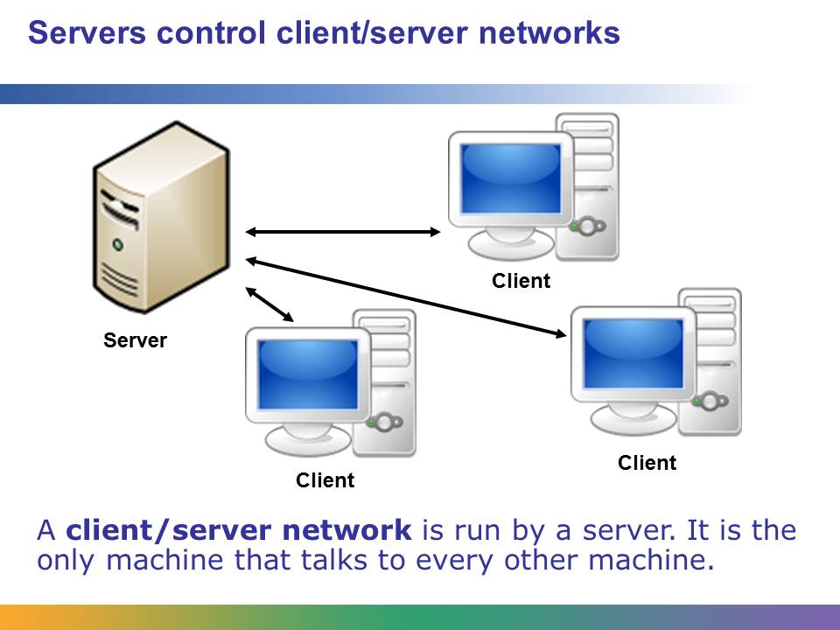
In a client/server network, one computer, called a server, controls everything. The server controls the access that other computers have to shared resources like storage space, documents, email, fax machines, and printers. Some servers are set up to perform many functions, while others perform only one particular task. Larger networks may utilize multiple servers to help balance the load, or there may be multiple servers, each handling a difference service (for instance, an email server, a web server, and a print server).
The client machines, those that talk to the server and receive data from it, usually do not communicate with each other unless they first go to the server.
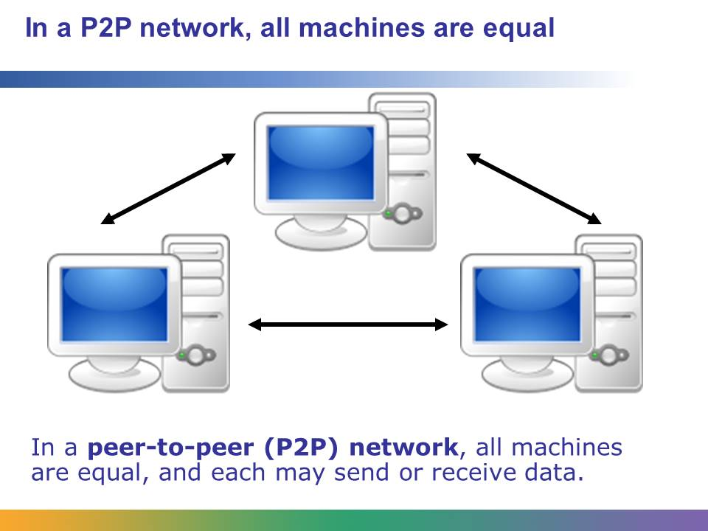
Peer-to-peer networks are more democratic than client/server networks. With this type of network, each computer is equal to every other computer on the network, and all may send and receive data without going through any other machine first.
When a P2P network is in place, any user on the network can access explicitly shared files and folders stored on the other machines in the network. This works well when those on the network have a high level of trust in one another, but it can be a security risk, too.
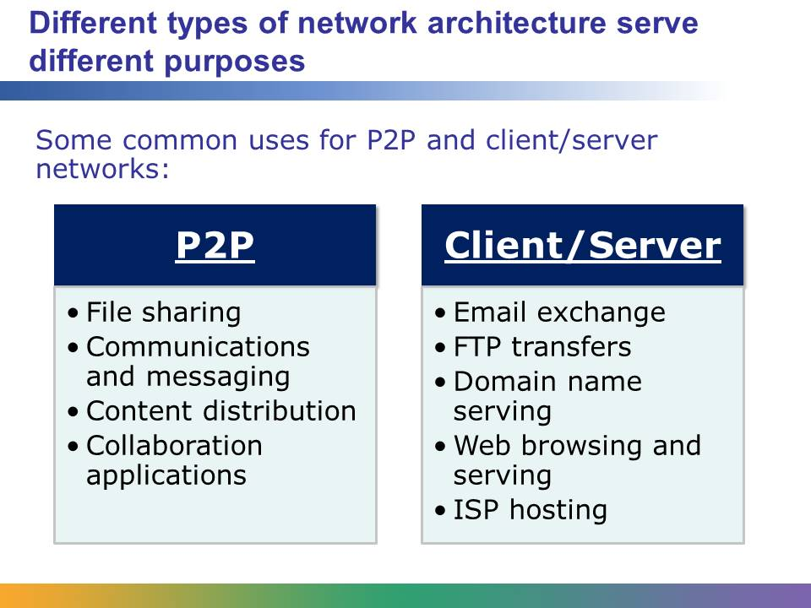
You can choose whether to set up a P2P or client/server network depending on your situation and technology needs. In addition, a client/server network will be more expensive because one or more computers must act as dedicated servers rather than clients.
The online music sharing service Napster was an early, popular P2P file sharing system. Another example is Skype, which uses P2P technology to enable users to make phone calls over the Internet. The service was originally called “Sky peer-to-peer,” which was eventually shortened to “Skype.”
Skype can be seen as a proprietary implementation of voice over IP (VoIP), which is a way of sending communication traffic over P2P connections that use the same VoIP industry standards.
P2P networks are also used for instant messaging by applications such as Jabber, Yahoo! Messenger, and AIM.
The client/server model is used by WANs and LANs whenever a client device receives information from a dedicated server. A typical example is email, which usually is hosted on an email server, to which clients can connect to download messages. Other examples are websites that are hosted on the Internet and accessed by client PCs.

Student Resource 9.6
Network Design Assignment:
Peer-to-Peer and Client/Server Networks
Student Name:_______________________________________________________ Date:___________
Directions: On the following pages of this assignment, draw a peer-to-peer network and a client/server network. Before you begin drawing, read all of the specifications below and read the assessment criteria so that you know how your work will be assessed.
Specifications for peer-to-peer and client/server network drawings:
- Each network should have at least four computers.
- Choose a network topology for each network. You may use any network topology (star, bus, star bus, ring, etc.) that is appropriate for the type of network.
- Write a sentence above each design to explain what the network is used for and why you chose its particular topology.

Make sure your assignment meets or exceeds the following assessment criteria:
- The peer-to-peer and client/server drawings show accurate connections between the computers.
- The drawings show an understanding of different network topologies and accurately depict reasonable topologies for the given network type.
- The written descriptions for each type of network match typical uses for such a network.
- The drawings are neat and the descriptions use proper spelling and grammar.
Description of Peer-to-Peer Network:

Description of Client/Server Network:

Student Resource 9.7
Project Planner Page 5:
Planning a Dream Personal Technology System
Student Names:_______________________________________________ Date:____________
This is the fifth page of the project planner you’ll use to help plan your group’s personal technology system. Later, you will add items such as the operating system, Internet access, and other considerations you might need to keep in mind. Remember that you should be keeping track of all of your project planner pages for the entire course. Your group will collect and submit all of these resources at the end of the project.
Answer the questions below to identify and plan if and how the dream system your group is designing will connect to a network. List the factors (such as ease of hardware sharing, shared storage, and so on) you will keep in mind while making plans for the system. Don’t forget to think about your system’s stated purpose when you are making these choices.
When discussing your plans, be as specific as you can, but don’t worry about the exact model number of networking card, router, or other hardware you might buy. For example, if you know you will choose a networking card but have not yet chosen the specific one you would want, you can come back to this later and add that information. If you do not believe that your personal technology system needs any networking equipment, be sure to explain this and justify your reasoning.
When your group has completed this planning sheet, add the information to the culminating project report you began in Lesson 7. Be sure to keep that report up-to-date—including adding a line to your project planning summary table!
What this system will be used for:

Networking hardware we need to buy (be as specific as you can):

Why did you make these choices?

Additional notes:

