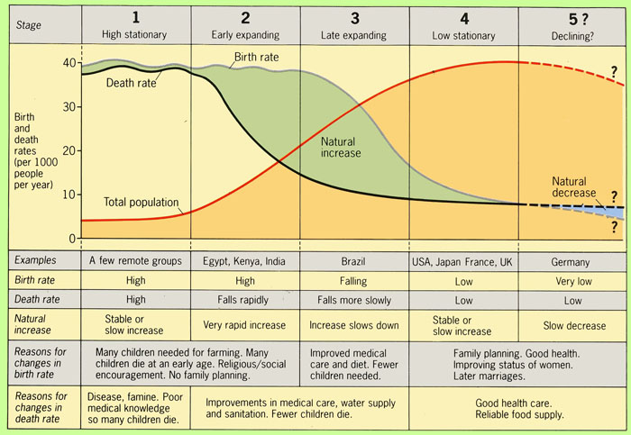

The "Demographic Transition" is a model that describes population change over time. It is based on an interpretation begun in 1929 by the American demographer Warren Thompson, of the observed changes, or transitions, in birth and death rates in industrialized societies over the past two hundred years or so.
By "model" we mean that it is an idealized, composite picture of population change in these countries. The model is a generalization that applies to these countries as a group and may not accurately describe all individual cases. Whether or not it applies to less developed societies today remains to be seen.
STAGE ONE is associated with pre Modern times, and is characterized by a balance between birth rates and death rates. This situation was true of all human populations up until the late 18th century when the balance was broken in Western Europe. Given its characteristics, Stage One is sometimes referred to as the "High Stationary Stage" of population growth ("high" birth and death rates; "stationary" rates and "stationary" total population numbers). Death rates were very high at all times in this stage for a number of reasons, including:
- lack of knowledge of disease prevention and cure;
- occasional food shortages.
STAGE TWO sees a rise in population caused by a decline in the death rate while the birth rate remains high, or perhaps even rises slightly. The decline in the death rate in Europe began in the late 18th century in northwestern Europe and spread over the next 100 years to the south end east.
The decline in the death rate is due initially to two factors:
- First, improvements in food supply brought about by higher yields as agricultural practices were improved in the Agricultural Revolution of the 18th.C. These improvements included crop rotation, selective breeding, and seed drill technology. In England, the greater wealth this brought about enabled people to marry earlier, thus raising the birth rate slightly at the same time. Another food related factor was the introduction of the potato and maize (corn) from the Americas. These new crops increased the quantity of foodstuffs in the European diet, especially in northern Europe.
- Second, there were significant improvements in public health that reduced mortality, particularly in childhood. These are not so much medical breakthroughs (which did not come until the mid 20th.C.) as they are improvements in water supply, sewage, food handling, and general personal hygiene following on from growing scientific knowledge of the causes of disease. This is illustrated below for the case of measles and TB in the USA over the past 100 years. However, bear in mind that killer infectious diseases such as TB are airborne and not water borne, so public engineering works such as sewer and water supply cannot take all the credit. In fact, perhaps the most important factor here was increased female literacy allied with public health education programs in the late 19th. and early 20th. Centuries.
Another characteristic of Stage Two of the demographic transition is a change in the age structure of the population. In Stage One the majority of death is concentrated in the first 5-10 years of life. Therefore, more than anything else, the decline in death rates in Stage Two entails the increasing survival of children. Hence, the age structure of the population becomes increasingly youthful. This trend is intensified as this increasing number of children enters into reproduction while maintaining the high fertility rate of their parents.
STAGE THREE moves the population towards stability through a decline in the birth rate. This shift belies Malthus's belief that changes in the death rates were the primary cause of population change. In general the decline in birth rates in developed countries began towards the end of the 19th century in northern Europe and followed the decline in death rates by several decades.
There are several factors contributing to this eventual decline, although some of them remain speculative:
- In rural areas continued decline in childhood death means that at some point parents realize they need not require so many children to be born to ensure a comfortable old age. As childhood death continues to fall parents can become increasingly confident that even fewer children will suffice.
- Increasing urbanization changes the traditional values placed upon fertility and the value of children in rural society. Urban living also raises the cost of dependent children to a nuclear family (education acts and child labor acts increased dependency through the late 1800s). People begin to assess more rationally just how many children they desire or need. Once traditional patterns of thinking are broken the decline is likely to accelerate.
- Increasing female literacy and employment lower the uncritical acceptance of childbearing and motherhood as measures of the status of women. Valuation of women beyond childbearing and motherhood becomes important. In addition, as women enter the work force their life extends beyond the family and the connections they make with other women serve to break their isolation and change their attitudes towards the burdens of childbearing. Within the family they become increasingly influential in childbearing decisions.
- Improvements in contraceptive technology help in the second half of the 20th.C. However, contraceptives were not widely available in the 19th.C. and likely contributed little to the decline. Fertility decline is caused by a change in values than by simply the availability of contraceptives and knowledge of how to use them. Today in the world there exists a close correspondence between fertility and contraceptive use, but this likely means that those families that have chosen to limit family size find contraceptives the easiest and most effective way to do so.
STAGE FOUR is characterized by stability. In this stage the population age structure has become older. In some cases the fertility rate falls well below replacement and population decline sets in rapidly.

THE TRANSITION IN LESS WELL DEVELOPED COUNTRIES
Mexico and Sweden illustrate the salient differences and similarities between less and more developed countries. These differences include:
- A later (20th century.) transition in LDCs.
- A faster decline in death rates (50 yrs. vs. 150 yrs.). Death control has been imported from MDCs and applied rapidly. In most LDCs childhood mortality remains high, but 1/3 to 1/2 what it was 50 years ago. However the most rapid improvements have occurred in places in which female literacy has increased the most. Therefore, it is not simply the application of modern drugs that is responsible but, rather, behavioral changes that have improved survival (e.g. changes related to hygiene). These types of behavioral change are readily adopted because, in so far as they improve survival, they act to support traditional values that favor life over death in almost all societies.
- A relatively longer lag between the decline in death rates and the decline in birth rates (death rates are lower before decline in birth rate starts). Fertility change requires a more conscious effort than mortality change and requires social and behavioral changes that conflict more with traditional values. This has been slower coming in LDCs because economic change has been delayed in many cases. The same economic pressures that existed in urban areas 100 years ago in MDCs have been slower to develop in LDCs because many, particularly in Africa, remain very rural. Hence, attitudes and values have been slower to change.
- Higher maximum rates of growth in LDCs: over 3.5% growth per year at the height of Stage 2 in Mauritius and Mexico, compared to 1.3% in the same stage in Sweden. Also, therefore, age structures are far younger in LDCs. These data yield doubling times of 20 years versus 55 years.
But the greatest similarity concerns the fertility behavior of both populations (at different times) with respect to infant mortality

