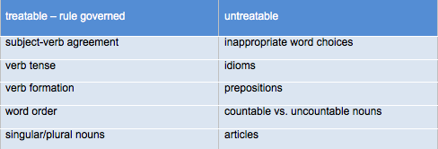
Note that treatable errors are best treated through indirect feedback. Point out the error but let the student figure out how to correct it. Conversely, untreatable errors are better corrected through direct feedback because students cannot be expected to find the correction.

Finally, remember that students learn best when learning grammar in context of their own writing and immediately applying the acquired knowledge through correcting their own work.

