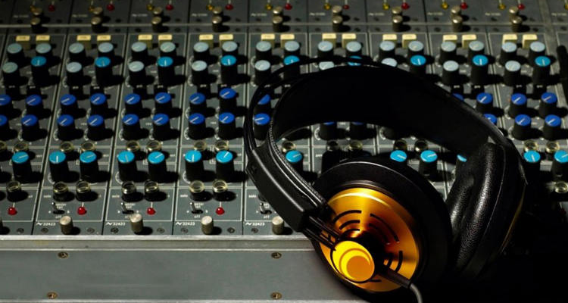

Music Technology & Audio Engineering I
Teacher: Mr. Mastrovito
NMastrovito@dadeschools.net
Date: 2016-2017

Course Description
An introduction to real world experiences with electronic music and sound engineering in the 21st century.

Topics
- Characteristics of sound
- Components of a sound system
- Intro to recording (Garage Band for Mac, iPad, and iPhone)
- Knowing the best equipment for the job

Materials Needed
- 3-prong duo tang folder (handouts, diagrams)
- Pencil
- One time class fee of: $15

Grading
30%: Class Assignments
25%: Practical Exams
20%: Class Attendance
15%: Quizzes
10%: Conduct

I HAVE READ THE SYLLABUS IN ITS ENTIRETY. I UNDERSTAND IT AND AGREE TO FOLLOW THESE EXPECTATIONS AS WELL AS THE EXPECTATIONS ESTABLISHED IN THE MIAMI BEACH SENIOR HIGH HANDBOOK.
Please sign below to show that you have read the class syllabus and understand its content. Please detach this sheet and turn it into Mr. Mastrovito no later than Tuesday, Sept 13th, 2016.
Student Name ________________________________
Student Signature _____________________________
Date _________________________
Parent Signature _________________________________
Date _________________________

