Evolution | Name________________  December 05, 2013

1. The accompanying diagram represents one possible evolutionary change that could have led lobe-finned fish to develop into the first amphibians. Amphibians are animals that live on land some of their life.
This change from fins on the lobe-finned fish to legs and feet on the early amphibian is most likely due to

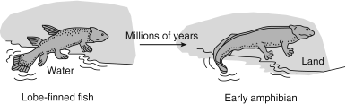

 | 1. a sudden mutation that changed the gills of the lobe-finned fish to lungs | 3. the need to move to land because of increased competition for food in the ocean
 | 2. increased competition between animals that had adapted to living on the land | 4. variations among offspring, followed by natural selection

2. The crucian carp, a Scandinavian fish, thrives in shallow ponds that freeze over during winter. While other creatures in the pond die from lack of oxygen, these carp are able to obtain energy through a biochemical pathway that does not require oxygen. This characteristic is an example of a
 | 1. feedback mechanism common to carnivores that inhabit shallow pond ecosystems | 3. stage of succession that leads to a new community
 | 2. favorable adaptive trait that has led to increased survival | 4. gene mutation that occurred because carp need to survive to maintain ecological stability

3. Examination of ancient rock layers at a certain location reveals many different fossils. Which conclusion can be drawn concerning the species that formed these fossils?
 | 1. Only the predators are still present. | 3. They produced offspring that were all genetically identical.
 | 2. Many of them are now extinct. | 4. They had no variations due to mutations.

4. The accompanying diagram represents some changes that took place in a bacterial population recently exposed to an antibiotic.
Which statement would best explain the presence of bacteria on day 4?

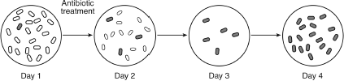

 | 1. A bacterial population cannot survive exposure to antibiotics. | 3. Bacteria can change whenever it is necessary to survive antibiotic treatment.
 | 2. This bacterial population cannot survive exposure to this antibiotic. | 4. Some of the bacterial population was resistant to this antibiotic.

5. A population of animals is permanently split by a natural barrier into two separate populations in different environments. What will likely result after a long period of time?
 | 1. The evolution of the two populations will be identical. | 3. The two populations will evolve into separate species.
 | 2. The production of variations will stop in the two populations. | 4. Autotrophic nutrition will replace heterotrophic nutrition in the two populations.

6. In order for a species to evolve, it must be able to
 | 1. consume a large quantity of food | 3. maintain a constant body temperature
 | 2. reproduce successfully | 4. be domesticated

7. A population of white moths lives in a forest near a factory. This factory burns coal and pollutes the air with black dust. Over time, this dust has settled on the trees in the area, making them darker in color. This could result in
 | 1. an increase in the white moth population | 3. an increase in the number of trees in the area
 | 2. a decrease in the white moth population | 4. a decrease in the air pollution affecting the area

8. A chemical known as 5-bromouracil causes a mutation that results in the mismatching of molecular bases in DNA. The offspring of organisms exposed to 5-bromouracil can have mismatched DNA if the mutation occurs in
 | 1. the skin cells of the mother | 3. all the body cells of both parents
 | 2. the gametes of either parent | 4. only the nerve cells of the father

9. A species that lacks the variation necessary to adapt to a changing environment is more likely to
 | 1. develop many mutated cells | 3. begin to reproduce sexually
 | 2. become extinct over time | 4. develop resistance to diseases

10. If the same antibiotic is used too many times, it can become less effective against a certain type of bacteria. This observation is best explained by the
 | 1. presence of pathogens in antibiotics | 3. replication of viruses that attack bacteria
 | 2. production of antibiotics by white blood cells | 4. survival and reproduction of unaffected bacteria

11. When changes occur in the genes of sex cells, these changes
 | 1. lead to mutations in the parent organism | 3. can be the basis for evolutionary change
 | 2. are always harmful to the offspring | 4. only affect asexually reproducing organisms

12. The diversity of organisms present on Earth is the result of
 | 1. ecosystem stability | 3. natural selection
 | 2. homeostasis | 4. direct harvesting

13. The accompanying diagram shows a process that affects chromosomes during meiosis.
This process can be used to explain

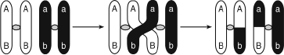

 | 1. why some offspring are genetically identical to their parents | 3. why some offspring physically resemble their parents
 | 2. the process of differentiation in offspring | 4. the origin of new combinations of traits in offspring

14. Which statement is best supported by the theory of evolution?
 | 1. Genetic alterations occur every time cell reproduction occurs. | 3. Populations that have advantageous characteristics will increase in number.
 | 2. The fossil record provides samples of every organism that ever lived. | 4. Few organisms survive when the environment remains the same.

15. An evolutionary pathway is represented in the accompanying diagram. Which statement about evolutionary pathways is most accurate?

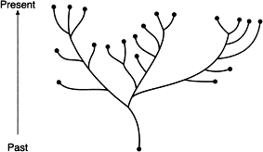

 | 1. All evolutionary pathways show that life began with autotrophic organisms that soon evolved into heterotrophic organisms. | 3. All the organisms shown at the ends of evolutionary pathway branch tips are alive today.
 | 2. Two organisms on the same branch of an evolutionary pathway are more closely related to each other than to those on distant branches. | 4. Evolutionary pathways show that evolution is a short-term process.

16. The accompanying diagram represents the bones of the forelimbs of two animals alive today that most likely evolved from a common ancestor. Members of the original ancestral population were isolated into two groups by natural events.
If these two animals did have a common ancestor, which statement would best explain why there are differences in the bones?

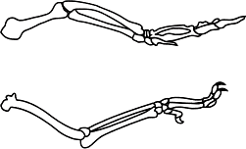

 | 1. Changes occurred to help the animals return to their original environment. | 3. Changes helped reduce competition within each group.
 | 2. Changes contributed to the survival of the organisms in their new environment. | 4. Changes indicate the species are evolving to be more like the ancestral species.

17. The sorting and recombining of genes during meiosis and fertilization usually leads to the production of
 | 1. gametes with many copies of the same chromosome | 3. zygotes with the genetic information to produce only females
 | 2. embryos with traits identical to those of all other members of the species | 4. offspring with some traits that did not appear in their parents

18. Which situation would most likely produce a gene mutation in a squirrel?
 | 1. The squirrel stops using its claws for digging. | 3. Oak trees gradually become less common.
 | 2. The squirrel is exposed to radiation for several days. | 4. The weather becomes wetter for a short period of time.

19. When antibiotics were first developed, most infectious diseases could be controlled by them. Today, certain bacteria are resistant to many antibiotics.
One possible explanation for this change is that
 | 1. the antibiotics killed most of the bacteria that did not have a genetic variation for resistance | 3. some of the bacteria learned how to resist the antibiotics
 | 2. the bacteria needed to change in order to produce more antibiotics | 4. antibiotics have become weaker over the years

20. The females of certain species of turtles will sneak into a nest of alligator eggs to lay their own eggs and then leave, never to return. When the baby turtles hatch, they automatically hide from the mother alligator guarding the nest and to the nearest body of water when it is safe to do so. Which statement best explains the behavior of these baby turtles?
 | 1. More of the turtles' ancestors who acted in this way survived to reproduce, passing this behavioral trait to their offspring. | 3. Turtles are not capable of evolving, so they repeat the same behaviors generation after generation.
 | 2. The baby turtles are genetically identical, so they behave in the same way. | 4. The baby turtles' ancestors who learned to behave this way taught the behaviors to their offspring.

21. Base your answer on the information below and on your knowledge of biology.
Honeybees have a very cooperative way of living. Scout bees find food, return to the hive, and do the "waggle dance" to communicate the location of the food source to other bees in the hive. The waggle, represented by the wavy line in the accompanying diagram, indicates the direction of the food source, while the speed of the dance indicates the distance to the food. Different species of honeybees use the same basic dance pattern in slightly different ways as shown in the table shown.
The number of waggle runs in 15 seconds for each of these species is most likely due to

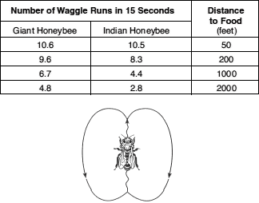

 | 1. behavioral adaptation as a result of natural selection | 3. alterations in gene structure as a result of diet
 | 2. replacement of one species by another as a result of succession | 4. learned behaviors inherited as a result of asexual reproduction [1]

22. The accompanying diagram represents the genetic contents of cells before and after a specific reproductive process.
This process is considered a mechanism of evolution because it
 | 1. decreases the chance for new combinations of inheritable traits in a species | 3. increases the chance for variations in offspring
 | 2. decreases the probability that genes can be passed on to other body cells | 4. increases the number of offspring an organism can produce

23. In several species of birds, the males show off their bright colors and long feathers. The dull-colored females usually pick the brightest colored males for mates. Male offspring inherit their father's bright colors and long feathers. Compared to earlier generations, future generations of these birds will be expected to have a greater proportion of
 | 1. bright-colored females | 3. dull-colored males
 | 2. dull-colored females | 4. bright-colored males

24. To determine evolutionary relationships between organisms, a comparison would most likely be made between all of the characteristics below except
 | 1. methods of reproduction | 3. sequences in their DNA molecules
 | 2. number of their ATP molecules | 4. structure of protein molecules present

25. A certain protein is found in mitochondria, chloroplasts, and bacteria. This provides evidence that plants and bacteria
 | 1. have some similar DNA base sequences | 3. digest proteins into simple sugars
 | 2. can use carbon dioxide to make proteins | 4. contain certain pathogenic microbes

26. Extinction of a species could result from
 | 1. evolution of a type of behavior that produces greater reproductive success | 3. limited genetic variability in the species
 | 2. synthesis of a hormone that controls cellular communication | 4. fewer unfavorable mutations in the species

27. The evolutionary pathways of five species are represented in the accompanying diagram.
Which statement is supported by the diagram?

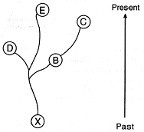

 | 1. Species C is the ancestor of species B. | 3. Species X evolved later than species D but before species B.
 | 2. Species D and E evolved from species B. | 4. Both species C and species D are related to species X.

28. Base your answer on the accompanying diagram that shows some evolutionary pathways. Each letter represents a different species.
Which two organisms are most closely related?

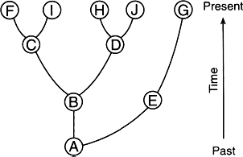

 | 1. F and I | 3. A and G
 | 2. F and H | 4. G and J

29. Base your answer on the accompanying diagram that shows some evolutionary pathways. Each letter represents a different species.
The most recent ancestor of organisms D and F is

 | 1. A | 3. C
 | 2. B | 4. I

30. Base your answer on the accompanying diagram that shows some evolutionary pathways. Each letter represents a different species.
If A represents a simple multicellular heterotrophic organism, B would most likely represent

 | 1. a single-celled photosynthetic organism | 3. a complex multicellular virus
 | 2. an autotrophic mammal | 4. another type of simple multicellular heterotroph

31. A mutation changes a gene in a cell in the stomach of an organism. This mutation could cause a change in
 | 1. both the organism and its offspring | 3. its offspring, but not the organism itself
 | 2. the organism, but not its offspring | 4. neither the organism nor its offspring

32. In an environment that undergoes frequent change, species that reproduce sexually may have an advantage over species that reproduce asexually because the sexually reproducing species produce
 | 1. more offspring in each generation | 3. offspring with more variety
 | 2. identical offspring | 4. new species of offspring in each generation

33. Mutations that occur in skin or lung cells have little effect on the evolution of a species because mutations in these cells
 | 1. usually lead to the death of the organism | 3. are usually beneficial to the organism
 | 2. cannot be passed on to offspring | 4. lead to more serious mutations in offspring

34. The teeth of carnivores are pointed and are good for puncturing and ripping flesh. The teeth of herbivores are flat and are good for grinding and chewing. Which statement best explains these observations?
 | 1. Herbivores have evolved from carnivores. | 3. The two types of teeth most likely evolved as a result of natural selection.
 | 2. Carnivores have evolved from herbivores. | 4. The two types of teeth most likely evolved as a result of the needs of an organism.

35. Even though the finches on the various Galapagos Islands require different biotic and abiotic factors for their survival, these finches would most likely be grouped in the same
 | 1. species, but found in different habitats | 3. species and found in the same biosphere
 | 2. kingdom, but found in different ecological niches | 4. population, but found in different ecosystems

36. Galapagos finches evolved partly due to
 | 1. cloning and recombination | 3. mutation and asexual reproduction
 | 2. migration and selective breeding | 4. variation and competition

37. In a group of mushrooms exposed to a poisonous chemical, only a few of the mushrooms survived. The best explanation for the resistance of the surviving mushrooms is that the resistance
 | 1. was transmitted to the mushrooms from the poisonous chemical | 3. was transferred through the food web to the mushrooms
 | 2. resulted from the presence of mutations in the mushrooms | 4. developed in response to the poisonous chemical

38. The evolutionary pathways of seven living species are shown in the accompanying diagram.
Which two species are likely to have the most similar DNA base sequences?

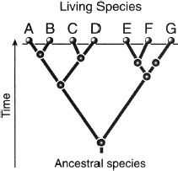

 | 1. B and G | 3. B and C
 | 2. E and G | 4. C and D

39. Base your answer on the information given, the accompanying diagram, and on your knowledge of biology.
The three great lakes in Africa (Victoria, Tanganyika, and Malawi) contain a greater number of fish species than any other lakes in the world. Lake Malawi alone has 200 species of cichlid fish. The diversity of cichlid species in these African lakes could have been caused by changes in water level over thousands of years. According to one hypothesis, at one time the three lakes were connected as one large lake and all the cichlids could interbreed. When the water level fell, groups of cichlids were isolated in smaller lakes as shown in the diagram. Over time, the groups of cichlids developed genetic differences. When the water levels rose again, the isolated populations were brought back into contact. Due to significant genetic differences, these populations were unable to interbreed. Variations in water level over thousands of years resulted in today's diversity of cichlid species.
Which discovery would support this explanation of cichlid diversity?

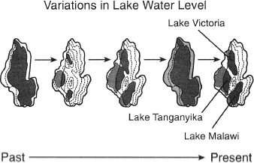

 | 1. The water level changed little over time. | 3. Differences between cichlid species are small and interbreeding is possible.
 | 2. The local conditions in each of the small lakes were very different. | 4. Once formed, the lakes remained isolated from each other.

40. The presence of some similar structures in all vertebrates suggests that these vertebrates
 | 1. all develop at the same rate | 3. all develop internally and rely on nutrients supplied by the mother
 | 2. evolved from different animals that appeared on Earth at the same time | 4. may have an evolutionary relationship

41. A mutation occurs in the liver cells of a certain field mouse. Which statement concerning the spread of this mutation through the mouse population is correct?
 | 1. It will spread because it is beneficial. | 3. It will not spread because it is not in a gamete.
 | 2. It will spread because it is a dominant gene. | 4. It will not spread because it is a recessive gene.

42. Which factor is least likely to contribute to an increase in the rate of evolution?
 | 1. presence of genetic variations in a population | 3. chromosomal recombinations
 | 2. environmental selection of organisms best adapted to survive | 4. a long period of environmental stability

43. When a particular white moth lands on a white birch tree, its color has a high adaptive value. If the birch trees become covered with black soot, the white color of this particular moth in this environment would most likely
 | 1. retain its adaptive value | 3. change to a more adaptive black color
 | 2. increase in adaptive value | 4. decrease in adaptive value

44. The graph (see image) shows the populations of two species of ants. Ants of species 2 have a thicker outer covering than the ants of species 1. The outer covering of an insect helps prevent excessive evaporation of water.
Which statement would best explain the population changes shown in the graph?

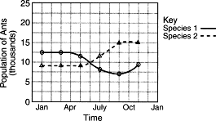

 | 1. The food sources for species 1 increased while the food sources for species 2 decreased from January through November. | 3. The weather was hotter and dryer than normal from April through September.
 | 2. Disease killed off species 1 beginning in May. | 4. Mutations occurred from April through September in both species, resulting in both species becoming better adapted to the environment.

45. Changes in the genetic code of a human can be transmitted to offspring if they occur in
 | 1. cancer cells | 3. cell membranes
 | 2. gametes | 4. antibodies

46. Which characteristics of a population would most likely indicate the lowest potential for evolutionary change in that population?
 | 1. sexual reproduction and few mutations | 3. asexual reproduction and few mutations
 | 2. sexual reproduction and many mutations | 4. asexual reproduction and many mutations

47. The theory of biological evolution includes the concept that
 | 1. species of organisms found on Earth today have adaptations not always found in earlier species | 3. individuals may acquire physical characteristics after birth and pass these acquired characteristics on to their offspring
 | 2. fossils are the remains of present-day species and were all formed at the same time | 4. the smallest organisms are always eliminated by the larger organisms within the ecosystem

48. Areas with many different niches will most likely have
 | 1. large numbers of organisms that will become extinct | 3. little diversity among the organisms
 | 2. no organisms that will become extinct | 4. great diversity among the organisms

49. Base your answer on the information below and on your knowledge of biology.
A small village was heavily infested with mosquitoes. The village was sprayed weekly with an insecticide for a period of several months. The results of daily counts of the mosquito population are shown in the graph (see image).
Which statement best explains why some mosquitoes survived after the first spraying?

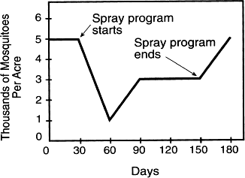

 | 1. Some mosquitoes were adapted to the climatic change that occurred over the several-month period of spraying. | 3. The spraying of the insecticide represented a change in the environment to which all adult mosquitoes were adapted.
 | 2. All of the mosquitoes contained DNA unique to the species. | 4. A natural variation existed within the mosquito population.

50. Base your answer on the information below and on your knowledge of biology.
A small village was heavily infested with mosquitoes. The village was sprayed weekly with an insecticide for a period of several months. The results of daily counts of the mosquito population are shown in the graph (see image).
Which statement best explains the decreased effectiveness of the insecticide?

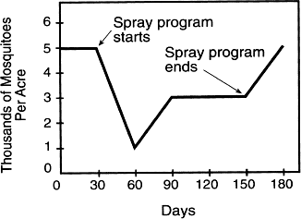

 | 1. The insecticide caused mutations that resulted in immunity in the mosquito. | 3. The insecticide reacted chemically with the DNA of the mosquitoes and was destroyed.
 | 2. Mosquitoes resistant to the insecticide lived and produced offspring. | 4. All of the mosquitoes produced antibodies that activated the insecticide.

51. The great variety of possible gene combinations in a sexually reproducing species is due in part to the
 | 1. sorting of genes as a result of gene replication | 3. pairing of genes as a result of differentiation
 | 2. pairing of genes as a result of mitosis | 4. sorting of genes as a result of meiosis

52. The information below was printed on a calendar of important events in the field of biology.
1859
Darwin Publishes
On the Origin of Species by Natural Selection
This information is most closely associated with
 | 1. an explanation for the change in types of minerals in an area through ecological succession | 3. an attempt to explain the structural similarities observed among diverse living organisms
 | 2. the reasons for the loss of biodiversity in all habitats on Earth | 4. the effect of carrying capacity on the size of populations

53. The Florida panther, a member of the cat family, has a population of fewer than 100 individuals and has limited genetic variation. Which inference based on this information is valid?
 | 1. These animals will begin to evolve rapidly. | 3. These animals are easily able to adapt to the environment.
 | 2. Over time, these animals will become less likely to survive in a changing environment. | 4. Over time, these animals will become more likely to be resistant to disease.

54. The accompanying diagram shows the bones in the forelimbs of two different vertebrate species.
The position and structure of these bones could best be used to make inferences about the

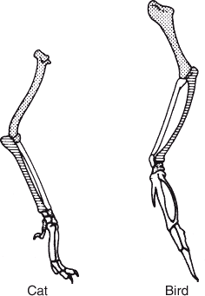

 | 1. food preferences of these vertebrate species | 3. history of these vertebrate species
 | 2. intelligence of these vertebrate species | 4. reproductive behavior of these vertebrate species

55. Base your answer on the information and data table shown and on your knowledge of biology.
A biology student performed an experiment to determine which of two species of single-celled organisms would survive best when cultured together in a certain environment. The student placed 10 organisms of each species into a large test tube. Throughout the experiment, the test tube was maintained at 30ºC. After the test tube was set up, the population of each species was determined each day for 5 days. The data collected are shown in the table shown.
The difference in the population sizes on the fifth day most likely resulted from

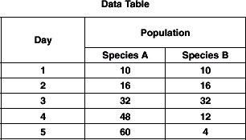

 | 1. temperature changes | 3. competition between species
 | 2. variations in light intensity | 4. the buildup of nitrogen gas

56. Which process is correctly matched with its explanation?

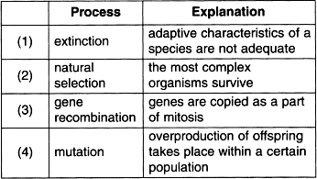

57. Meiosis and fertilization are important processes because they may most immediately result in
 | 1. many body cells | 3. genetic variation
 | 2. immune responses | 4. natural selection

58. Information related to the organisms found on Earth during various geological time periods is represented in the chart shown.
Which statement concerning the first appearance of the organisms over the time period represented in this chart is most likely correct?

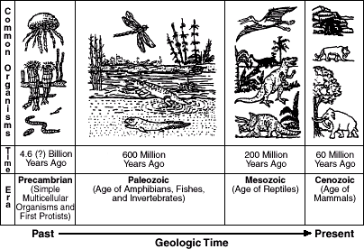

 | 1. Life on Earth has remained the same. | 3. Life on Earth began with complex organisms and changed to more complex organisms.
 | 2. Life on Earth has changed from primitive organisms to more complex organisms. | 4. Life on Earth has changed rapidly.

59. In an area in Africa, temporary pools form where rivers flow during the rainy months. Some fish have developed the ability to use their ventral fins as "feet" to travel on land from one of these temporary pools to another. Other fish in these pools die when the pools dry up. What can be expected to happen in this area after many years?
 | 1. The fish using ventral fins as ''feet'' will be present in increasing numbers. | 3. The fish using ventral fins as ''feet'' will develop real feet.
 | 2. ''Feet'' in the form of ventral fins will develop on all fish. | 4. All of the varieties of fish will survive and produce many offspring.

60. Characteristics that are harmful to a species tend to decrease in frequency from generation to generation because these characteristics usually
 | 1. have a high survival value for the species | 3. are inherited by more individuals
 | 2. have a low survival value for the species | 4. affect only the older members of the population

61. Which situation results in a characteristic that is inheritable?
 | 1. A limb is lost when two marine organisms fight. | 3. A gene is inserted into a bacterium, allowing the organism to produce insulin.
 | 2. A puppy learns to beg for food by watching an older dog perform tricks. | 4. A random mutation causes the immediate death of a microbe.

62. Many scientists suggest that billions of years ago, life on Earth began with
 | 1. simple, single-celled organisms | 3. complex, single-celled organisms
 | 2. simple, multicellular organisms | 4. complex, multicellular organisms

63. A sample of body cells and samples of sex cells received from four members of a species are screened for the presence of a specific gene mutation. The results of the gene-testing procedure conducted on the cells are shown in the accompanying table.
Which species member would be unlikely to pass the gene mutation on to its offspring?

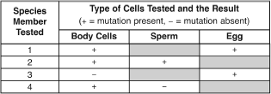

64. Buffalo grass is a species of plant found on the grazing prairies of Wyoming. It is a tough grass that has silicates (compounds containing oxygen and silicon) that reinforce its leaves. For hundreds of years, this grass has survived in an adverse environment. Which statement best explains the presence of this grass today?
 | 1. There are no variations in this grass species that help it to survive in an adverse environment. | 3. The current species has no mutations.
 | 2. Silicates are necessary for photosynthesis. | 4. The silicates in the grass have given the species an advantage in its environment.

65. Parrots are tropical birds. However, in some areas of New York City, some parrots have been able to survive outdoors year-round. These parrots survive, while most others cannot, due to
 | 1. overproduction of offspring | 3. asexual reproduction of parrots with a mutation
 | 2. extinction of previous species | 4. a variation that allows these parrots to live in colder climates

66. The accompanying table shows adaptations in two organisms.
The presence of these adaptations is most likely the result of

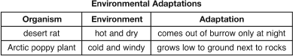

 | 1. reproductive technology | 3. asexual reproduction
 | 2. natural selection | 4. human interference

67. Which statement provides evidence that evolution is still occurring at the present time?
 | 1. The extinction rate of species has decreased in the last 50 years. | 3. New varieties of plant species appear more frequently in regions undergoing climatic change.
 | 2. Many bird species and some butterfly species make annual migrations. | 4. Through cloning, the genetic makeup of organisms can be predicted.

68. When a species includes organisms with a wide variety of traits, it is most likely that this species will have
 | 1. a high proportion of individuals immune to genetic diseases | 3. less success competing for resources
 | 2. a greater chance to survive if environmental conditions suddenly change | 4. limitless supplies of important resources, such as food and water

69. Which mutation in a fruit fly could be passed on to its offspring?
 | 1. a mutation in a cell of an eye that changes the color of the eye | 3. a mutation in a sperm cell that changes the shape of the wing
 | 2. a mutation in a leg cell that causes the leg to be shorter | 4. a mutation in a cell of the digestive tract that produces a different enzyme

70. A species of bird known as Bird of Paradise has been observed in the jungles of New Guinea. The males shake their bodies and sometimes hang upside down to show off their bright colors and long feathers to attract females. Females usually mate with the "flashiest" males. These observations can be used to support the concept that
 | 1. unusual courtship behaviors lead to extinction | 3. homeostasis in an organism is influenced by physical characteristics
 | 2. some organisms are better adapted for asexual reproduction | 4. behaviors that lead to reproductive success have evolved

71. Which statement concerning the evolution of species A, B, C, D, and E is supported by the accompanying diagram?

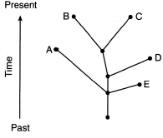

 | 1. Species B and C can be found in today's environments. | 3. Species A and C can still interbreed.
 | 2. Species A and D evolved from E. | 4. Species A, B, and E all evolved from a common ancestor and all are successful today.

72. Young birds that have been raised in isolation from members of their species build nests characteristic of their species. This suggests that the nest-building behavior is
 | 1. genetically inherited from parents | 3. a disadvantage to the survival of the species
 | 2. learned by watching members of their species | 4. a direct result of the type of food the bird eats

73. A characteristic that an organism exhibits during its lifetime will only affect the evolution of its species if the characteristic
 | 1. results from isolation of the organism from the rest of the population | 3. decreases the number of genes in the body cells of the organism
 | 2. is due to a genetic code that is present in the body gametes of the organism | 4. causes a change in the environment surrounding the organism

74. Agriculturists have developed some varieties of vegetables from common wild mustard plants, which reproduce sexually. Which statement best explains the development of these different varieties of vegetables?
 | 1. Different varieties can develop from a single species as a result of the recombination of genetic information. | 3. Mutations will occur in the genes of a species only if the environment changes.
 | 2. Different species can develop from a single species as a result of the effect of similar environmental conditions. | 4. Variations in a species will increase when the rate of mitosis is decreased.

75. Some evolutionary pathways are represented in the accompanying diagram.
An inference that can be made from information in the diagram is that

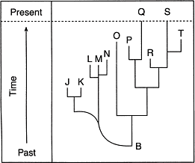

 | 1. many of the descendants of organism B became extinct | 3. most of the descendants of organism B successfully adapted to their environment and have survived to the present time
 | 2. organism B was probably much larger than any of the other organisms represented | 4. the letters above organism B represent members of a single large population with much biodiversity

76. Which species in the accompanying chart is most likely to have the fastest rate of evolution?

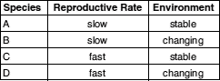

 | 1. A | 3. C
 | 2. B | 4. D

77. The kit fox and red fox species are closely related. The kit fox lives in the desert, while the red fox inhabits forests. Ear size and fur color are two differences that can be observed between the species. An illustration of these two species is shown in the accompanying image.
Which statement best explains how the differences between these two species came about?

 | 1. Different adaptations developed because the kit fox preferred hotter environments than the red fox. | 3. The foxes evolved differently to prevent overpopulation of the forest habitat.
 | 2. As the foxes adapted to different environments, differences in appearance evolved. | 4. The foxes evolved differently because their ancestors were trying to avoid competition.

78. What will most likely occur as a result of changes in the frequency of a gene in a particular population?
 | 1. ecological succession | 3. global warming
 | 2. biological evolution | 4. resource depletion

79. The puppies shown in the accompanying photograph are all from the same litter.
The differences seen within this group of puppies are most likely due to

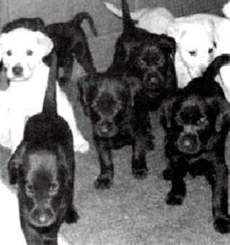

 | 1. overproduction and selective breeding | 3. evolution and asexual reproduction
 | 2. mutations and elimination of genes | 4. sorting and recombination of genes

80. A mutation that can be inherited by offspring would result from
 | 1. random breakage of chromosomes in the nucleus of liver cells | 3. abnormal lung cells produced by toxins in smoke
 | 2. a base substitution in gametes during meiosis | 4. ultraviolet radiation damage to skin cells

81. Which process will increase variations that could be inherited?
 | 1. mitotic cell division | 3. recombination of genes
 | 2. active transport | 4. synthesis of proteins

82. The accompanying diagram represents four different species of bacteria.
Which statement is correct concerning the chances of survival for these species if there is a change in the environment?

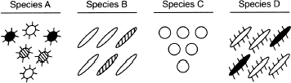

 | 1. Species A has the best chance of survival because it has the most genetic diversity. | 3. Neither species B nor species D will survive because they compete for the same resources.
 | 2. Species C has the best chance of survival because it has no gene mutations. | 4. None of the species will survive because bacteria reproduce asexually.

83. The accompanying diagram represents possible evolutionary relationships between groups of organisms.
Which statement is a valid conclusion that can be drawn from the diagram?

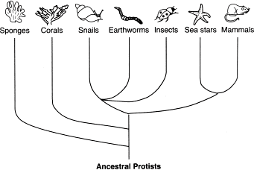

 | 1. Snails appeared on Earth before corals. | 3. Earthworms and sea stars have a common ancestor.
 | 2. Sponges were the last new species to appear on Earth. | 4. Insects are more complex than mammals.

84. Species of bacteria can evolve more quickly than species of mammals because bacteria have
 | 1. less competition | 3. lower mutation rates
 | 2. more chromosomes | 4. higher rates of reproduction

85. Certain insects resemble the bark of the trees on which they live. Which statement provides a possible biological explanation for this resemblance?
 | 1. The insects needed camouflage so they developed protective coloration. | 3. The lack of mutations resulted in the protective coloration.
 | 2. Natural selection played a role in the development of this protective coloration. | 4. The trees caused mutations in the insects that resulted in protective coloration.

86. When is extinction of a species most likely to occur?
 | 1. when environmental conditions remain the same and the proportion of individuals within the species that lack adaptive traits increases | 3. when environmental conditions change and the adaptive traits of the species favor the survival and reproduction of some of its members
 | 2. when environmental conditions remain the same and the proportion of individuals within the species that possess adaptive traits increases | 4. when environmental conditions change and the members of the species lack adaptive traits to survive and reproduce

87. The accompanying diagram represents four different species of wild birds. Each species has feet with different structural adaptations.
The development of these adaptations can best be explained by the concept of

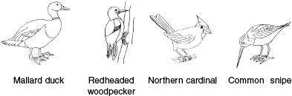

 | 1. inheritance of resistance to diseases that affect all these species | 3. natural selection
 | 2. inheritance of characteristics acquired after the birds hatched from the egg | 4. selective breeding

88. The diagram below represents a nucleus containing the normal chromosome number for a species.
Which diagram bests illustrates the normal formation of a cell that contains all of the genetic information needed for growth, development, and future reproduction of this species?

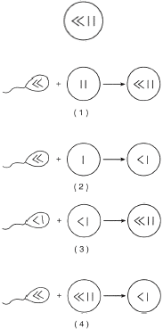

89. The accompanying diagram shows the effect of spraying a pesticide on a population of insects over three generations.
Which concept is represented in the diagram?

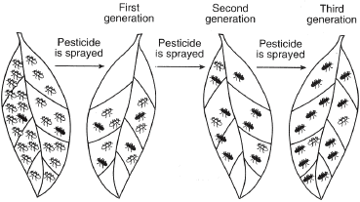

 | 1. survival of the fittest | 3. succession
 | 2. dynamic equilibrium | 4. extinction

90. A single pair of goldfish in an aquarium produced a large number of offspring. These offspring showed variations in body shape and coloration. The most likely explanation for these variations is that the
 | 1. offspring were adapting to different environments | 3. parent fish had not been exposed to mutagenic agents
 | 2. offspring were produced from different combinations of genes | 4. parent fish had not reproduced sexually

91. A certain species has little genetic variation. The rapid extinction of this species would most likely result from the effect of
 | 1. successful cloning | 3. environmental change
 | 2. gene manipulation | 4. genetic recombination

92. Which two structures of a frog would most likely have the same chromosome number?
 | 1. skin cell and fertilized egg cell | 3. kidney cell and egg cell
 | 2. zygote and sperm cell | 4. liver cell and sperm cell

93. Which two processes result in variations that commonly influence the evolution of sexually reproducing species?
 | 1. mutation and genetic recombination | 3. extinction and gene replacement
 | 2. mitosis and natural selection | 4. environmental selection and selective breeding

94. The accompanying illustration shows an insect resting on some green leaves.
The size, shape, and green color of this insect are adaptations that would most likely help the insect to

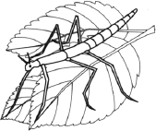

 | 1. compete successfully with all birds | 3. hide from predators
 | 2. make its own food | 4. avoid toxic waste materials

95. Some human body structures are represented in the accompanying diagram.
In which structures would the occurrence of mutations have the greatest effect on human evolution?

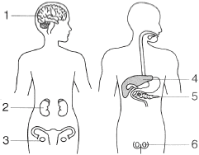

 | 1. 1 and 3 | 3. 3 and 6
 | 2. 2 and 5 | 4. 4 and 6

96. Base your answer on the accompanying diagram and on your knowledge of biology. Letters A through L represent different species of organisms. The arrows represent long periods of geologic time.
Which two species would most likely show the greatest similarity of DNA and proteins?

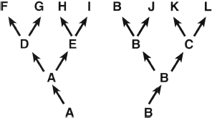

 | 1. B and J | 3. J and K
 | 2. G and I | 4. F and L

97. In members of a bird species living on a remote island, the greatest number of beak variations in the population would most likely be found when
 | 1. there is a high level of competition for limited resources | 3. they have a large and varied food supply
 | 2. homeostasis is limited by a severe climate | 4. they are prey for a large number of predators

98. The evolutionary pathways of ten different species are represented in the accompanying diagram.
Which two species are the most closely related?

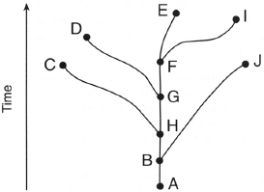

 | 1. C and D | 3. G and J
 | 2. E and I | 4. A and F

99. Which process can produce new inheritable characteristics within a multicellular species?
 | 1. cloning of the zygote | 3. gene alterations in gametes
 | 2. mitosis in muscle cells | 4. differentiation in nerve cells

100. According to the accompanying diagram, which three species lived on Earth during the same time period?

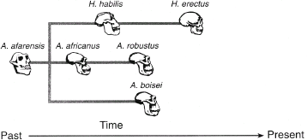

 | 1. robustus, africanus, afarensis | 3. habilis, robustus, boisei
 | 2. habilis, erectus, afarensis | 4. africanus, boisei, erectus

101. Base your answer on the accompanying diagram and on your knowledge of biology. Letters A through L represent different species of organisms. The arrows represent long periods of geologic time.
Which two species are the most closely related?

 | 1. J and L | 3. F and H
 | 2. G and L | 4. F and G

102. Base your answer on the accompanying diagram and on your knowledge of biology. Letters A through L represent different species of organisms. The arrows represent long periods of geologic time.
Which species was best adapted to changes that occurred in its environment over the longest period of time?

 | 1. A | 3. C
 | 2. B | 4. J

103. Which factor contributed most to the extinction of many species?
 | 1. changes in the environment | 3. inability to evolve into simple organisms
 | 2. lethal mutations | 4. changes in migration patterns

104. Meiosis and fertilization are important for the survival of many species because these two processes result in
 | 1. large numbers of gametes | 3. cloning of superior offspring
 | 2. increasingly complex multicellular organisms | 4. genetic variability of offspring

105. The diagram (see image) shows the evolution of some different species of flowers.
Which statement about the species is correct?

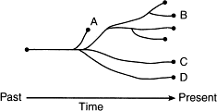

 | 1. Species A, B, C, and D came from different ancestors. | 3. Species A, B, and C can interbreed successfully.
 | 2. Species C evolved from species B. | 4. Species A became extinct.

106. Base your answer on the chart and on your knowledge of biology.
According to most scientists, which sequence best represents the order of biological evolution on Earth?

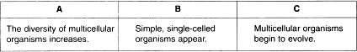

 | 1. A --> B --> C | 3. B --> A --> C
 | 2. B --> C --> A | 4. C --> A --> B

107. Which factor could be the cause of the other three in an animal species?
 | 1. the inability of the species to adapt to changes | 3. extinction of the species
 | 2. a lack of genetic variability in the species | 4. a decrease in the survival rate of the species

108. Natural selection and its evoluntionary consequences provide a scientific explanation for each of the following except
 | 1. the fossil record | 3. similar structures among different organisms
 | 2. protein and DNA similarities between different organisms | 4. a stable physical environment

109. If mitotic cell division is the only way a particular species of single-celled organism can reproduce, it is most likely that
 | 1. mutations can not occur in this species | 3. the number of organisms of this species in an area will remain constant
 | 2. the rate of evolution in this species is slower than in one that reproduces sexually | 4. this species belongs to the animal kingdom

110. In order for new species to develop, there must be a change in the
 | 1. temperature of the environment | 3. genetic makeup of a population
 | 2. migration patterns within a population | 4. rate of succession in the environment

111. Which statement is not part of the concept of natural selection?
 | 1. Individuals that possess the most favorable variations will have the best chance of reproducing. | 3. More individuals are produced than will survive.
 | 2. Variation occurs among individuals in a population. | 4. Genes of an individual adapt to a changing environment.

112. Which population of organisms would be in greatest danger of becoming extinct?
 | 1. A population of organisms having few variations living in a stable environment. | 3. A population of organisms having many variations living in a stable environment.
 | 2. A population of organisms having few variations living in an unstable environment. | 4. A population of organisms having many variations living in an unstable environment.

113. The relationship of some mammals is indicated in the diagram (see image).
Which statement about the African elephant is correct?

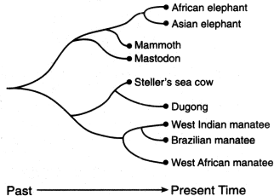

 | 1. It is more closely related to the mammoth than it is to the West African manatee. | 3. It is not related to the Brazilian manatee or the mammoth.
 | 2. It is more closely related to the West Indian manatee than it is to the mastodon. | 4. It is the ancestor of Steller's sea cow.

114. Base your answer on the diagram (see image) and on your knowledge of biology. Letters A through J represent different species of organisms. The vertical distances between the dotted lines represent long periods of time in which major environmental changes occurred.
Which species was the first to become extinct?

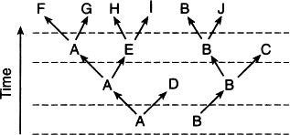

 | 1. E | 3. C
 | 2. J | 4. D

115. Base your answer on the diagram (see image) and on your knowledge of biology. Letters A through J represent different species of organisms. The vertical distances between the dotted lines represent long periods of time in which major environmental changes occurred.
Which species appears to have been most successful in surviving changes in the environment over time?

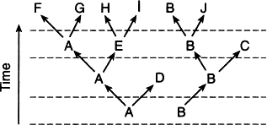

 | 1. A | 3. C
 | 2. B | 4. H

116. The diagram (see image) shows a process that can occur during meiosis.
The most likely result of this process is

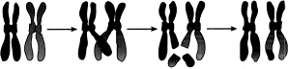

 | 1. a new combination of inheritable traits that can appear in the offspring | 3. a loss of genetic information that will produce a genetic disorder in the offspring
 | 2. an inability to pass either of these chromosomes on to offspring | 4. an increase in the chromosome number of the organism in which this process occurs

117. Structures in a human female are represented in the diagram (see image).
A heavy dose of radiation would have the greatest impact on genetic information in future offspring if it reached gametes developing within structure

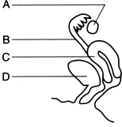

 | 1. A | 3. C
 | 2. B | 4. D

118. Organism X appeared on Earth much earlier than organism Y. Many scientists believe organism X appeared between 3 and 4 billion years ago, and organism Y appeared approximately 1 billion years ago. Which row in the chart shown most likely describes organisms X and Y?

