Introduction to Scientific Inquiry: Controlled Experiments and The Scientific Method

Science is about observing things, asking questions, proposing solutions, and testing those solutions. One way to test solutions in through a controlled experiment.

Controlled Experiment: a test in which one variable (something that can change in your experiment) is purposely and steadily changed to see what effect occurs.

Example Question/Purpose: Will plants change the direction they grow in order to face the light?

Possible Hypothesis: If different plants are placed different directions (angles) from the light, then over time they will bend toward the light because plants require light to grow.

To test this solution, you can conduct a controlled experiment to determine whether the angle of light shining on the plants effects the direction that the plant grows.
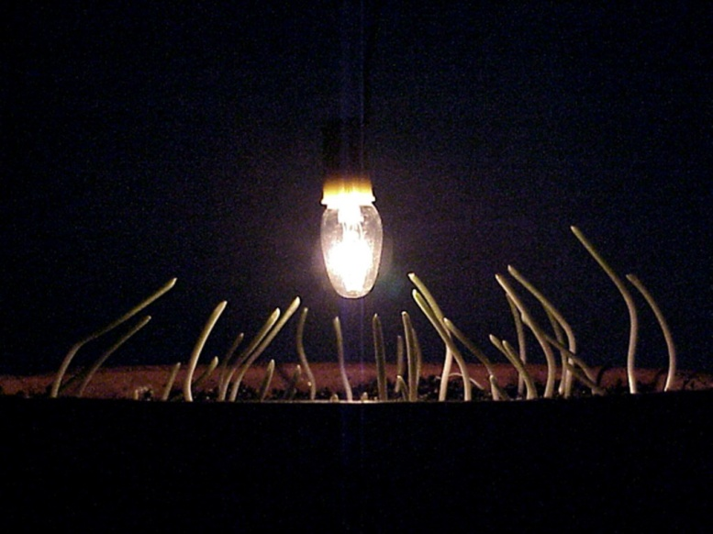
Figure 1-
Corn seedlings
bending toward
the light

Independent Variable:

Example:

Dependent Variable:

Example:

What other factors in this experiment would have to be kept the same to make sure it is a “controlled experiment” that is only testing the effect of one variable on the direction of plant growth?

Control group-

Ex. The light source is placed directly above the plant, not at an angle.
The control group helps to determine if changing the independent variable is really the reason that the plants grew sideways.

The Scientific Method
The Scientific Method is a process that scientists use to find answers to their questions. The steps of this process must be followed whenever you design or conduct an experiment.
- Asking a Question (Determining a Problem):

Ex. Why does water freeze? ( )

Ex. What is the effect of decreasing the temperature on the time it takes for water to freeze? ( )

- Hypothesizing: Making an _________________________about your question. Suggesting an answer to how one ______________will affect another. This can be based on ________________________, __________________________, or ____________________________.

Ex. The lower the surrounding temperature, the faster that water will freeze.

- Designing the Experiment:
- Identifying your______________
- Deciding on ________________ you will need to conduct the experiment
- Writing a _________________ that explains how you will conduct the experiment
- Drawing a labelled _________________of your procedure and materials
- Creating a _____________ to record ____________.

- Conducting the Experiment:

- Observing and Recording Data: Describe and record the results of experiment clearly and accurately.

Qualitative Data-
Ex. Colour, smell, sound, shininess, state, etc.
Quantitative Data-
Ex. Length, mass, height, time, temperature, etc.

- Analyze Observations and State Conclusions:
- Creating ___________ to study _________________to identify _____________and trends
- Deciding whether to support or refute your __________________
- Thinking about how you would ____________ your experiment in the future
- Developing an explanation for your _______________

- Repeating the Process- Testing the experiment again to make sure your results are reliable.

