Ms. Levenson August 2017
Pre-IB Inquiry Skills Room 247
Course Overview
The purpose of this semester course is to help you strengthen your math foundation, prepare you for the standardized assessments you will take throughout High School, and to prepare you for the International Baccalaureate Diploma Program you may enroll in your Junior/ Senior year.
In this class, we will:
- Review & (re)-learn math concepts that will be on the SAT (and in your core math classes)
- Investigate the process behind certain math concepts
- Work Collaboratively on complex, high level problems
- Create and execute presentations (mini-lessons) to classmates
SAT Math Test
Heart of Algebra
- Create, solve, or interpret a linear expression or equation in one variable that represents a context.
- Create, solve, or interpret linear inequalities in one variable that represent a context.
- Build a linear function that models a linear relationship between two quantities.
- Create, solve, and interpret systems of linear inequalities in two variables. T
- Create, solve, and interpret systems of two linear equations in two variables.
- Algebraically solve linear equations (or inequalities) in one variable.
- Algebraically solve systems of two linear equations in two variables.
- Interpret the variables and constants in expressions for linear functions within the context presented.
- Understand connections between algebraic and graphical representations.
Problem Solving & Data Analysis
- Use ratios, rates, proportional relationships, and scale drawings to solve single- and multistep problems.
- Solve single- and multistep problems involving percentages.
- Solve single- and multistep problems involving measurement quantities, units, and unit conversion.
- Given a scatterplot, use linear, quadratic, or exponential models to describe how the variables are related.
- Use the relationship between two variables to investigate key features of the graph.
- Compare linear growth with exponential growth.
- Use two-way tables to summarize categorical data and relative frequencies, and calculate conditional probability.
- Make inferences about population parameters based on sample data.
- Use statistics to investigate measures of center of data and analyze shape, center, and spread.
- Evaluate reports to make inferences, justify conclusions, and determine appropriateness of data collection methods.
Passport to Advanced Mathematics
- Create a quadratic or exponential function or equation that models a context.
- Determine the most suitable form of an expression or equation to reveal a particular trait, given a context.
- Create equivalent expressions involving rational exponents and radicals, including simplifying or rewriting in other forms.
- Create an equivalent form of an algebraic expression by using structure and fluency with operations.
- Solve a quadratic equation having rational coefficients.
- Add, subtract, and multiply polynomial expressions and simplify the result.
- Solve an equation in one variable that contains radicals or contains the variable in the denominator of a fraction.
- Solve a system of one linear equation and one quadratic equation.
- Rewrite simple rational expressions. .
- Interpret parts of nonlinear expressions in terms of their context.
- Understand the relationship between zeros and factors of polynomials, and use that knowledge to sketch graphs.
- Understand a nonlinear relationship between two variables by making connections between their algebraic and graphical representations
- Use function notation, and interpret statements using function notation.
- Use structure to isolate or identify a quantity of interest in an expression or isolate a quantity of interest in an equation.
Additional Topics in Math
- Solve problems using volume formulas.
- Use trigonometric ratios and the Pythagorean theorem to solve applied problems involving right triangles.
- Add, subtract, multiply, divide, and simplify complex numbers.
- Convert between degrees and radians and use radians to determine arc lengths; use trigonometric functions of radian measure.
- Apply theorems about circles to find arc lengths, angle measures, chord lengths, and areas of sectors.
- Use concepts and theorems about congruence and similarity to solve problems about lines, angles, and triangles.
- Use the relationship between similarity, right triangles, and trigonometric ratios; use the relationship between sine and cosine of complementary angles.
- Create or use an equation in two variables to solve a problem about a circle in the coordinate plane.

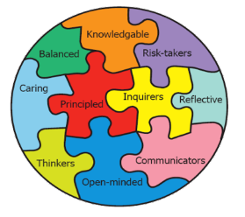
IB Learner Profile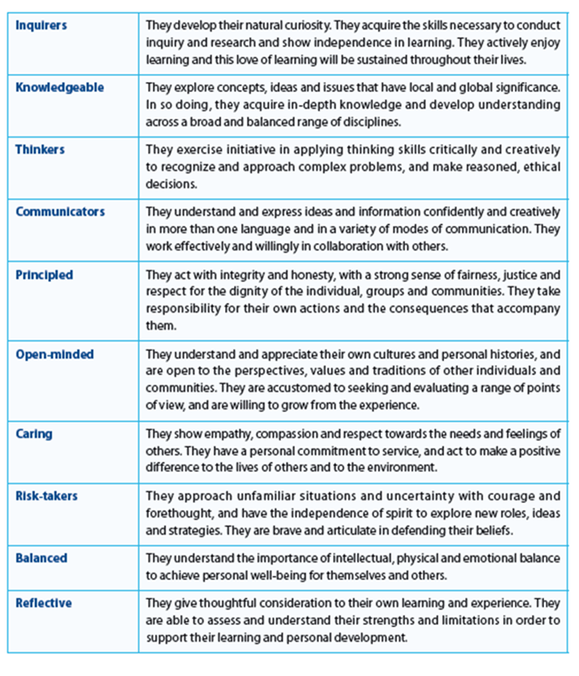

IB Approaches to Learning
Social Skills

Self-Management Skills

Thinking Skills

Communication Skills
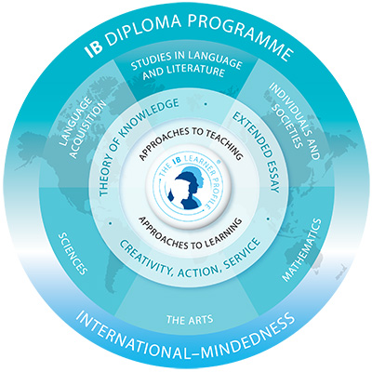
Research Skills

IB Approaches to Teaching
Based on Inquiry
Focused on Conceptual Understanding
Developed in Local and Global contexts
Focused on Effective Teamwork and Collaboration
Differentiated to Meet the Needs of All Learners
Informed by Formative and Summative Assessment

