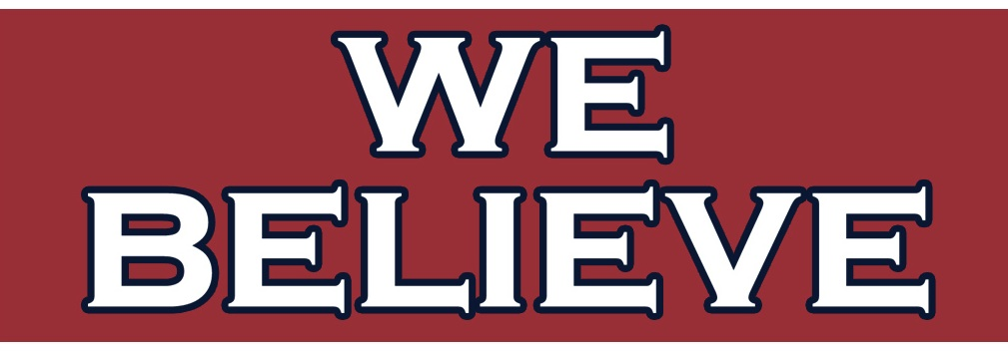
Ms. Levenson August 2017
Pre-International Baccalaureate Inquiry (Skills) Room 247
“MATHEMATICS is not about numbers, equations, computations, or algorithms; it is about UNDERSTANDING” –William Paul Thurston

This year, you will need to work hard in order to succeed. Remember the 5 P’s for success. Patience, Perspective, Persistence, Personality, and Professionalism.
The motto of our classroom is: WE BELIEVE – I believe in you, and over the course of the year, you will all learn to believe in yourselves and your own success.

Expectations:  - Show up, be ready, and keep your head in the game  Be PRESENT and PREPARED, Physically and Mentally  That means be on time (or early!), in uniform with your ID visible, have all of your work and materials, be ready to learn and ACTIVELY PARTICIPATE!  - Respect all the players, staff, and playing field  Respect one another, the teacher, any visitors, and the classroom and equipment  Treat everyone as you would like to be treated. Respect everyone’s opinions, and listen silently when someone else is talking. Treat our classroom with respect- do not draw or damage any of the furniture, walls, floors, decorations, or computers! |  |  | Rules:  - Follow the appropriate class procedures at all times  - Follow directions the first time they are given  - Do not talk out of turn or when others are talking  - Keep your hands, feet, and body to yourself  - Only have relevant materials out  - Use appropriate language at all times; no curse or offensive words, no putdowns  - NO food (or gum), cosmetics  - You must have teacher’s approval to open the door
General Classroom Procedures
- There is NO talking during loudspeaker announcements
- Collaborative work is always encouraged, EXCEPT during assessments
- During work time, try to get help from classmates before asking the teacher!
Entrance Procedure:  - Be in class and seated QUIETLY before the bell rings and begin working  - Turn off your phone/ put on SILENT  - Turn any assignments in on my desk  - Borrow relevant materials  - Check agenda for the day (and seating arrangements)  - Take out materials for the day and begin to work on the bell ringer  Exit Procedure:  - The teacher dismisses you, NOT the bell  - Stay seated until dismissed  - When told, you may get up, return your materials to the proper place, push your chair in, and silently walk out of the class. |  |  |  | Bathroom/Clinic Procedure:  - Bathroom passes are issued at teacher’s discretion  - If you need to use the restroom, you must raise your hand and wait to be answered  - If you must use the clinic, you are required to bring back a note with reason and time listed  - Students who take advantage of using the restroom will lose their privileges  Late Procedure:  - If you are late, you must knock and wait for the door to be opened  - You must sign in by the front door with the time and reason  - If you have an excuse indicate that when you sign in, and leave a note on my desk.
Electronic Devices: You are expected to be familiar with the M-DCPS BYOD Policy, and my personal BYOD Policy. Tablets and/or cell phones may be used in class AT TIMES for the lesson. Unless specifically directed, cell phones must be turned OFF and put away. If the cell phone is heard or seen, there will be consequences as outlined in the BYOD Policy.
EDMODO: Students are to sign up for Edmodo at the beginning of the year. Edmodo is use for communication with myself and classmates and class announcements.
Teacher Instruction Procedures:  - Attention is on the teacher (or person working at the board)  - Stay seated while someone is speaking!  - Raise your hand and wait to be called on  - Take notes and do the work!  Group Work Procedures:  - Work with your assigned partners only  - Follow the directions  - Show all work |  | Independent Work/ Test Procedures:  - Stay silent  - Raise your hand if you need anything or have a question  Computer/Tablet Procedures:  - Raise your hand if you need anything or have a question  - Do not visit any other websites or applications; any violations will be dealt with seriously  - Do not touch the screen or have drinks nearby  - Takes note and monitor your progress!
Assignments:  - ALL WORK must have the proper heading (date, lesson number, and assignment details)  - Pencil ONLY (for math work)  - MUST SHOW WORK!  - All assignments must be handed in on time.  - Assignments will only be accepted 1 class day after it is due. See Absence Policy  - Online HW will be open through at least 1 weekend. Late assignments will be deducted points |  |  |  | Class Notes & Work:  - Proper heading- including essential question, lesson number, and date  - Cornell style notes- important terms, questions and problems on left side, work shown on right  - Must answer the essential question at the end of the notes  - Notes should not be copied from board verbatim  - Notes can be completed online, but must follow the same format (and be shared with me)
Materials:  Suggested Book: Collegeboard Official SAT Guide  Required:  -TABLET (Must be Windows Compatible)  -1 binder with > 3 dividers  Sections: (Reference, Class Notes, Class Work)  -PENCIL & Colored pen for corrections  -Extra LINED and GRAPH paper  Suggested:  -Calculator- TI30XA/ TI84  -Dry Erase Marker  -Ruler | Grading Rubric:  20% Home Learning—primarily online assignments  30% Assessments/Projects—1 major project per quarter and occasional quizzes  15% Class Work—in-class assignments, binder checks & smaller projects  25% Participation—includes deductions for absences & tardies  10% Administrative—includes preparedness, BYOD, any required signed forms
Grading Scale:
A- 90-100; 3.5-4
B- 80-89; 2.5-3.49
C- 70-79; 1.5-2.49
D- 60-69;1 -1.49
F- Below 60; 0- 0.99
“10 point rule”—students must earn a D average for the year AND a D average in the second semester.
Inappropriate behaviors:  Familiarize yourself with the MB Discipline Policy. Any misbehaviors in class will be dealt with on a case by case basis. Multiple misbehaviors will result in a parent conference, and continued infractions will result in an administrative conference and/or referral.  Uniform & IDs:  Students must be properly attired in uniform with ID around the neck in order to be in class.  Students can be penalized for failing to follow the ID & Uniform policy. |  |  |  |  | Excessive Tardies:  Excessive tardies (3 or more) will affect your grade, and be dealt with on a case by case basis.  Absences:  All absences must be excused by a parent or Doctor’s note. You will have 3 days to bring in a note and make up any work you missed.  Makeup work will not be given for unexcused absences

Contact Information:
Website: http://miamibeachhigh.schoolwires.com/Domain/356
Edmodo class code:

My e-mail: hlevenson@dadeschools.net

