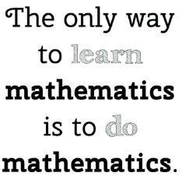



**Instructor:** Ms. Levenson **Room #:** 281

**E-mail:** [hlevenson@dadeschools.net](mailto:hlevenson@dadeschools.netP) **Phone:** (305)532-4515 **Ext** 2281

**EDMODO:** Edmodo is use for communication with myself and classmates and class announcements.

***Edmodo class code:***

**KHAN ACADEMY:** Used as homework and classwork, and for optional review.

***Khan Academy class code:***

**WEBSITE:** All relevant documents for class (including this syllabus), copies of notes, and important information.

(My homepage can be found by going directly to the school website and searching teachers, or at this link:)

[*http://miamibeachhigh.schoolwires.com/Domain/356*](http://miamibeachhigh.schoolwires.com/Domain/356)

**Geometry** Students explore more complex geometric situations and deepen their explanations of geometric relationships, moving towards formal mathematical arguments.

*See the Course Overview Document for details on topics and standards covered in the Geometry curriculum.*

**Topics**

* Transformations & Congruence
* Lines, Angles, & Triangles



* Quadrilaterals and Coordinate Proof
* Similarity
* Trigonometry
* Properties of Circles
* Measurement & Modeling in 2 and 3 Dimensions

**Materials:**

GRAPH PAPER PENCIL Calculator Tablet Binder (two sections)

**Grading Scale:**

**A** 90-100 **B** 80-89 **C** 70-79 **D** 60-69 **F** Below 60

*25% Home Learning*—primarily online HMH assignments

*30% Assessments*—quizzes (1 grade) & tests (2 grades)

*25% Class Work*—in-class assignments, exit tickets, binder checks & projects

*20% Participation*— includes preparedness, classroom behavior, and participation

***“10 point rule****”—students must earn a D average for the year AND a D average in the second semester*

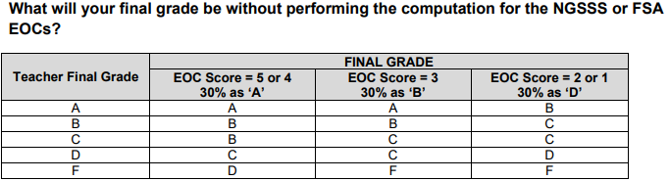

**Class Schedule:**

* 0-10 Min students are to complete Bell work
* Go over any questions from homework
* Lesson of the day
* Classwork/activity
* Assign Homework

**ABSENCES:** Makeup work is the student’s responsibility.

Homework will be online; it is the student’s responsibility to complete online homework while absent.

Class Work will only be graded if the student has a valid ADMIT.

Please follow school policies.

**Passes**

* You may not go to the restroom during **ANY** lesson or assessment.
* NO passes will be given during the first and last 15 minutes of any period.
* Abuse of passes will result in the entire period’s pass privilege to be taken away.

**Student Expectations**

* + You must follow all school rules, including UNIFORM, ID, and CELL PHONE policies.
  + You are expected to be in class, seated, and QUIET when the bell rings.
  + You should come to class prepared to learn, with your materials and work.
  + You will always show respect for yourself, other students, any adult, and all objects in the room.

**Extra Credit**

Participation & Leadership is the best way to “earn” extra credit points, through your “Passport to Success”.

**No extra credit will be awarded during the last 2 weeks of each quarter. Stay on top of your assignments ahead of schedule!**

**Electronic Devices:**

You are expected to be familiar with the M-DCPS BYOD Policy, and **my personal BYOD Policy.** Tablets and/or cell phones may be used in class AT TIMES for the lesson. Unless specifically directed, cell phones must be turned OFF and put away. If the cell phone is heard or seen, there will be consequences as outlined in the BYOD Policy.

***ACKNOWDLEGEMENT:*** Visit my school webpage and complete the form acknowledging you have read & reviewed the syllabus.

***PARENT ACKNOWLEDGEMENT:*** Parents should go to my school webpage and complete the form under ***Parent Corner*** to acknowledge receipt & review.